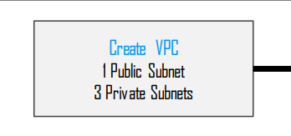

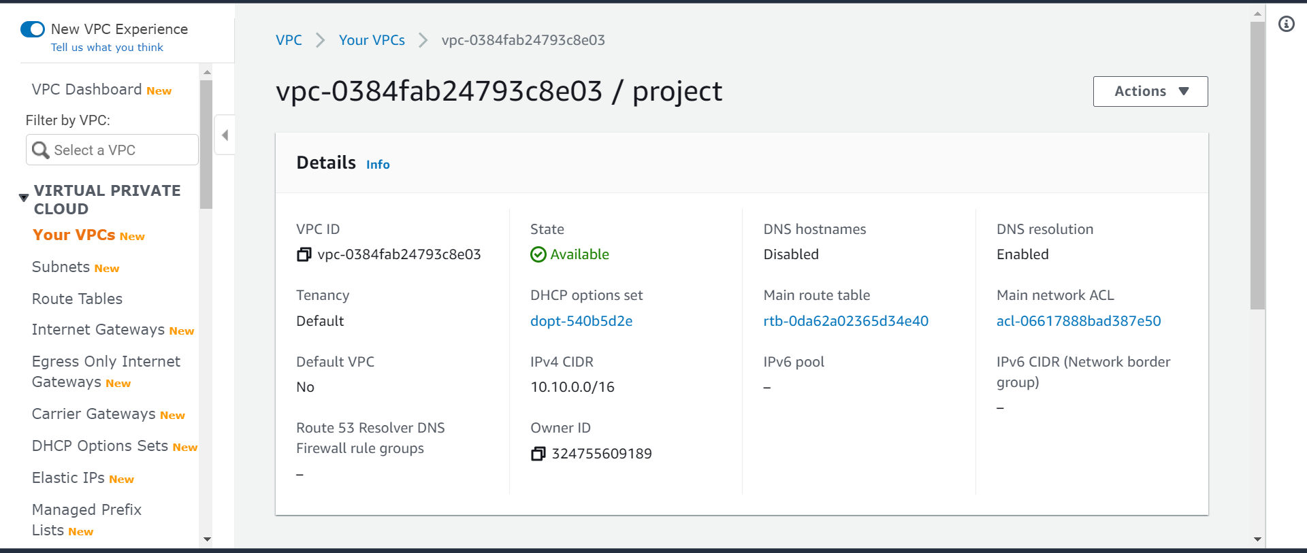

Created three subnets two are public public-01 public-02 private-01 attached all this three subnet to the project vpc

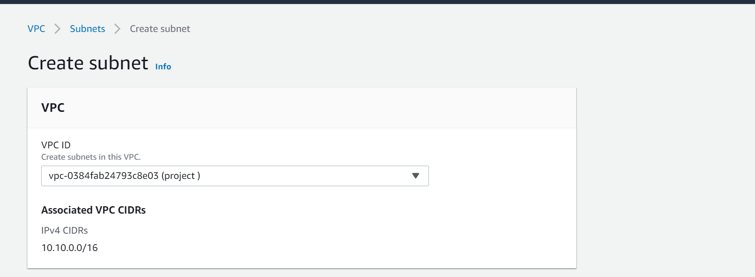

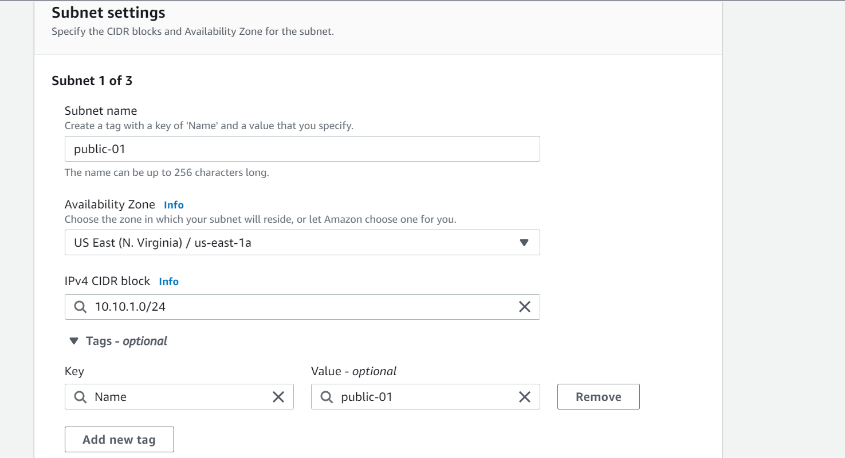

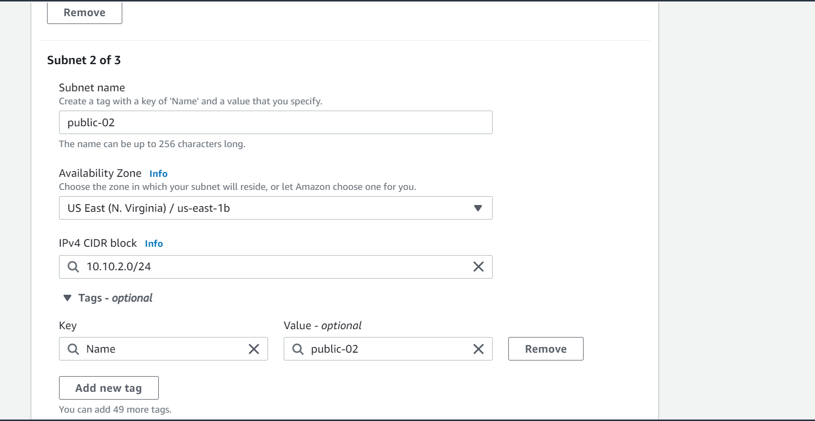

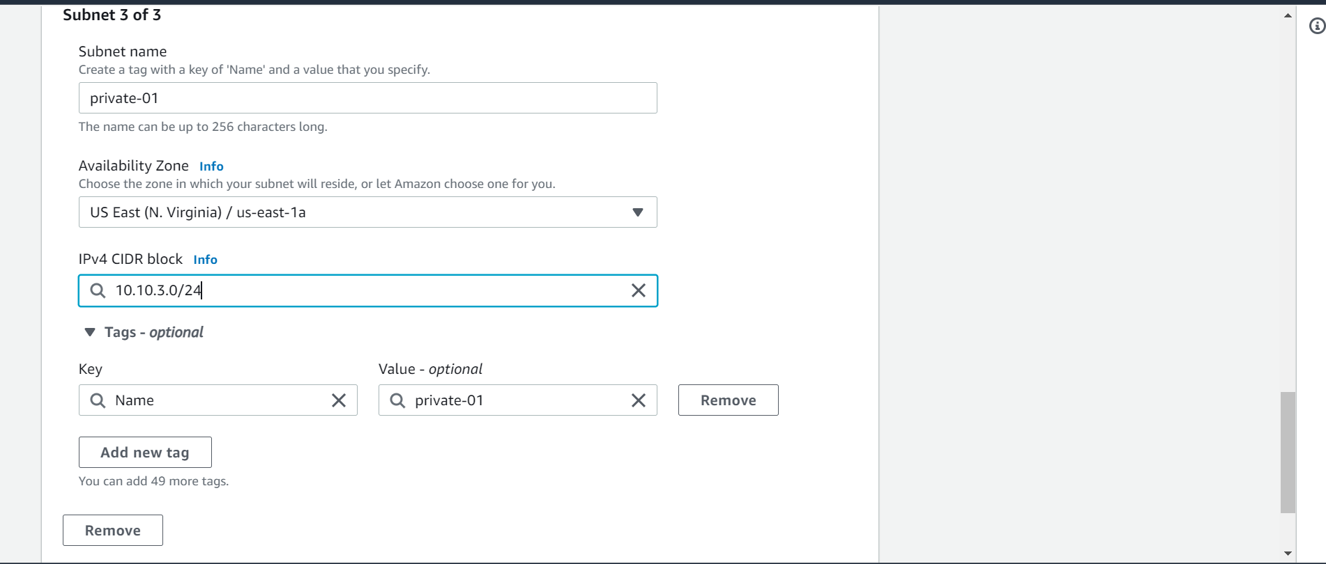

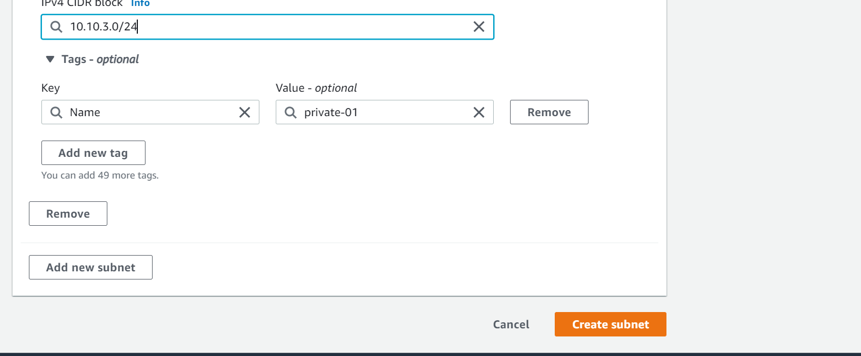

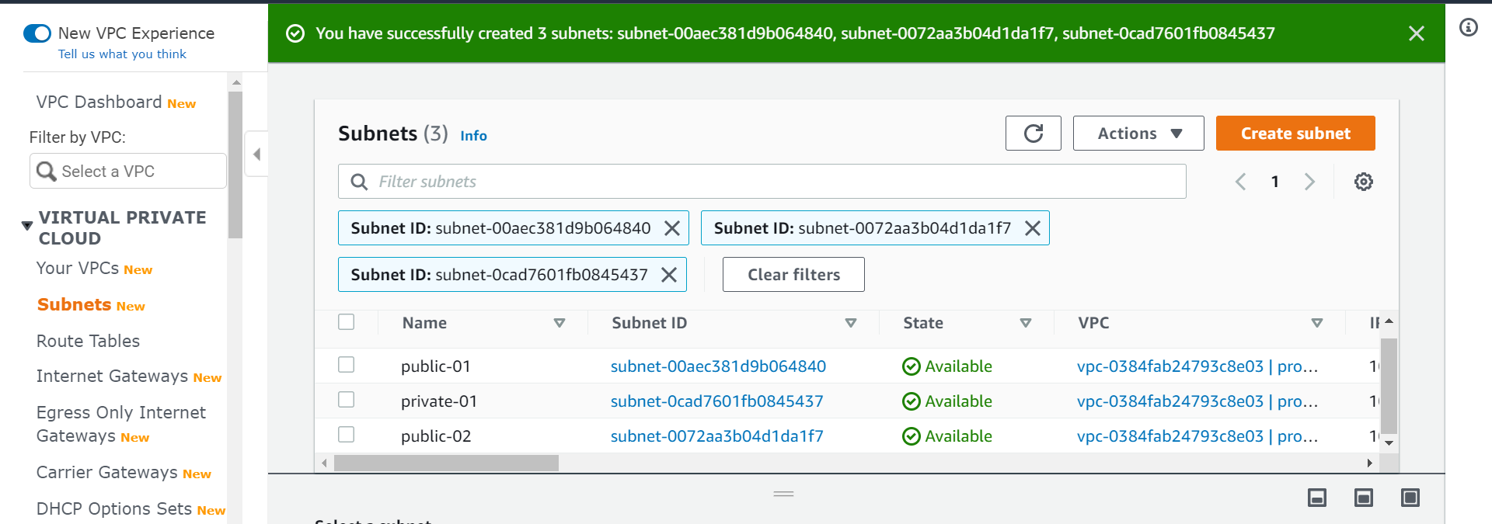

Create an internet gateway and attach it to vpc

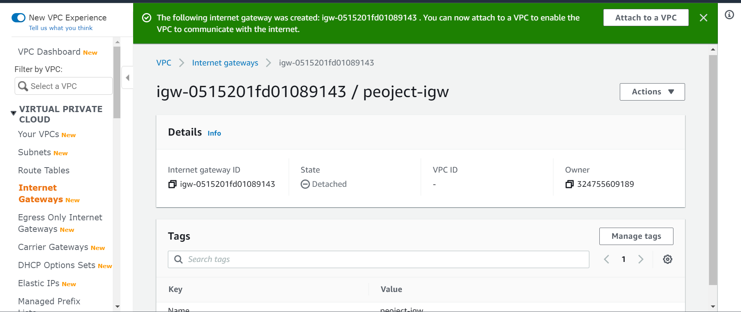

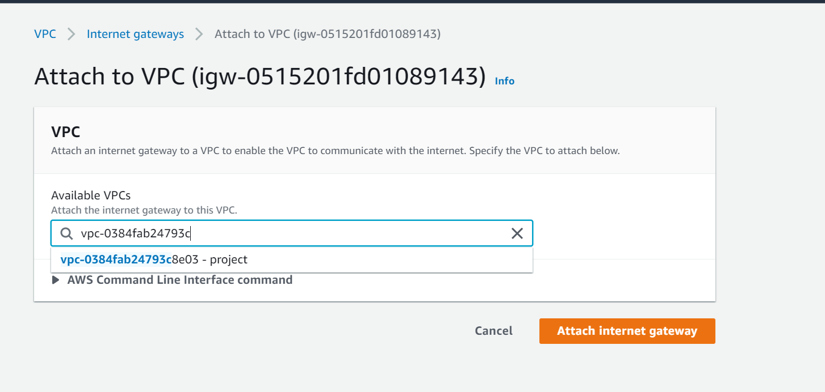

Attached it to the project vpc

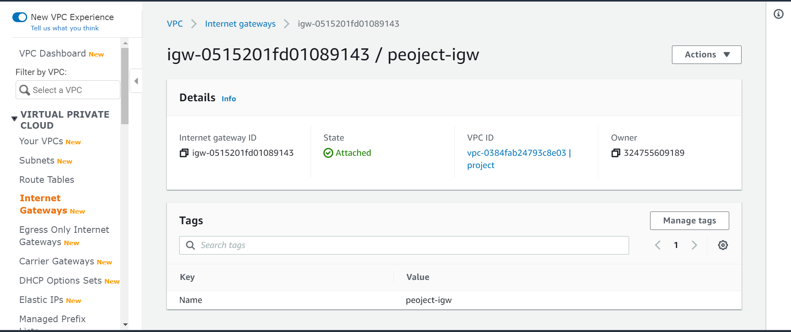

We need to deploy our application in a private instance so we need a nat gateway

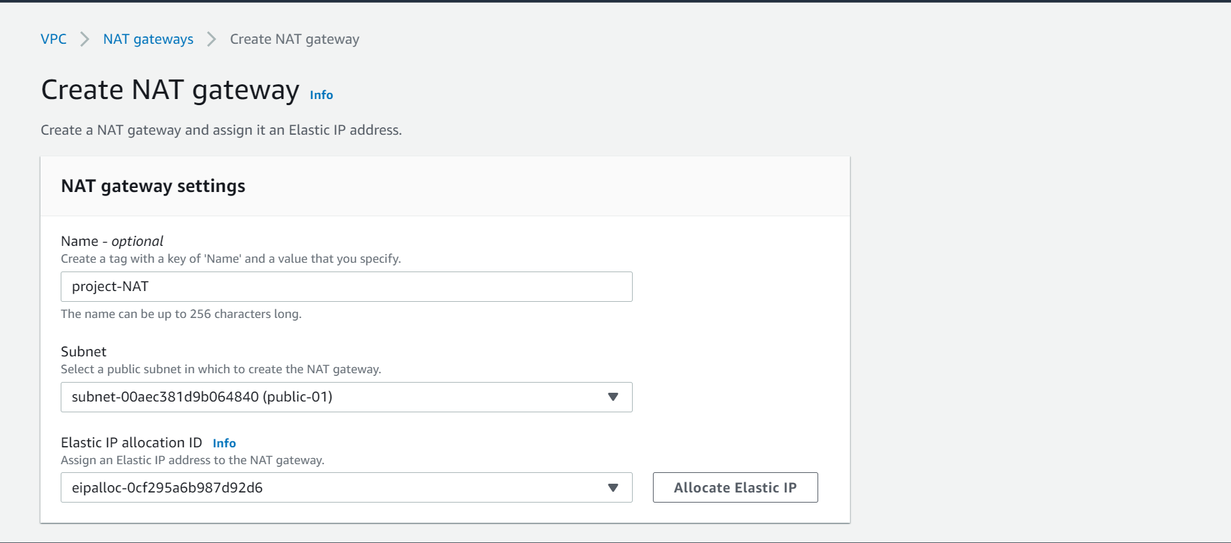

Created Nate gateway and attached it to a public-01 subnet as we are defining it as a public subnet and need access to internet

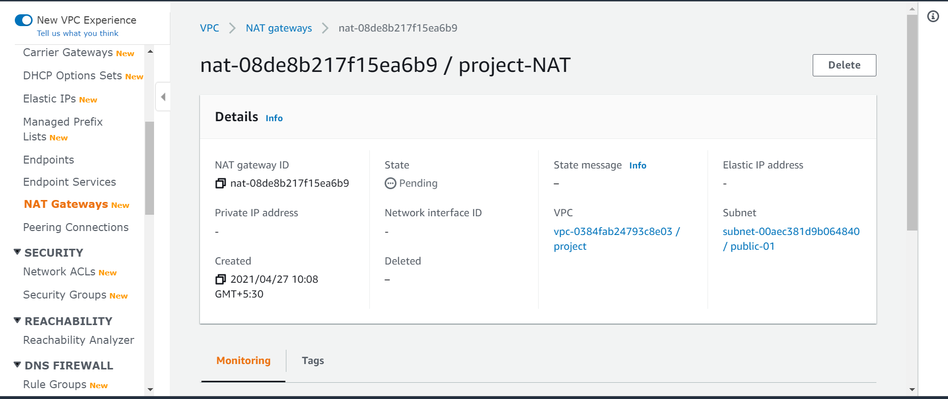

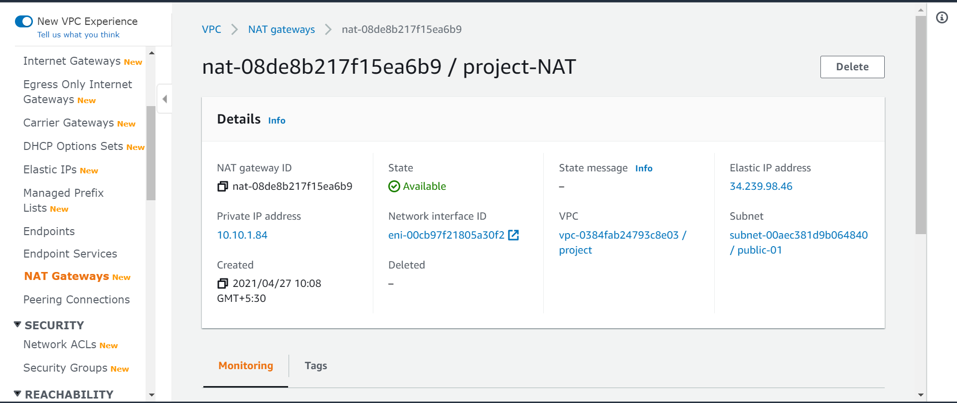

Now the nat gateway is available

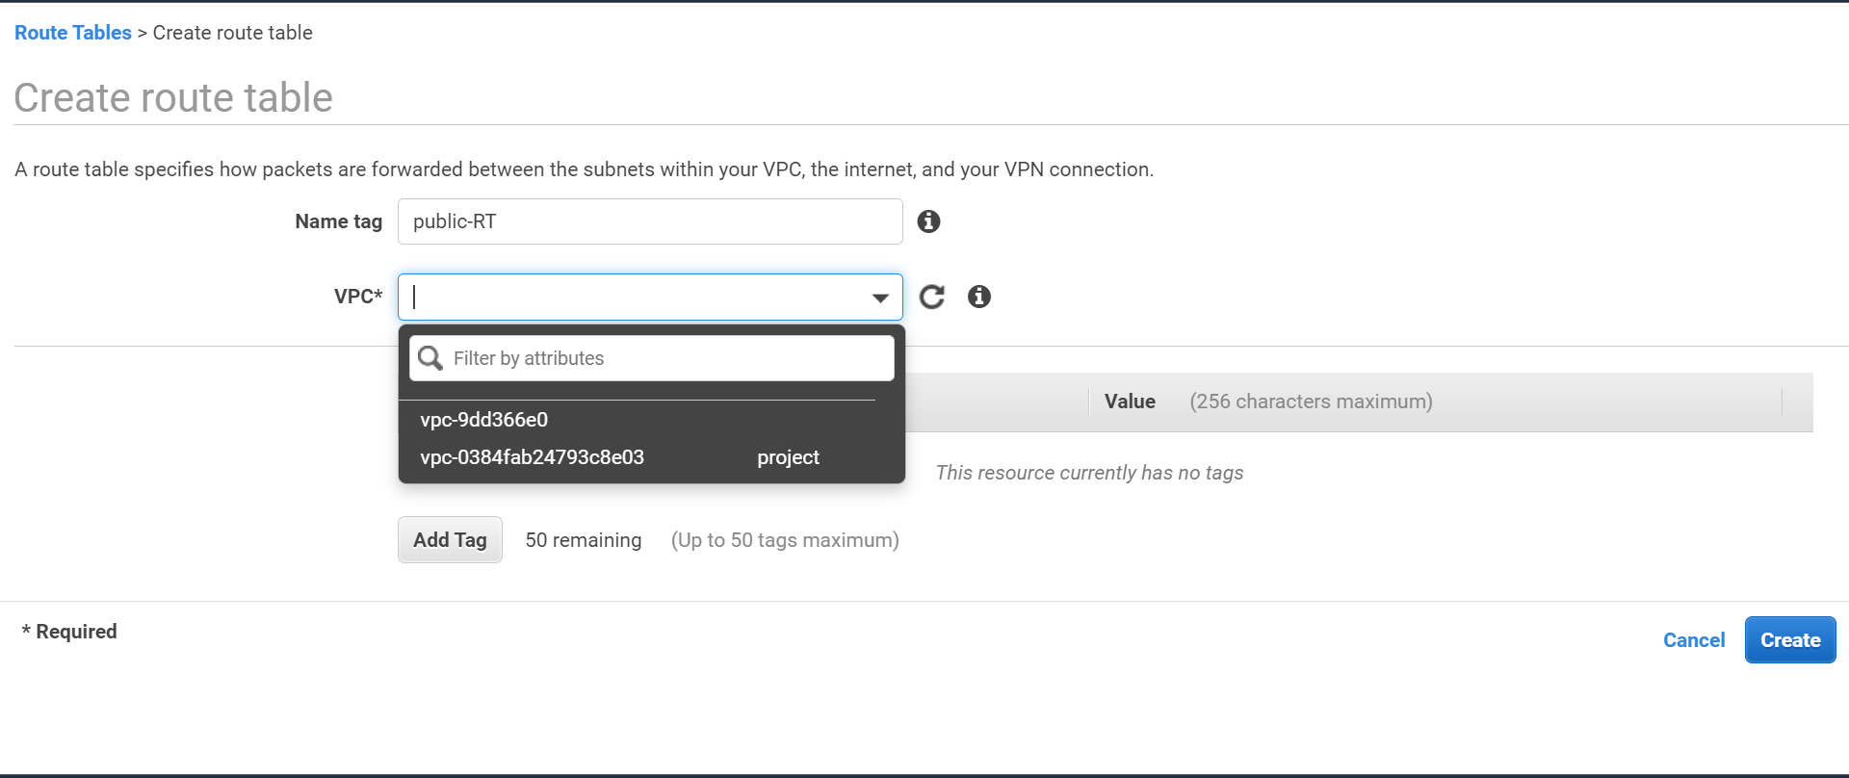

Create route table public-RT and attached it to the project vpc

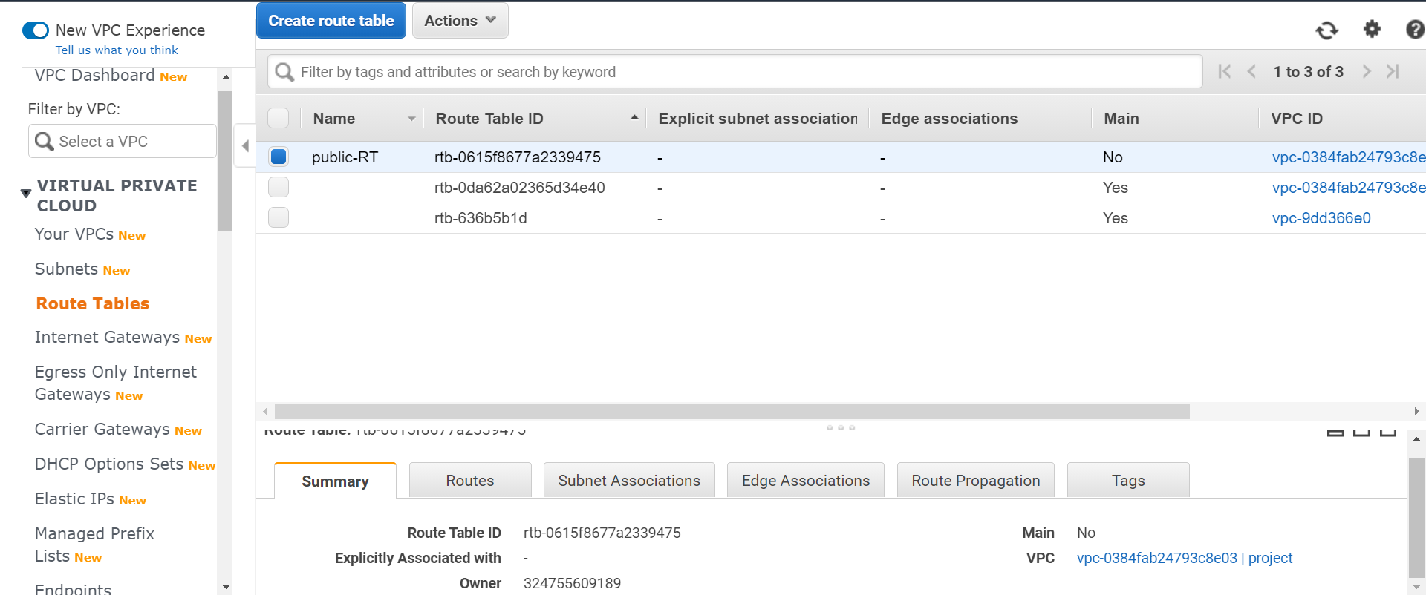

Public route table has been created and we have attached it to the project vpc andwe are editing the routes to this route table

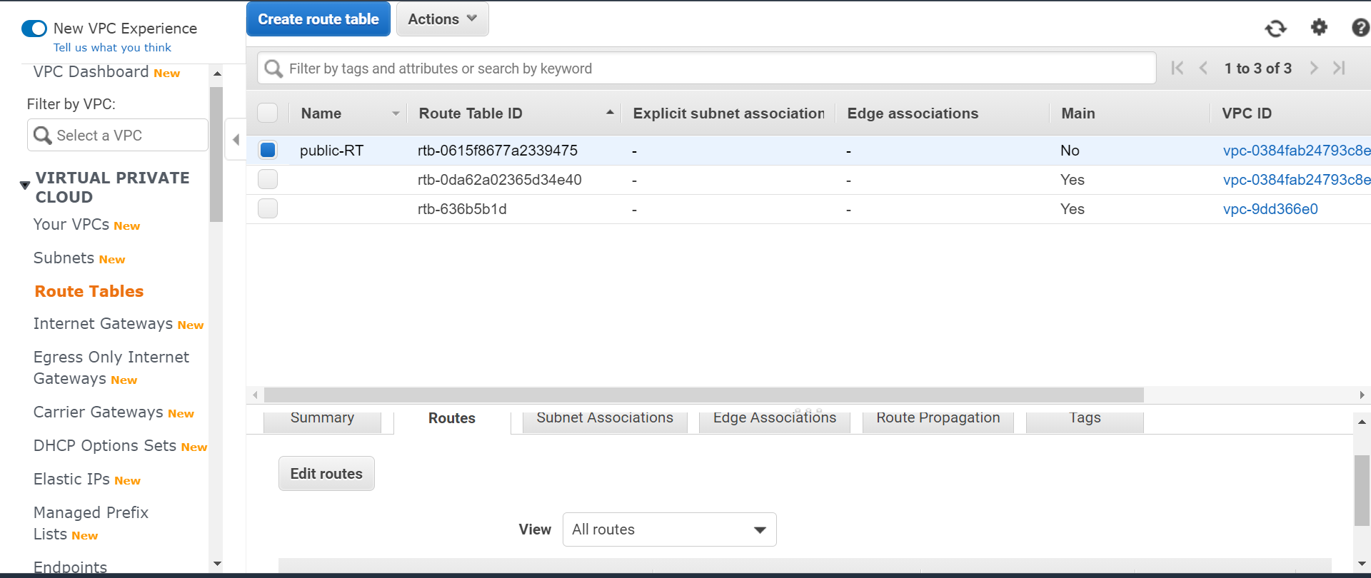

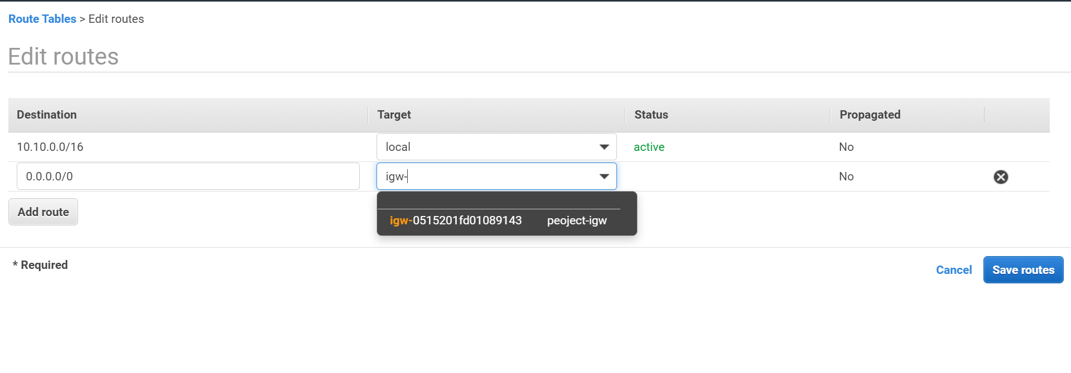

**We have created the route table and we are editing the routes and adding inter net gateway as**

**A route because for public subnet we need internet access**

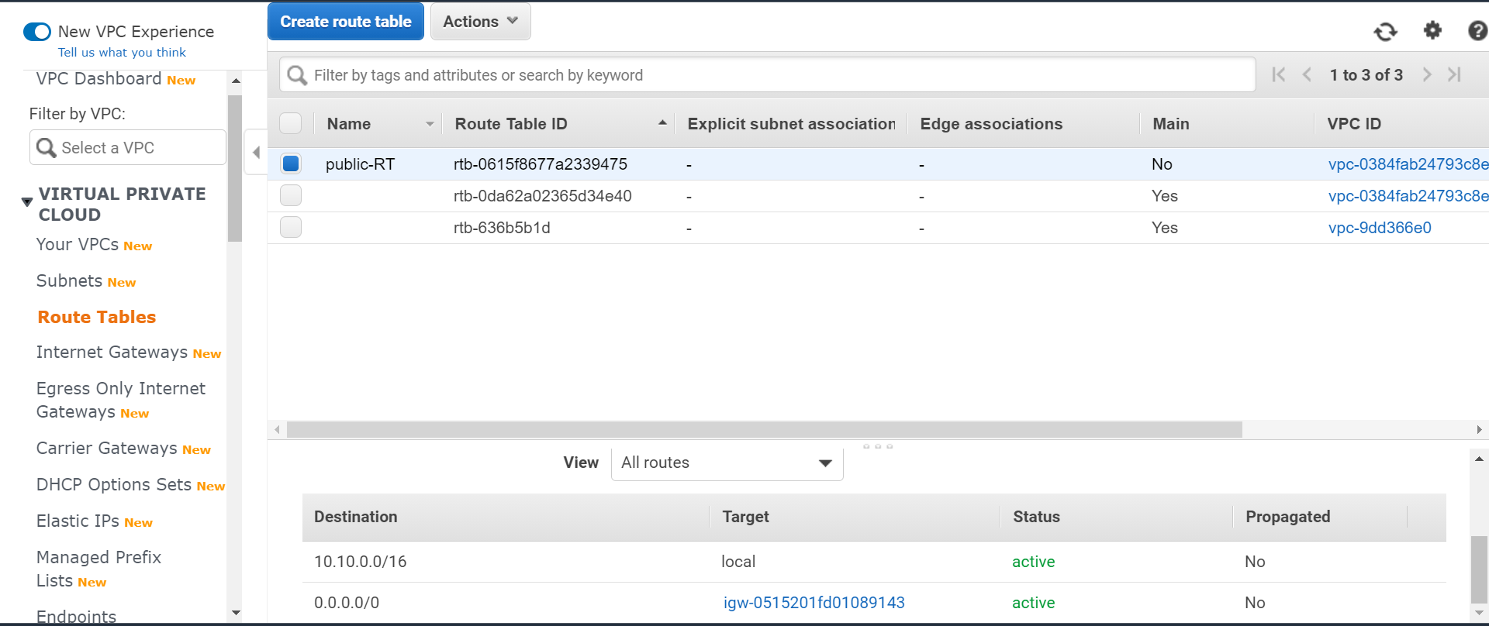

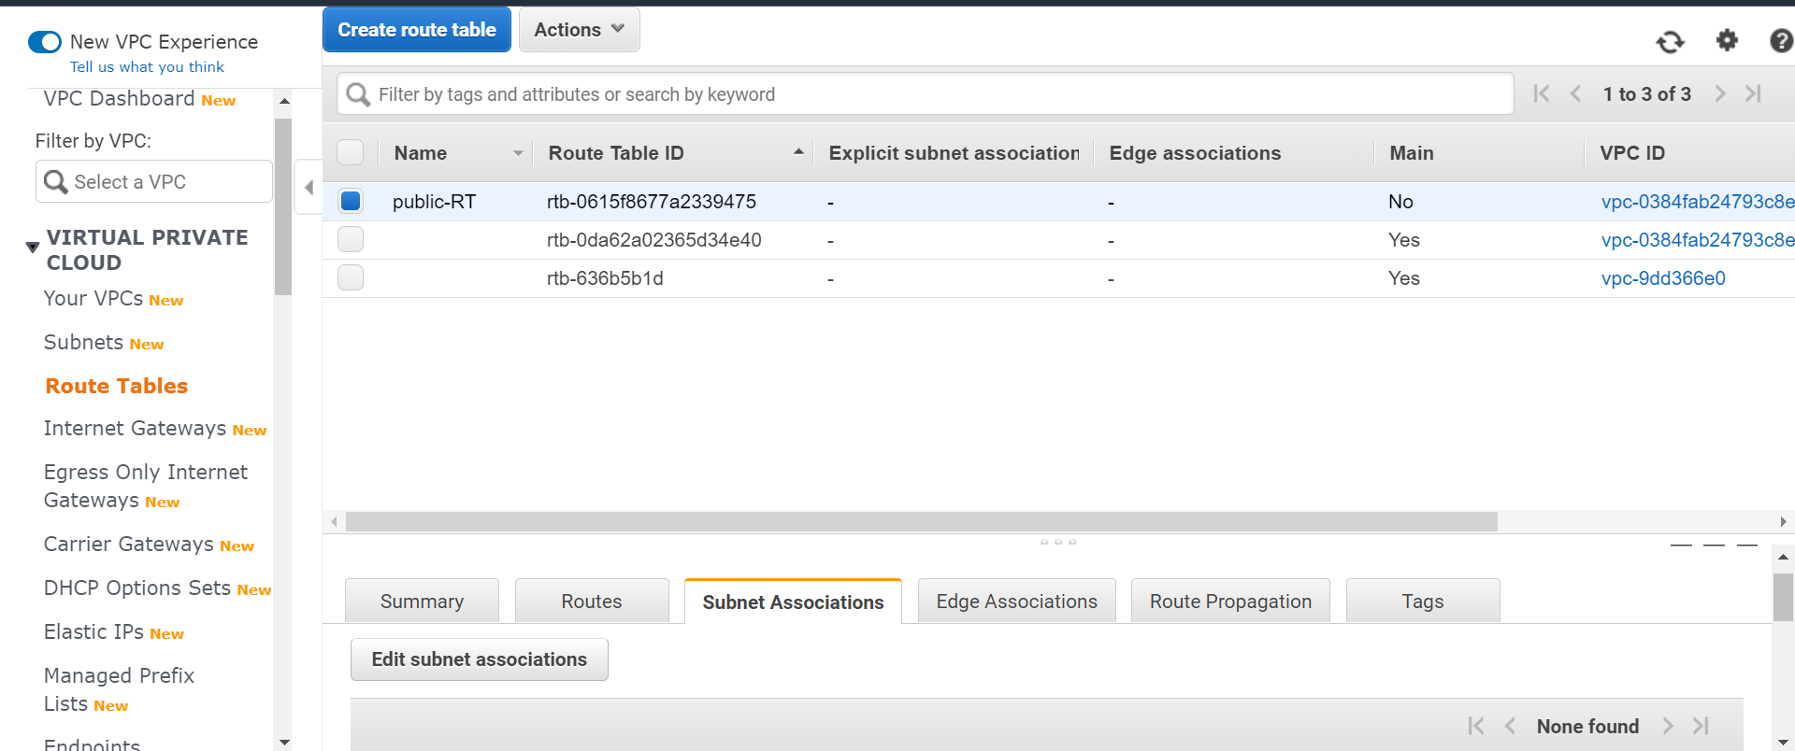

**Under route table subnet associations we are editing the subnet and we are adding subnet for this**

**We are adding both the public subnet 01 and public subnet 02 for this because we need public access for this and we should be able to access these**

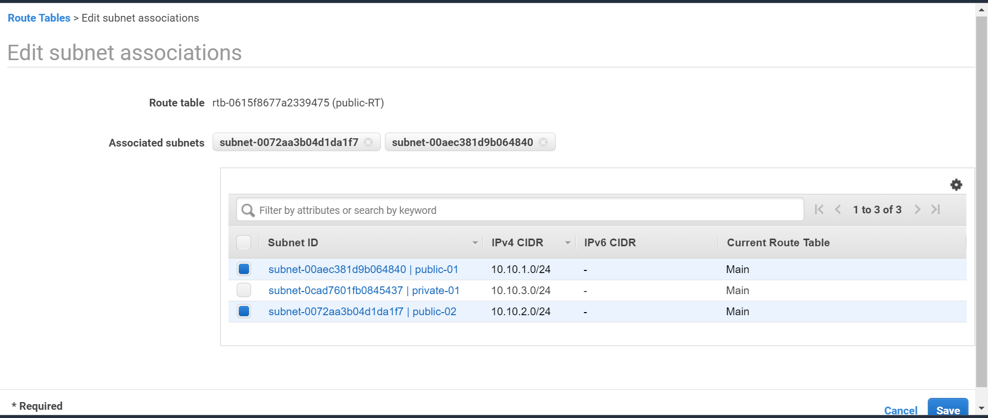

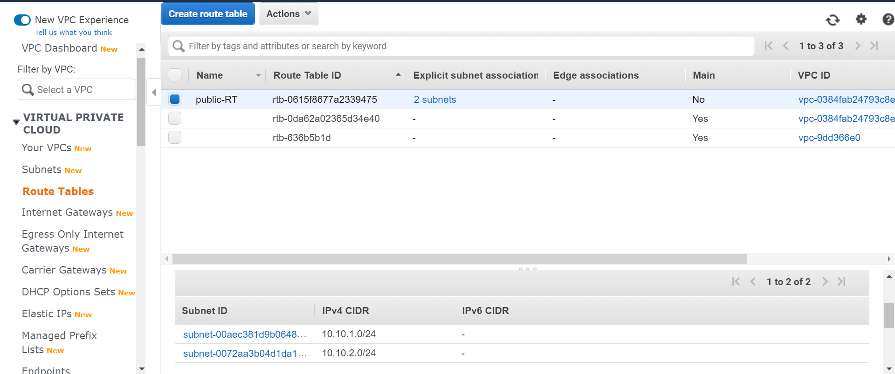

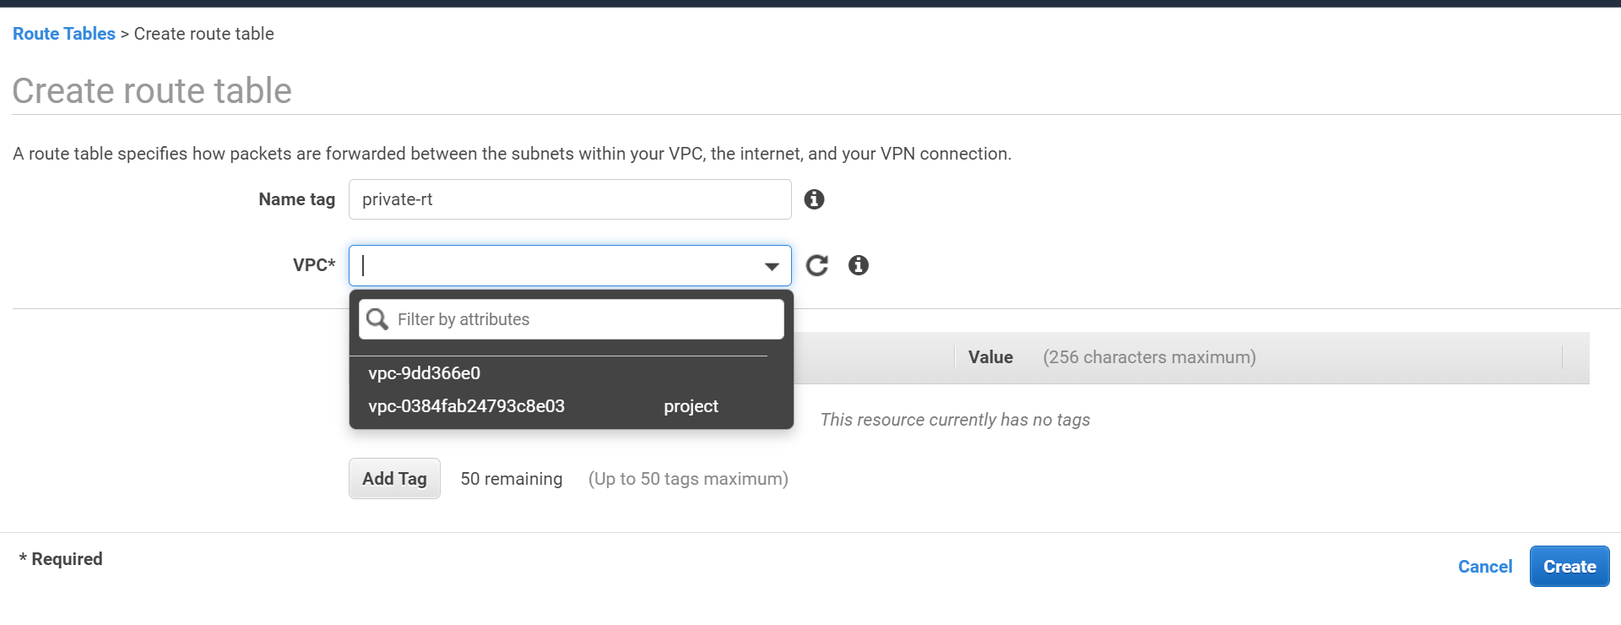

**We are creating one more route table private-rt and we are attaching the project vpc for that**

**Because private subnet should not have any access to internet**

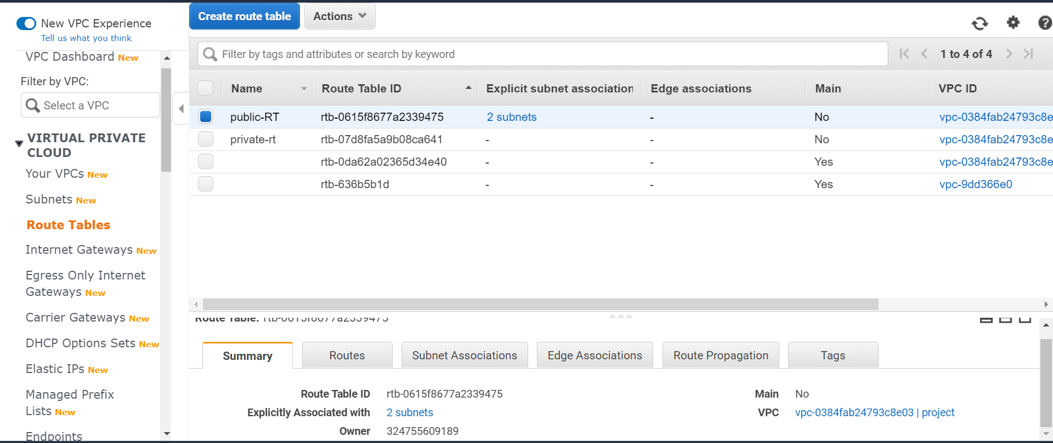

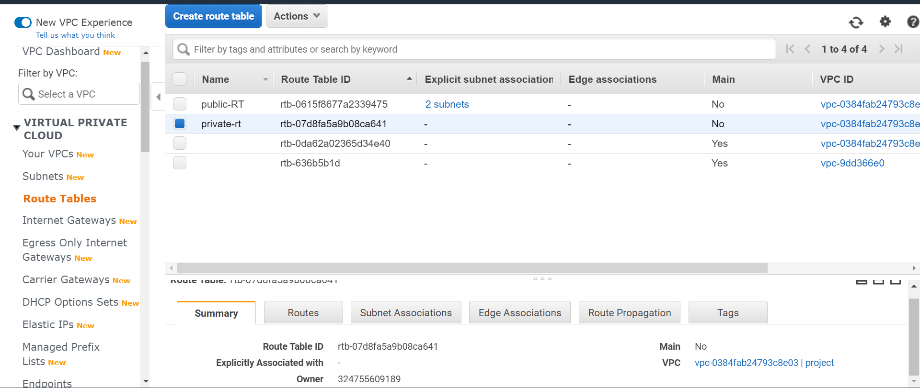

**We have created the private route and attached a vpc to that private-route table**

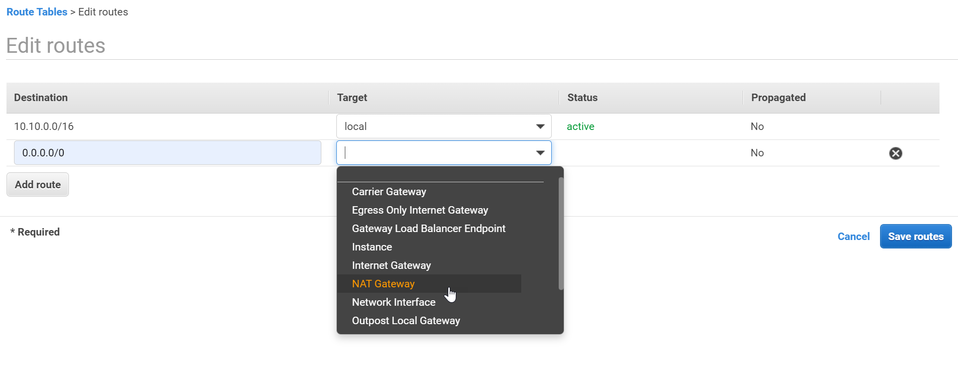

**For private subnet we should not have access to the internet so we are attaching NAT Gateway**

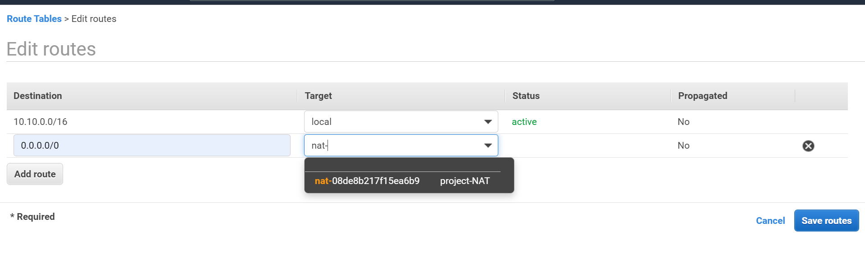

**Attaching nat gateway project-NAT not internet gateway not internet gateway because we should not have access to the internet**

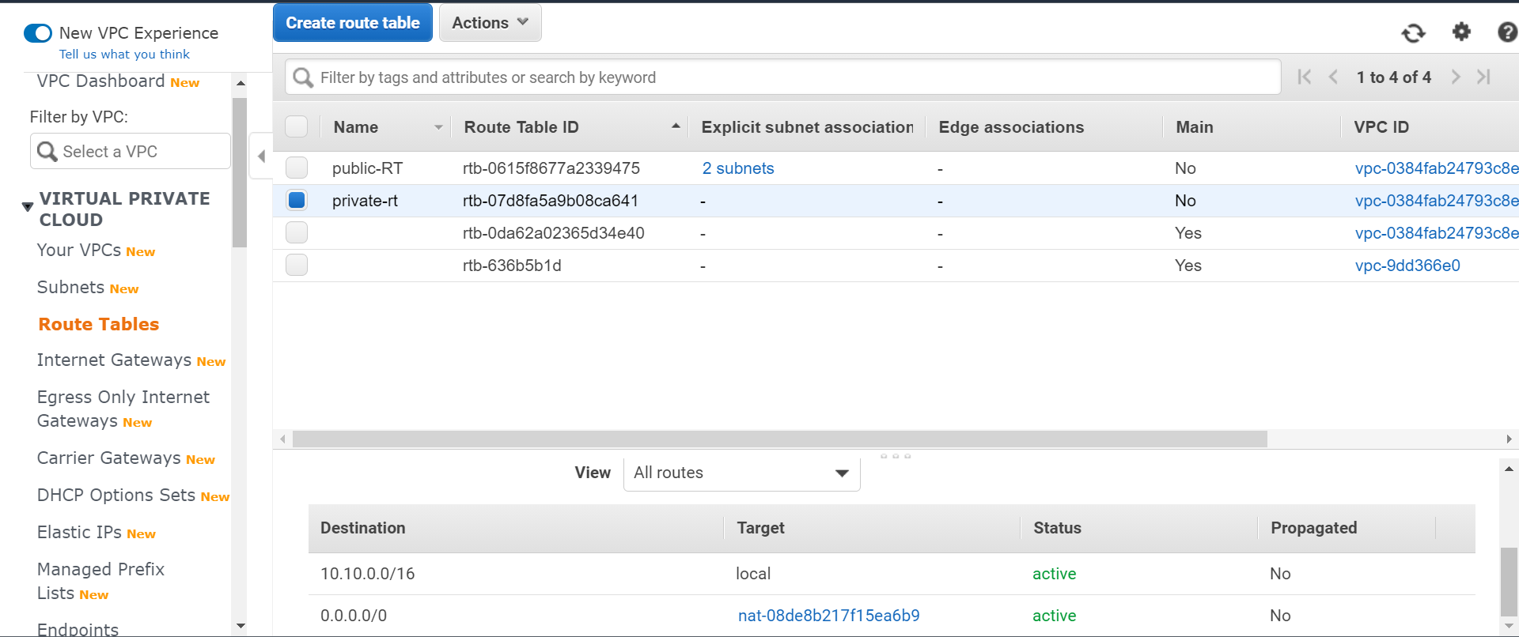

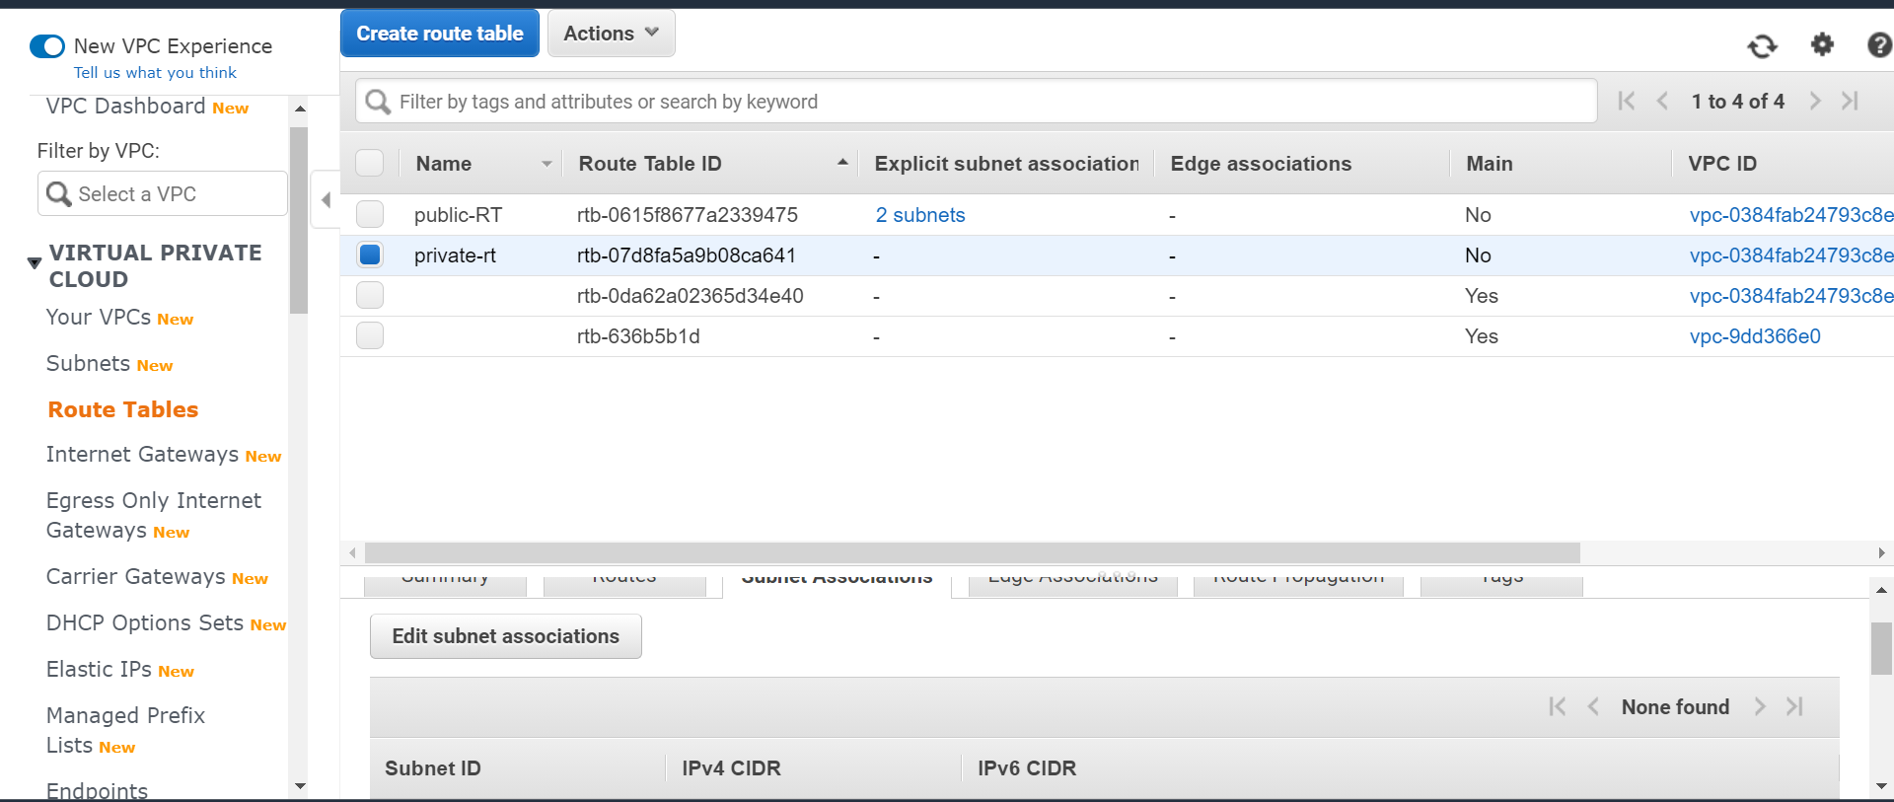

**In subnet associations we are attaching a private-subnet to this private route table**

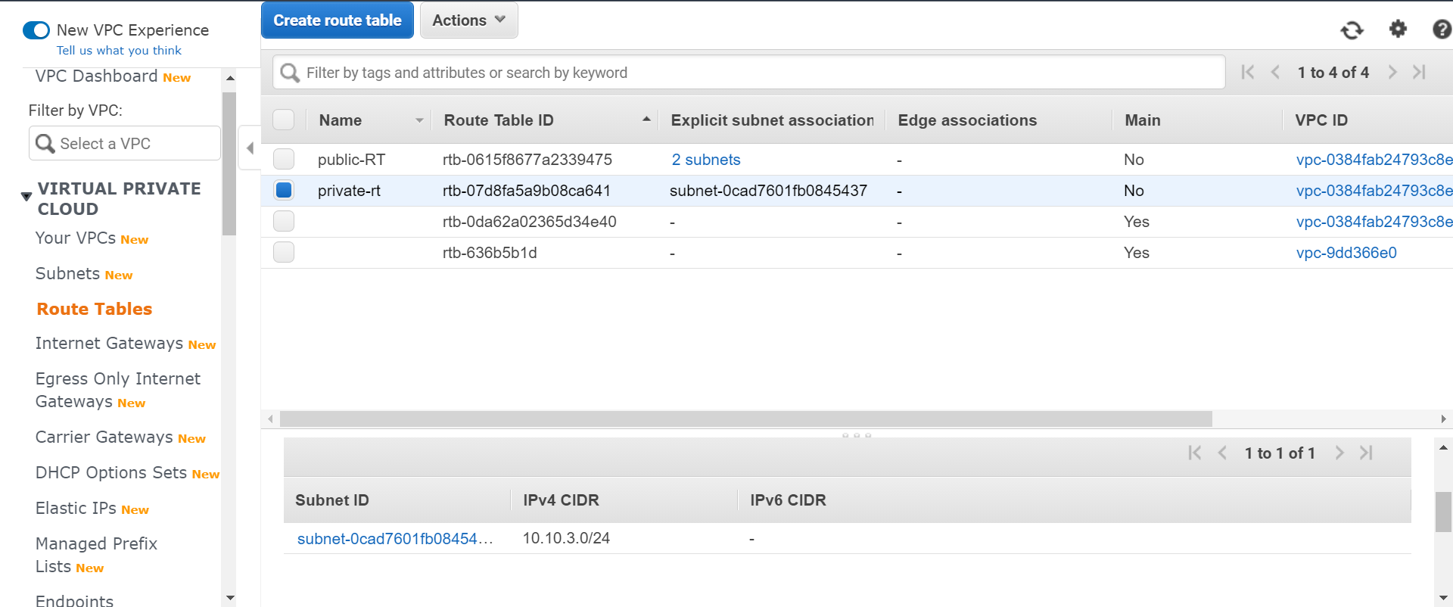

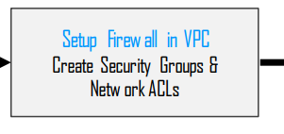

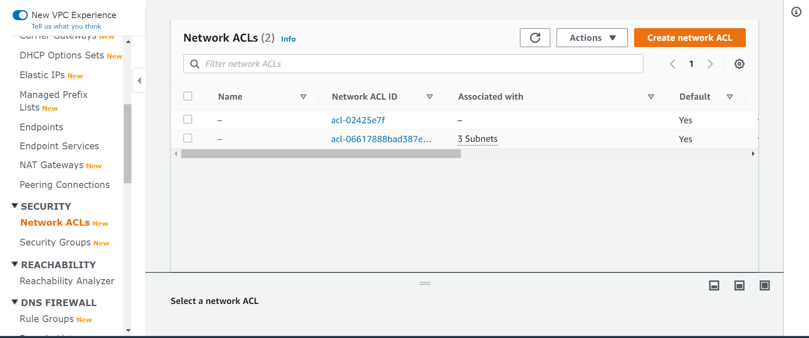

**We are arranging the network acl by default network acl will be created once you created your subnet**

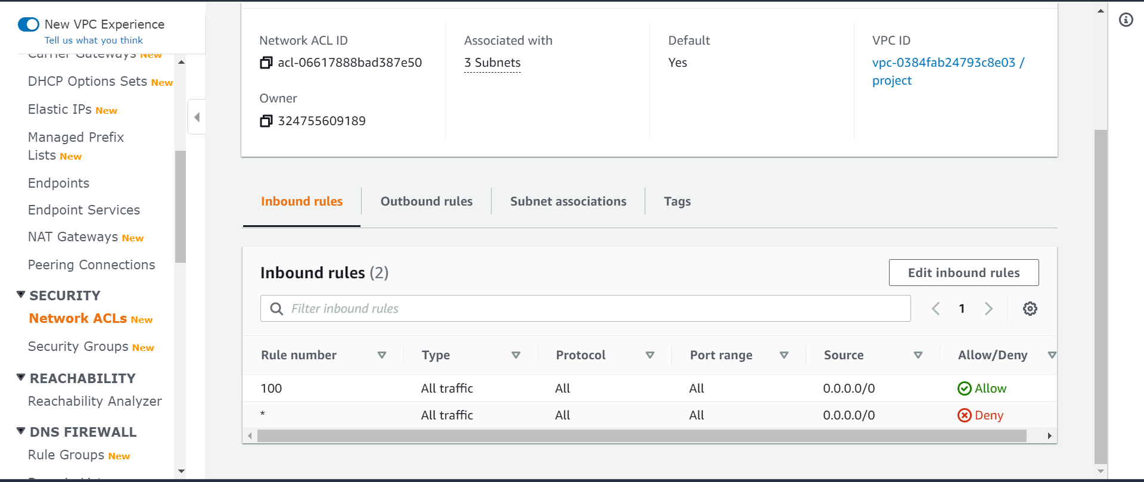

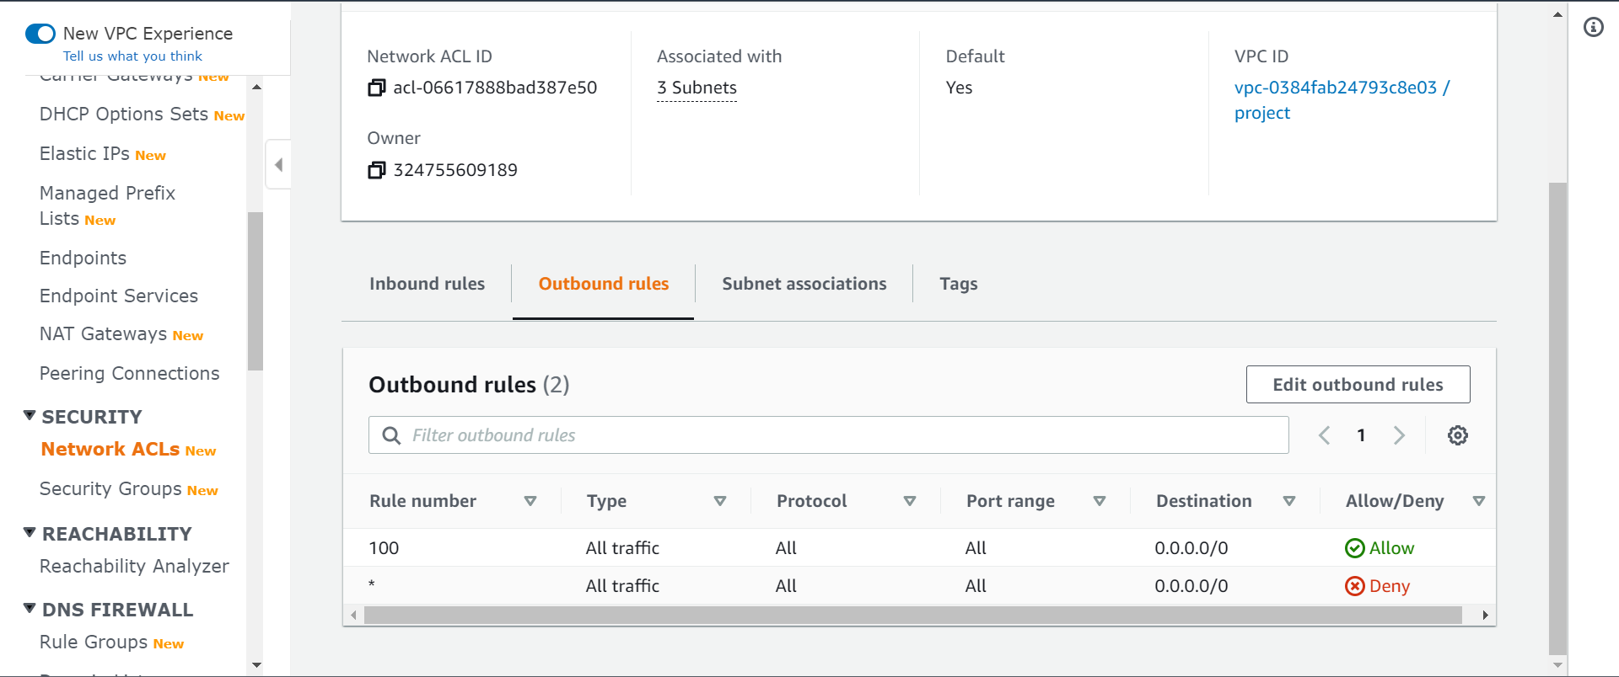

**If you want to make any changes in the in bound and outbound rules we are doing through it**

**If we need to make any restrictions also we can make it through this network acls as of now we are not making any changes we are using the detault network acls only**

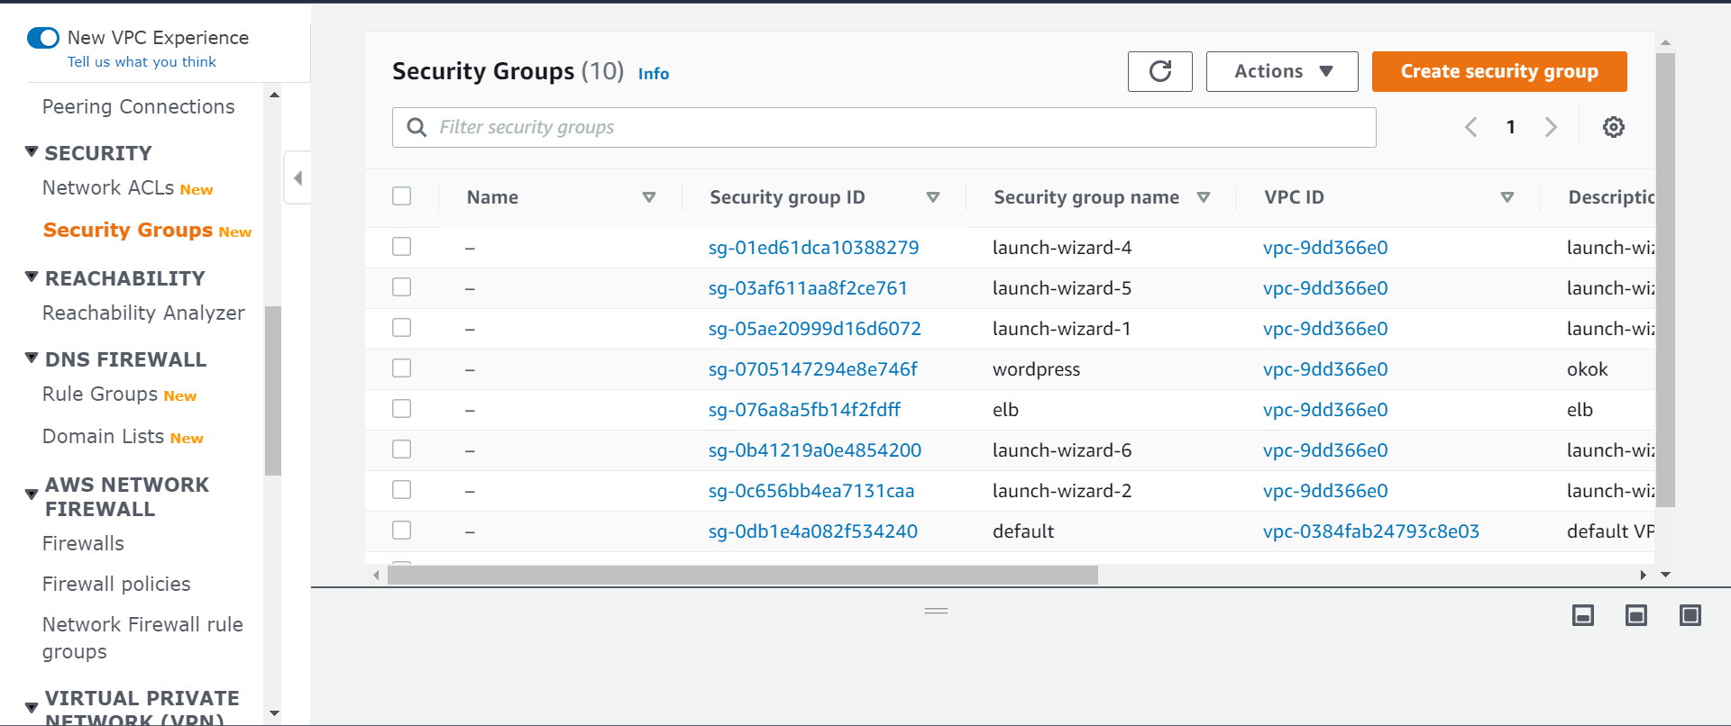

**We are going for the security groups and we are creating a new security groups**

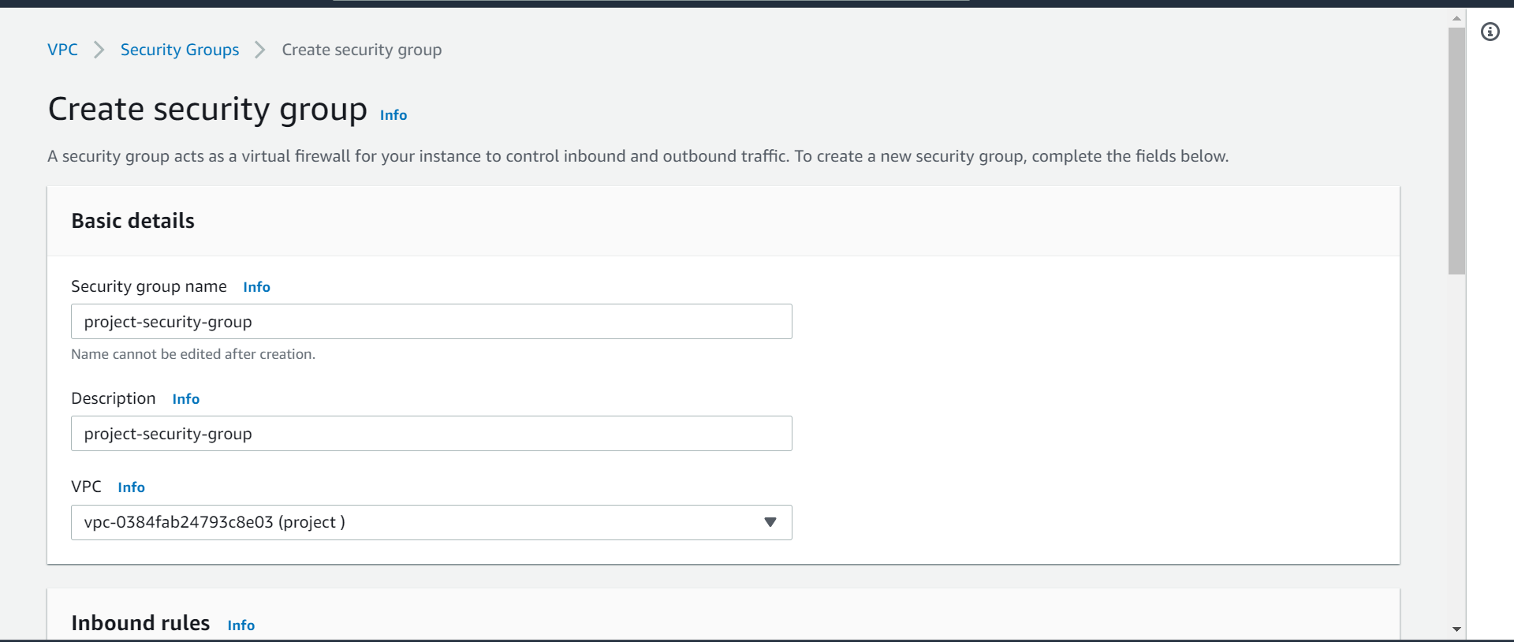

**We have created a new security group and we have added the project vpc in this place**

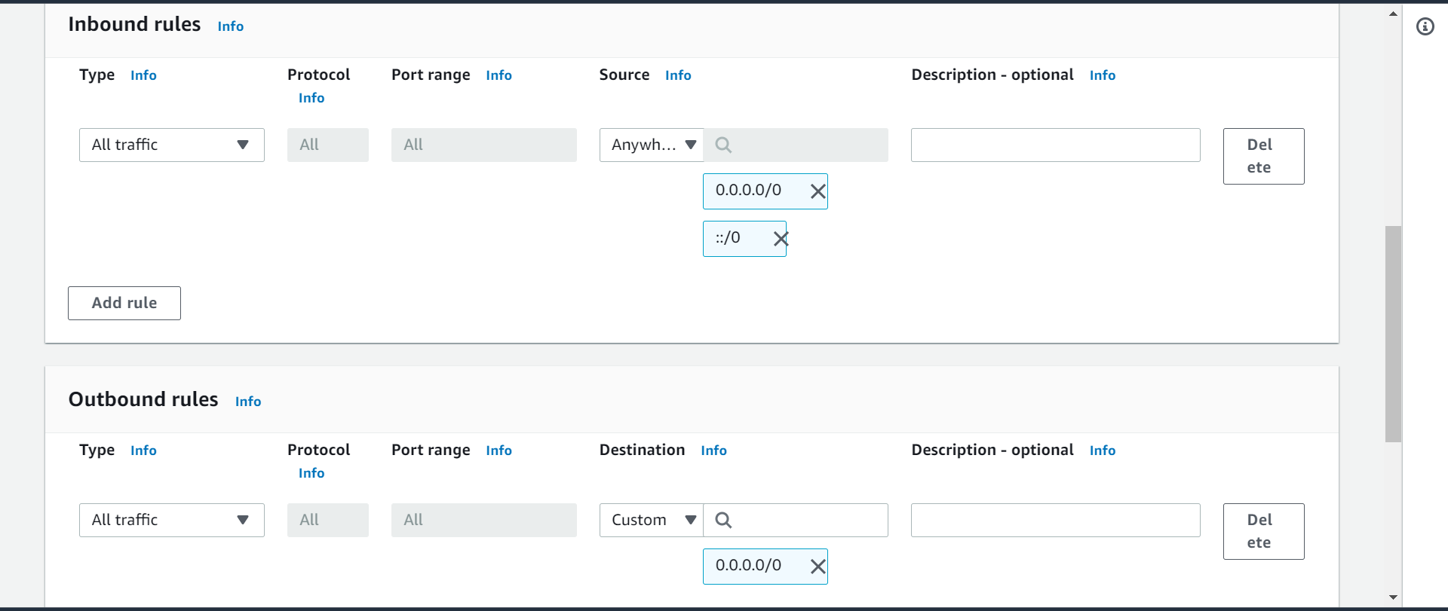

**We are making changes in the inbound and outbound rules in the security groups**

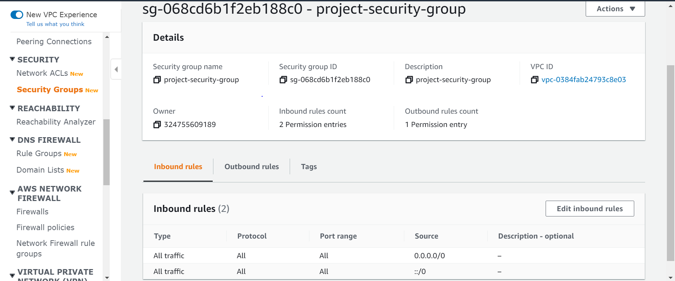

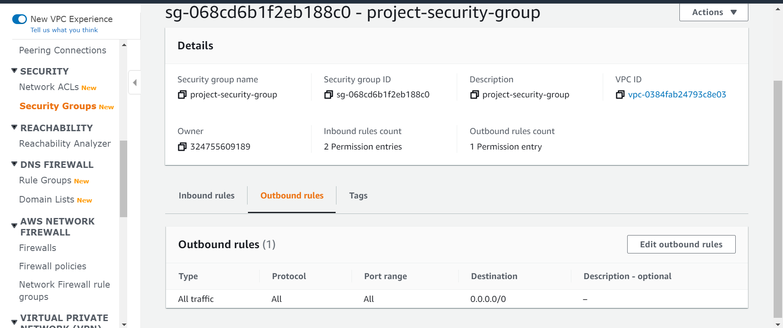

**Created security group with all the required in bound and out bound rule**

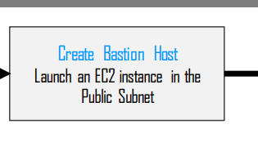

**We are launching the instances in both public and private subnet**

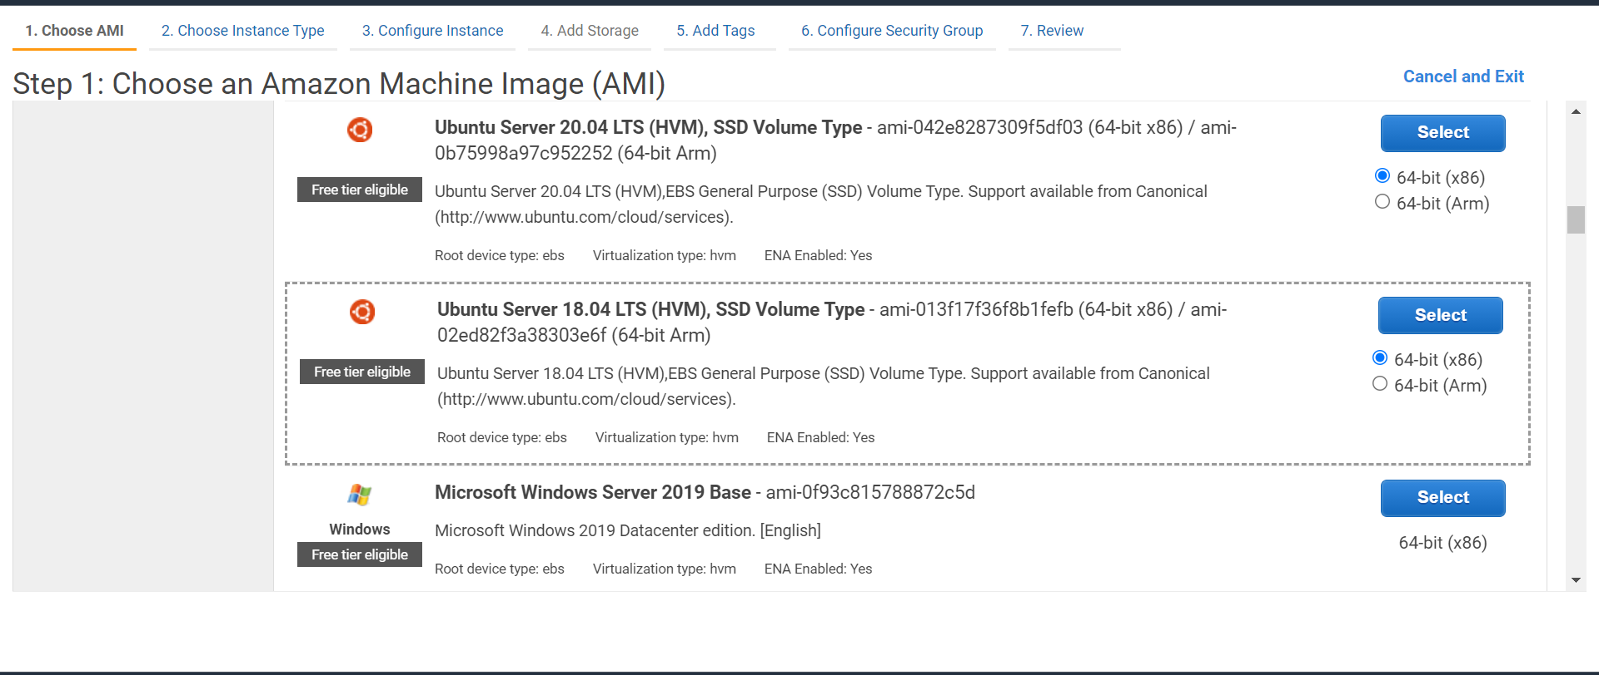

**Launching an instance os is ubuntu I am going with the free tire eligibility**

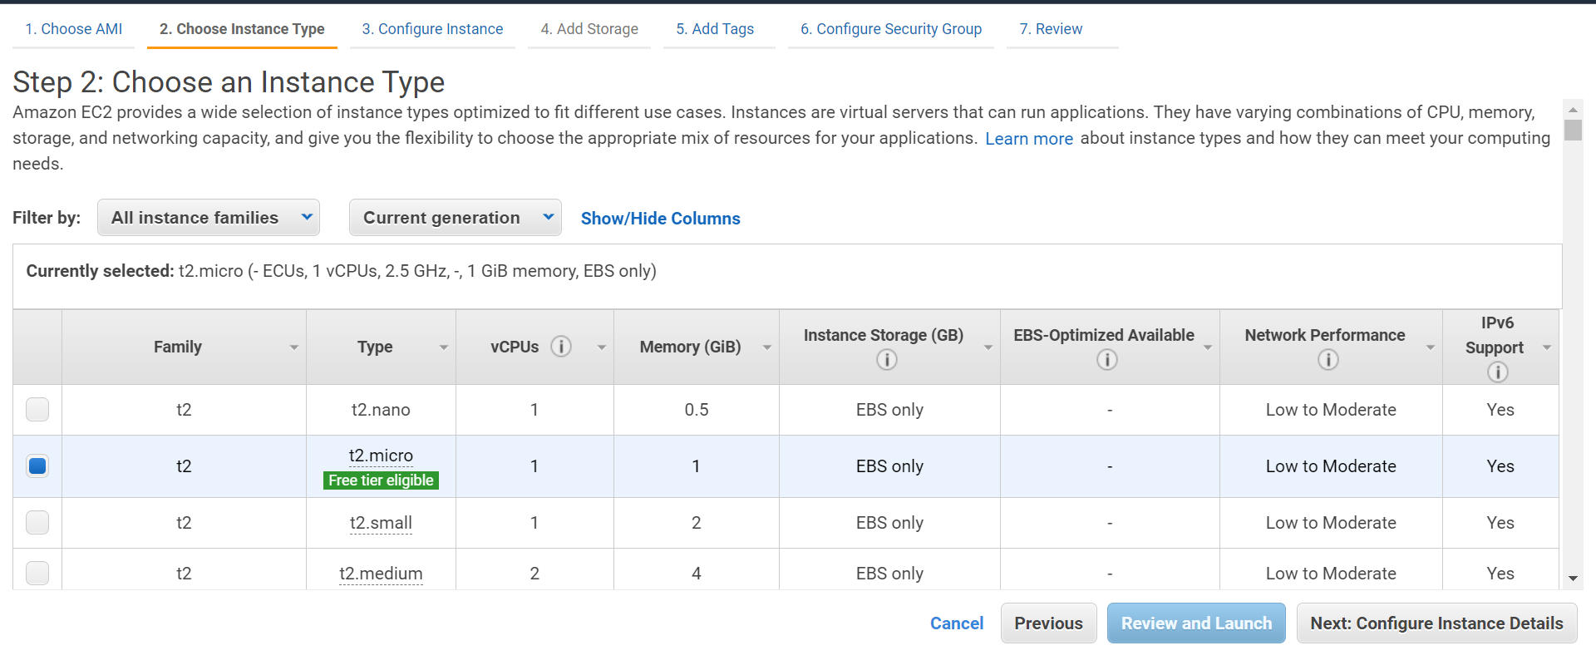

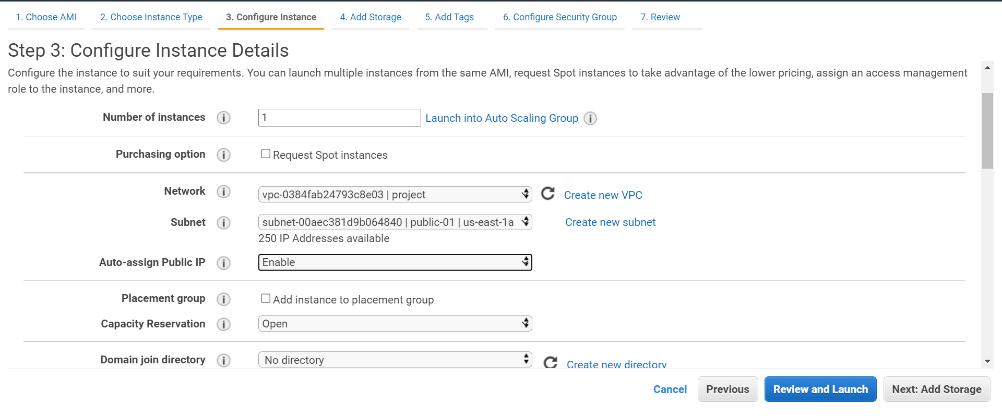

**I am creating it in the public-01 subnet with the project vpc which I have created and with the auto assigned public ip enabled**

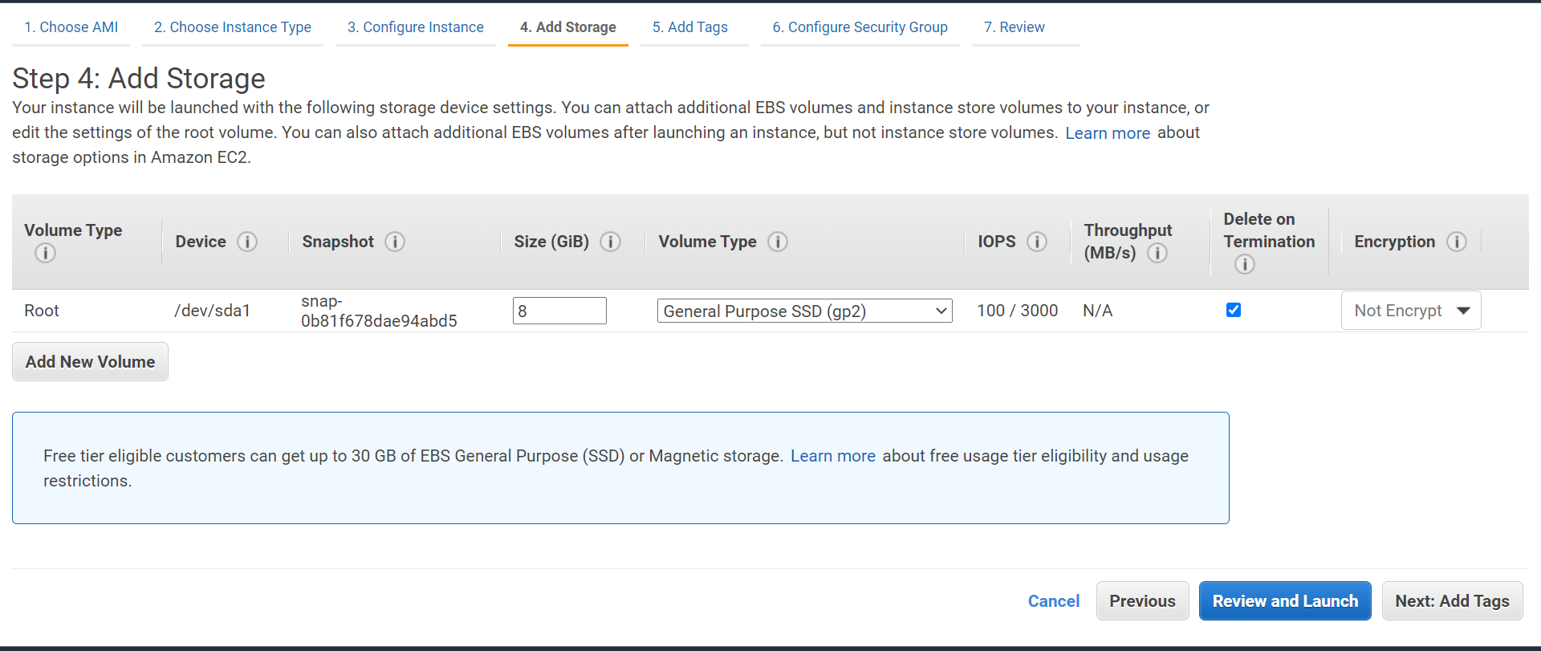

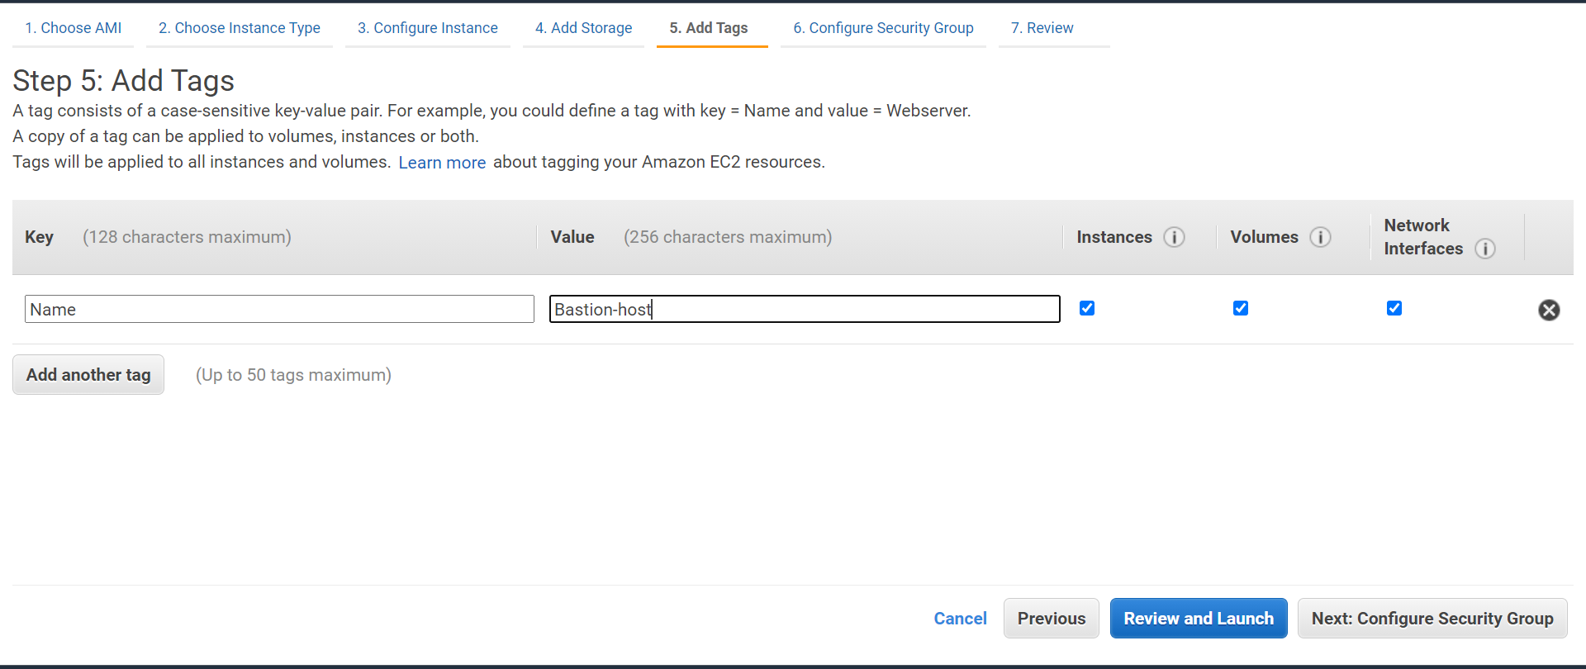

**I have given name for my ec2 instance as bastion-host**

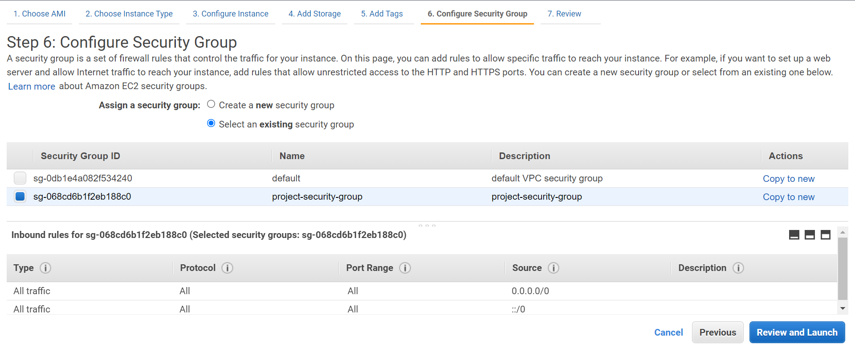

**I am creating a security group as a project-security-group which I have created.**

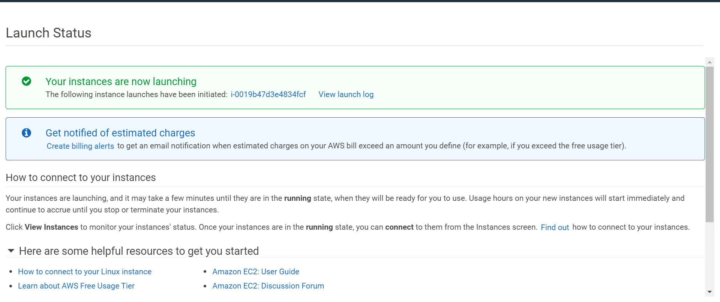

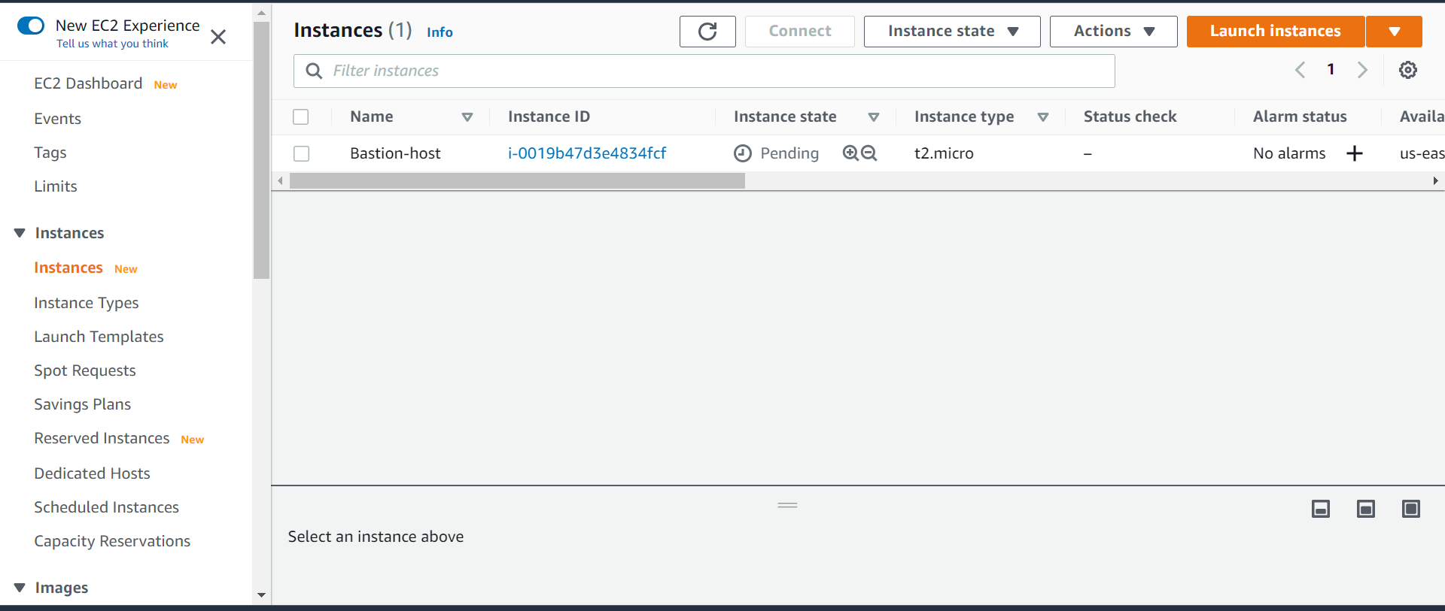

**Instance is getting launched**

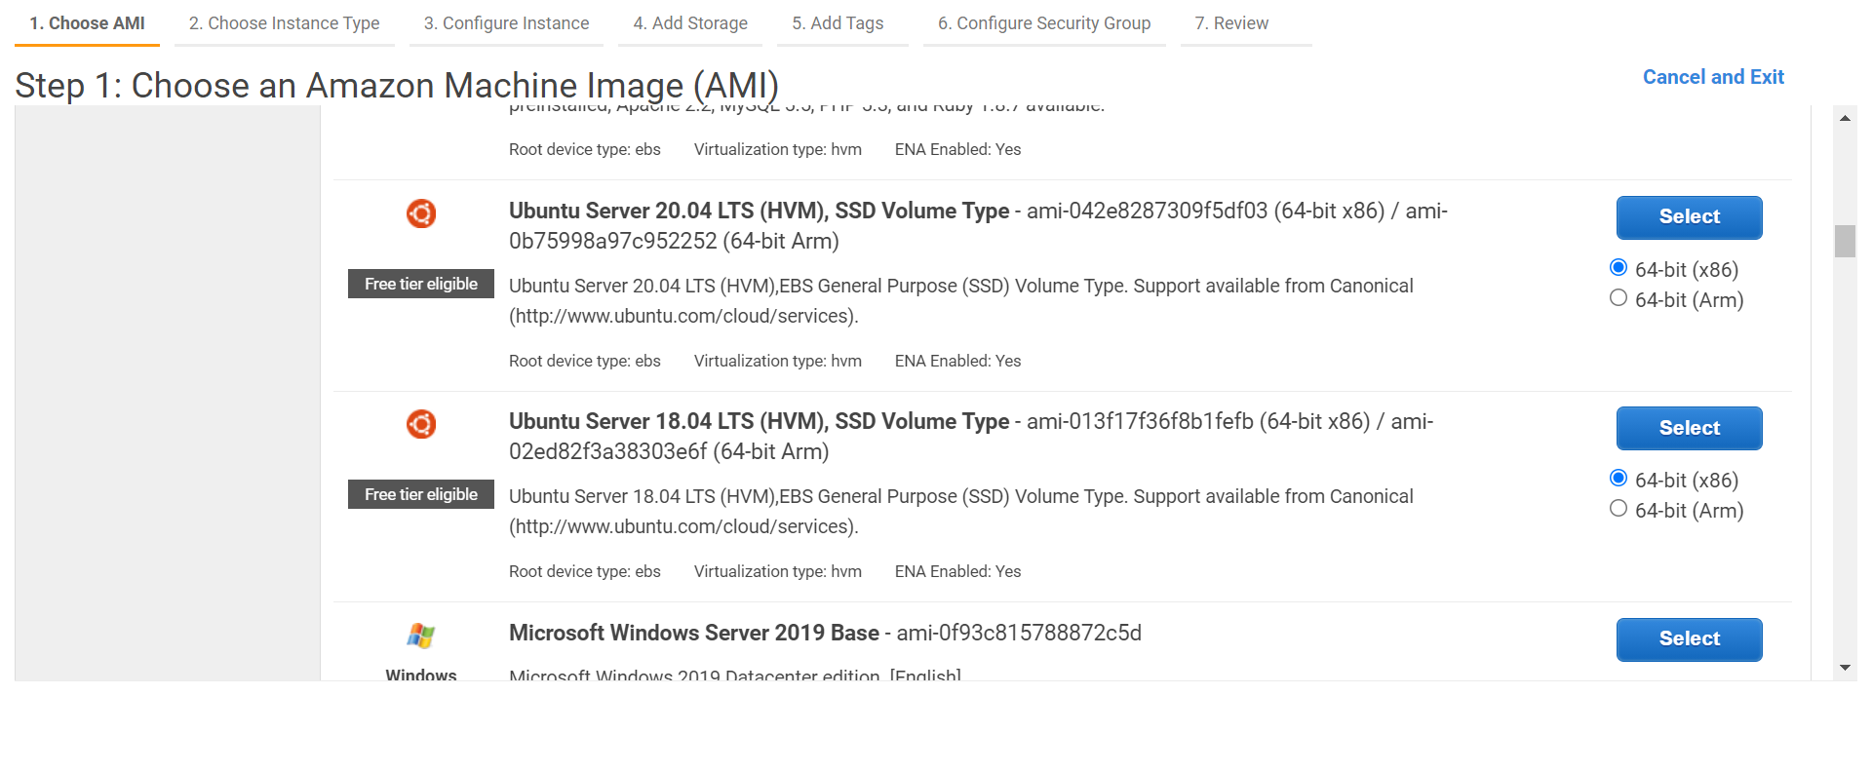

**Launching one more instance with the same configuration**

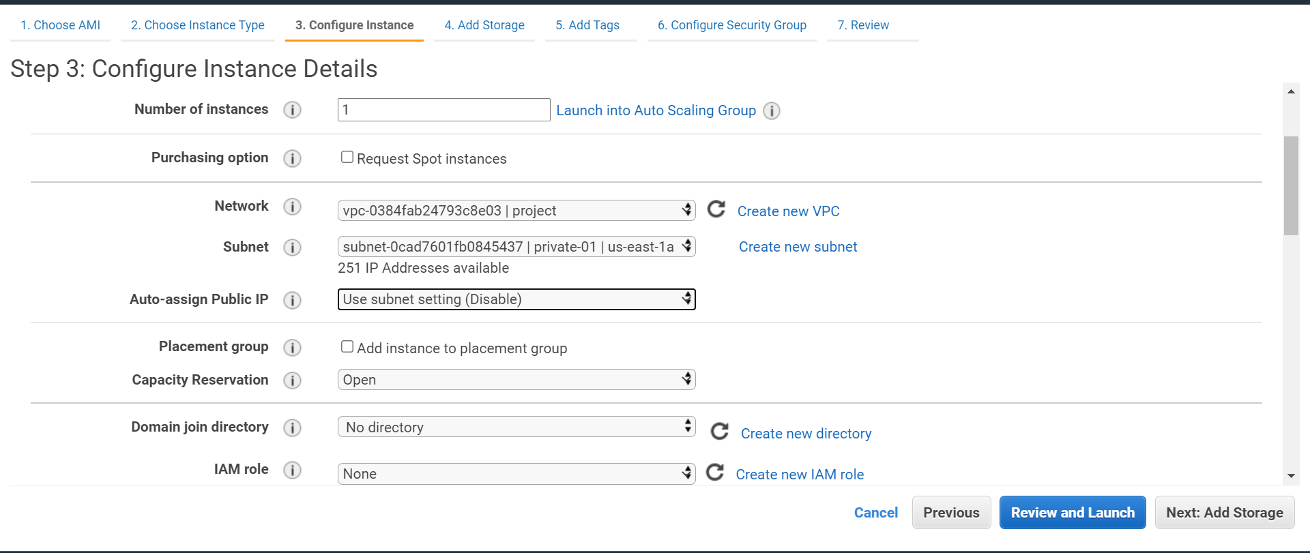

**Launching my second instance in the private subnet with the auto assigned ip address disabled because it wont be having any access to internet**

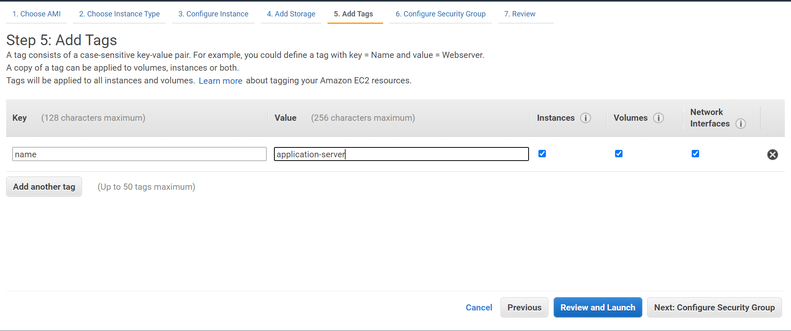

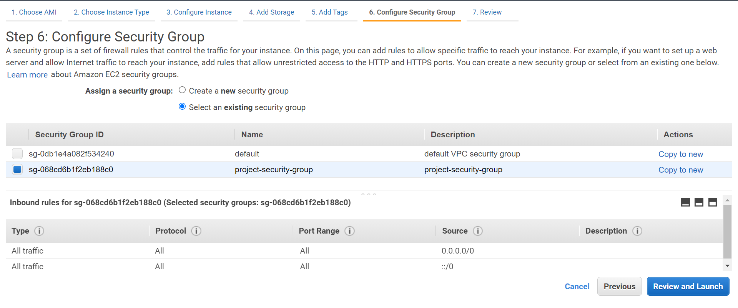

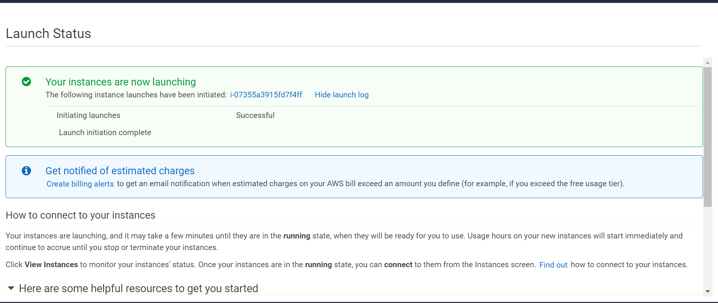

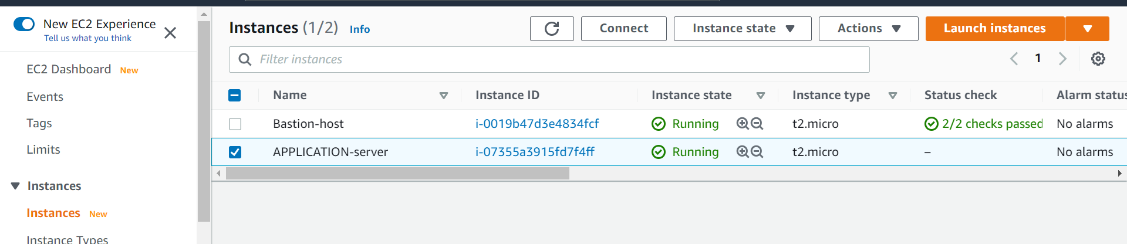

**All my two instances are up and running fine**

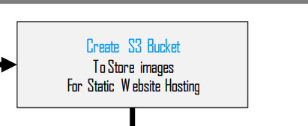

**Creating an s3 bucket to store our images uploaded**

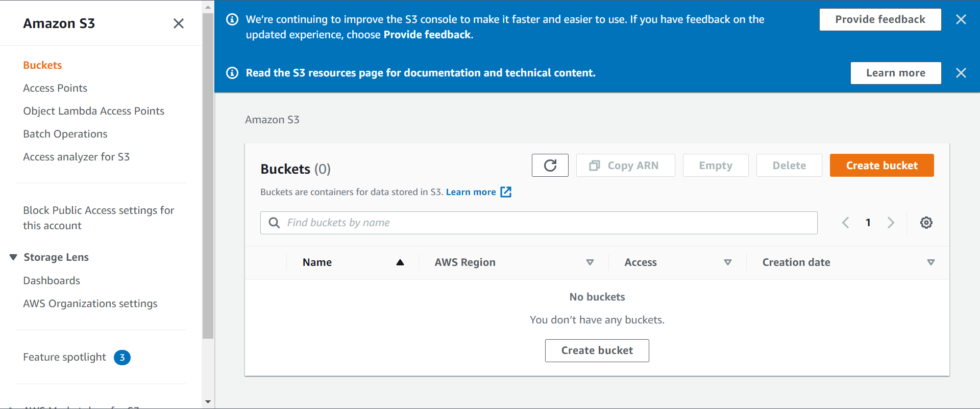

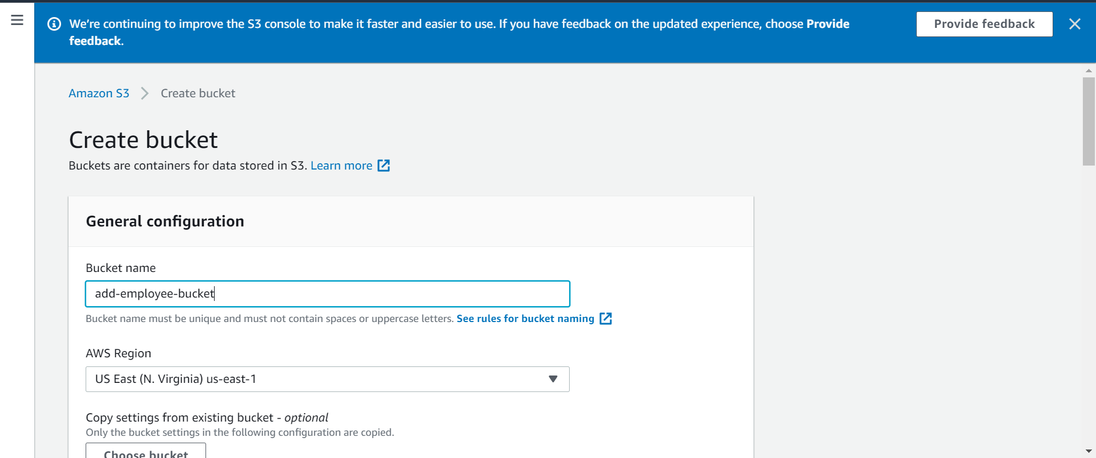

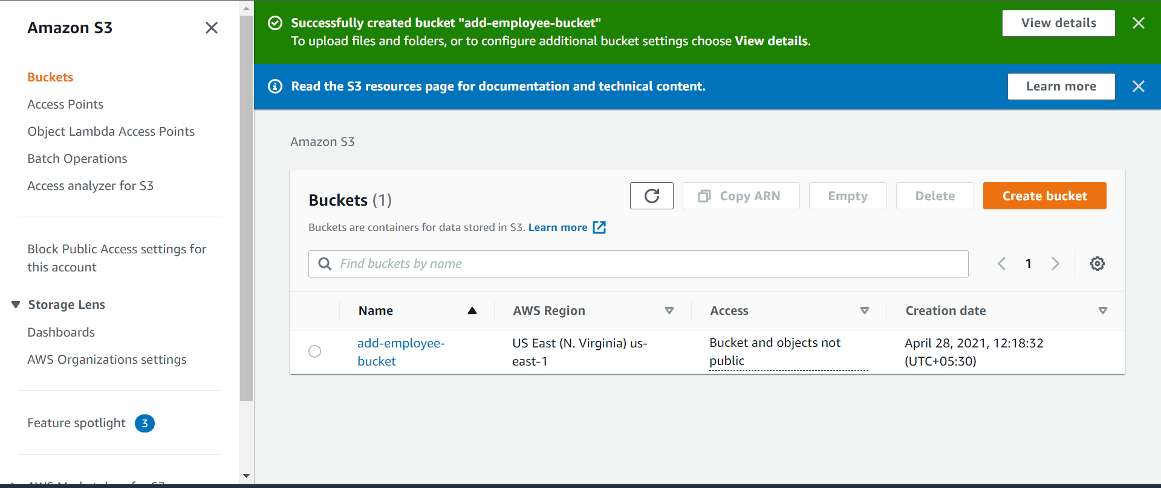

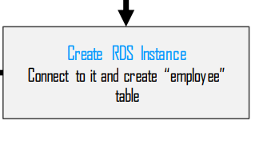

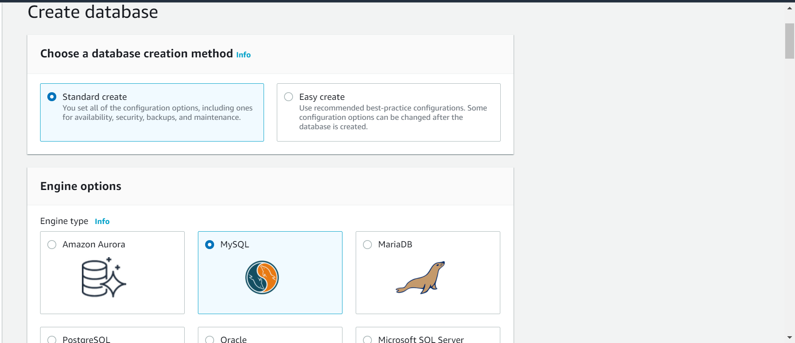

**We are selecting with standard create and mysql with free tire**

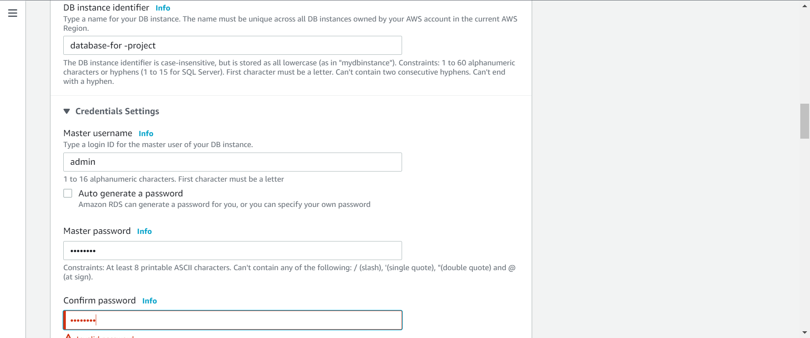

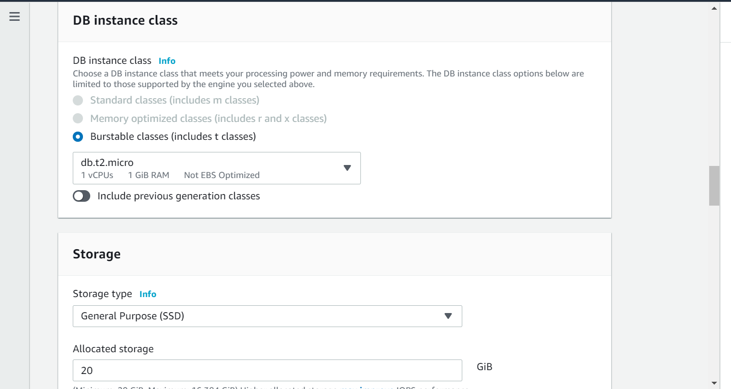

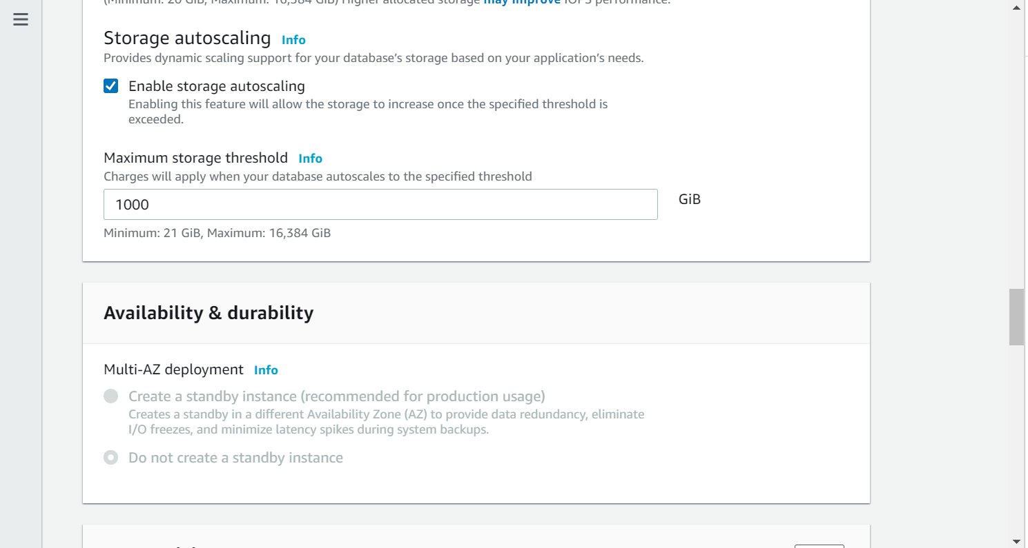

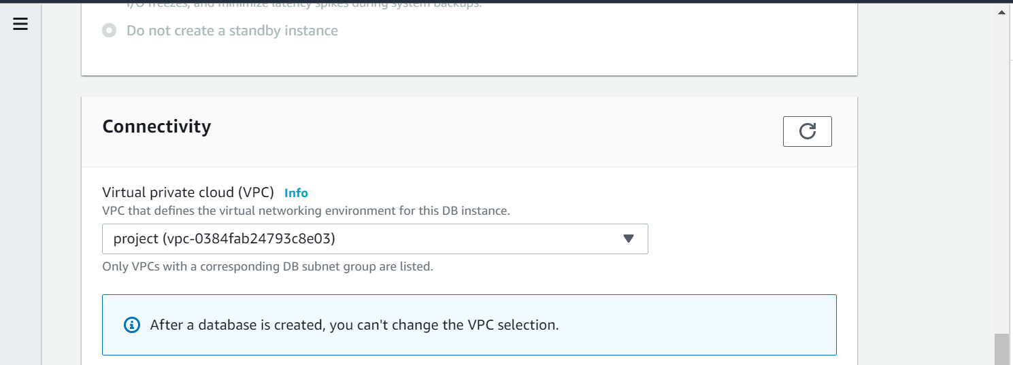

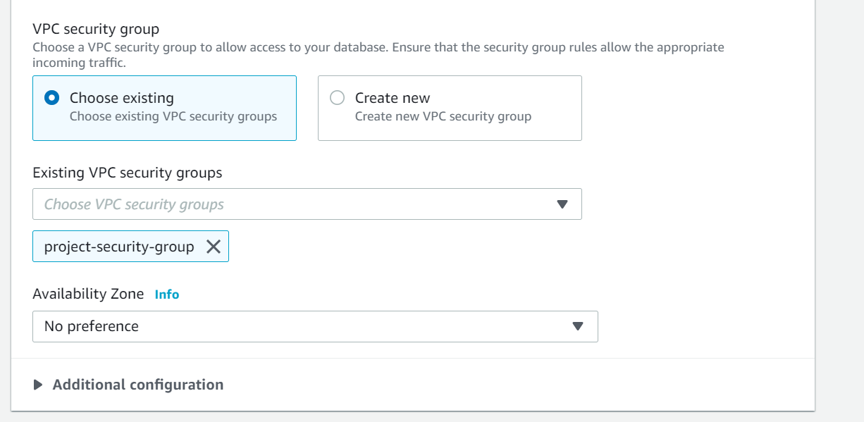

**Created a new project-security-group**

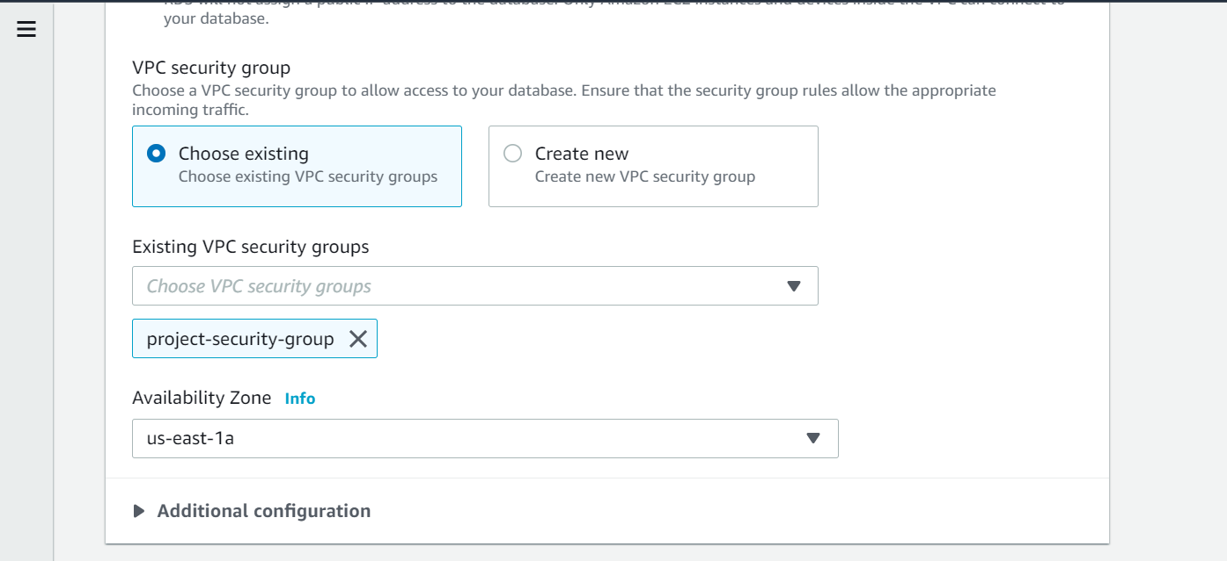

**We are using the project-vpc and project-security-group in security group and available zone as us-east-1a it will launch the instance in this security group**

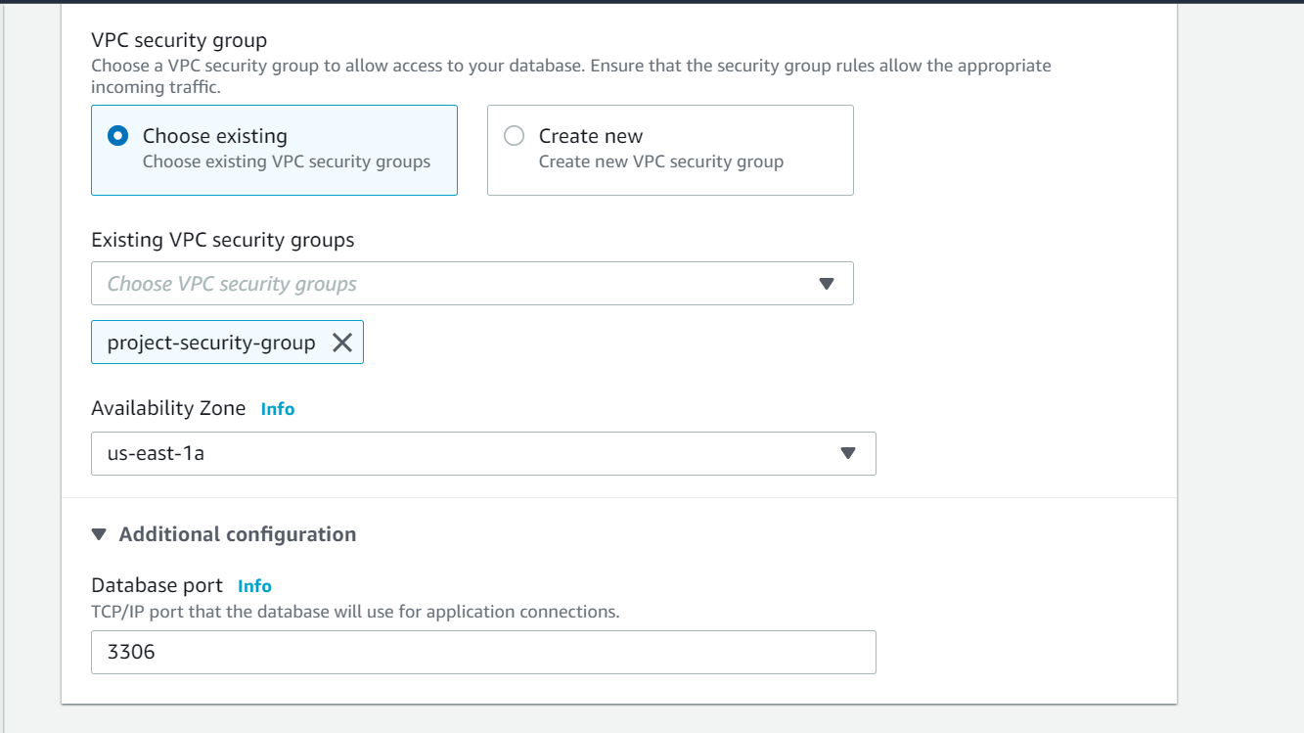

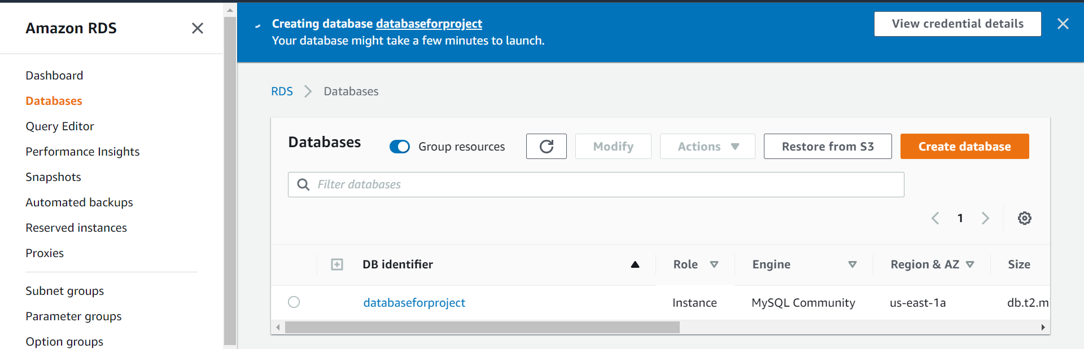

**Database for project was created successfully**

**We have made a mistake we have selected the value as publicly accessible as yes so we are getting error with the vpc selected and asked to change the vpc details so we have again changed the value as publicly accessible as no and then we can able to create a database instance.**

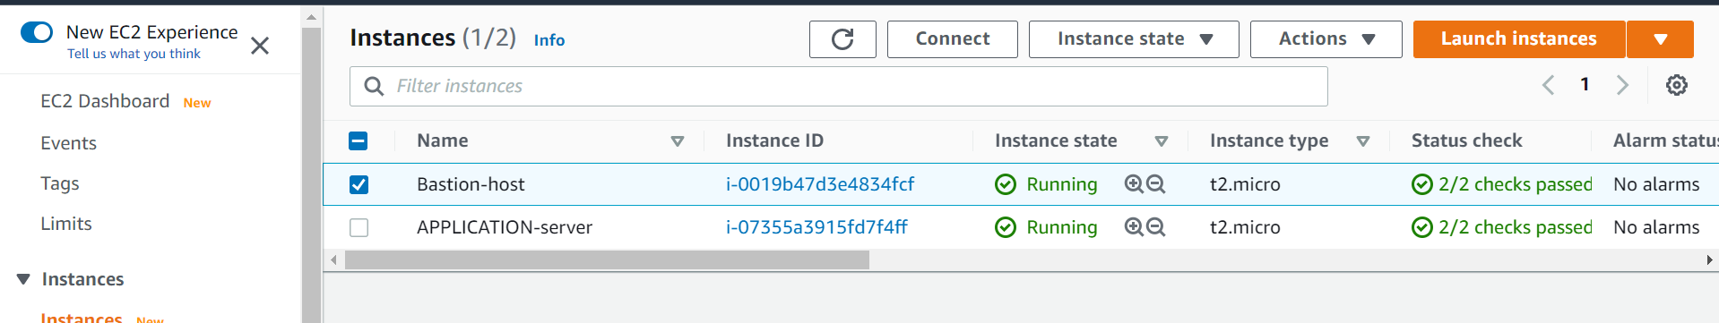

**We are connecting to bastion-host**

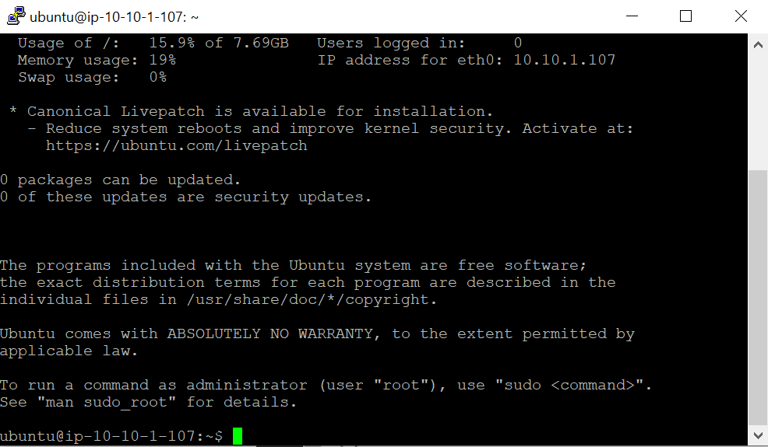

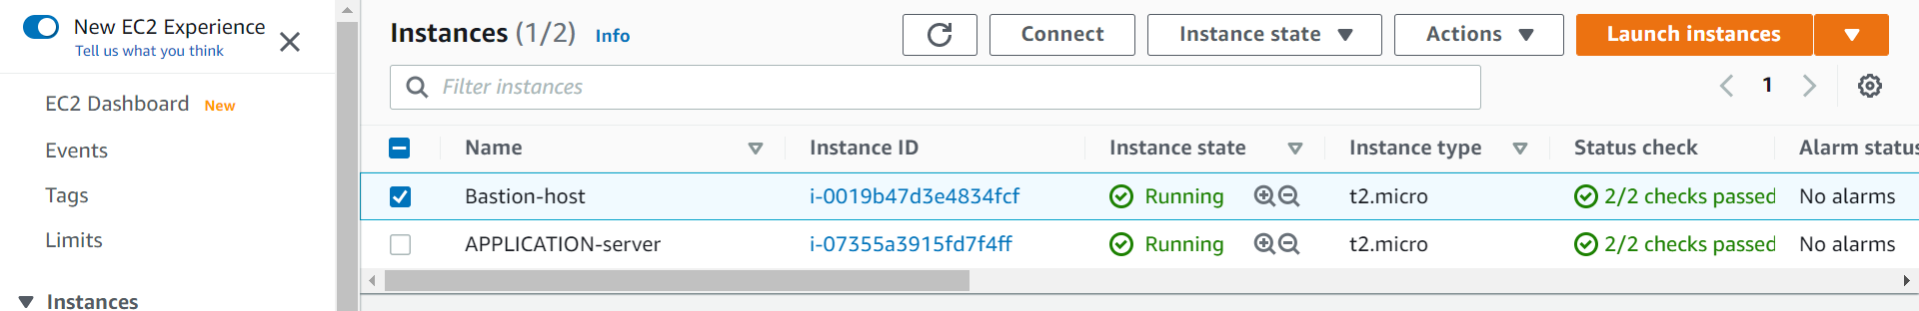

**We are connecting to application-server to connect to deploy our application**

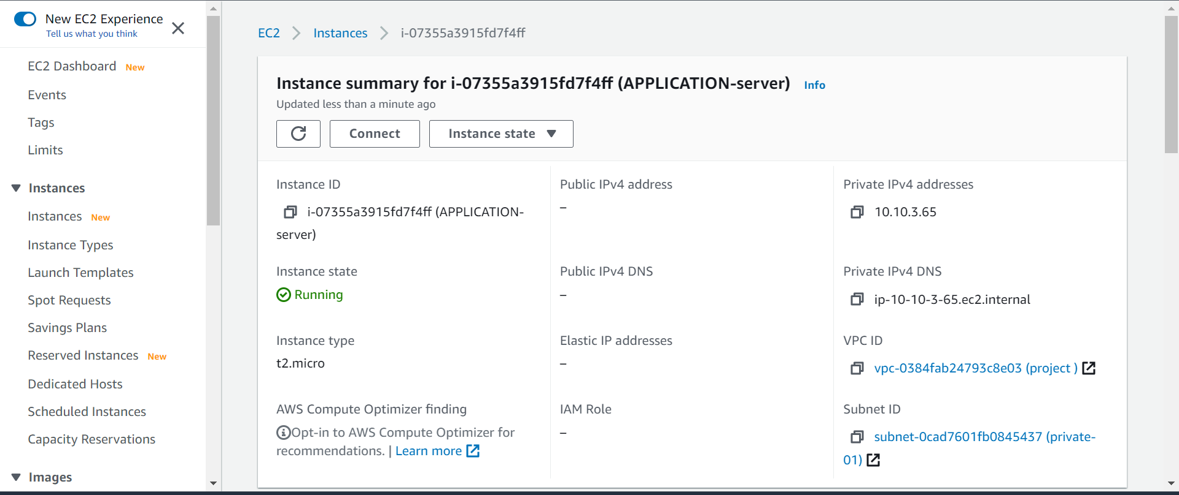

**This application server is not having any public ipv4 address so we can ssh from the bastion application**

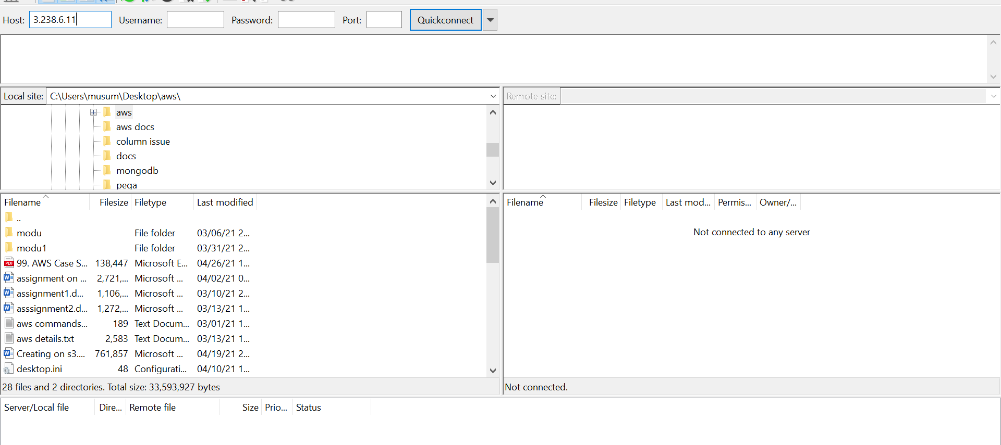

**By using file zilla we are copying the key**

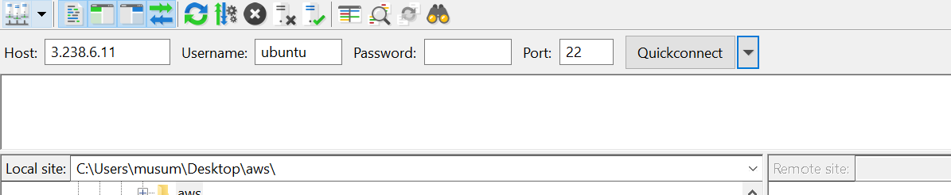

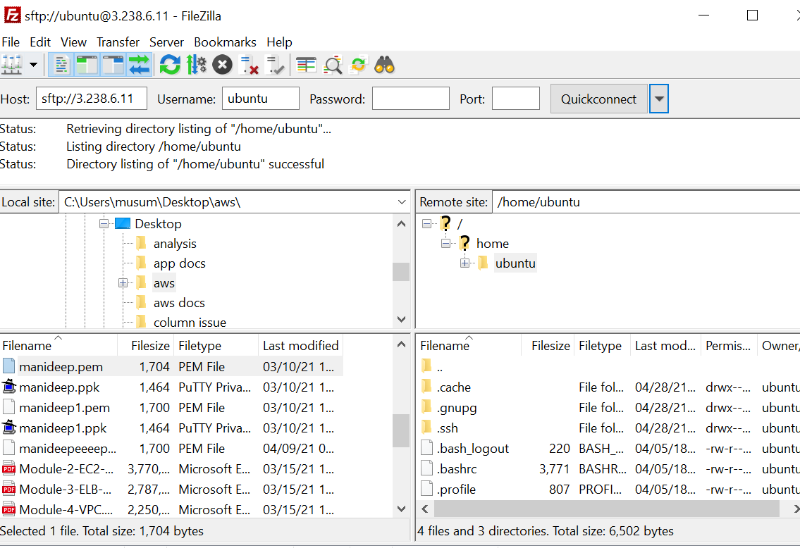

**We have copied the Manideep.pem file it will use to connect to private instance**

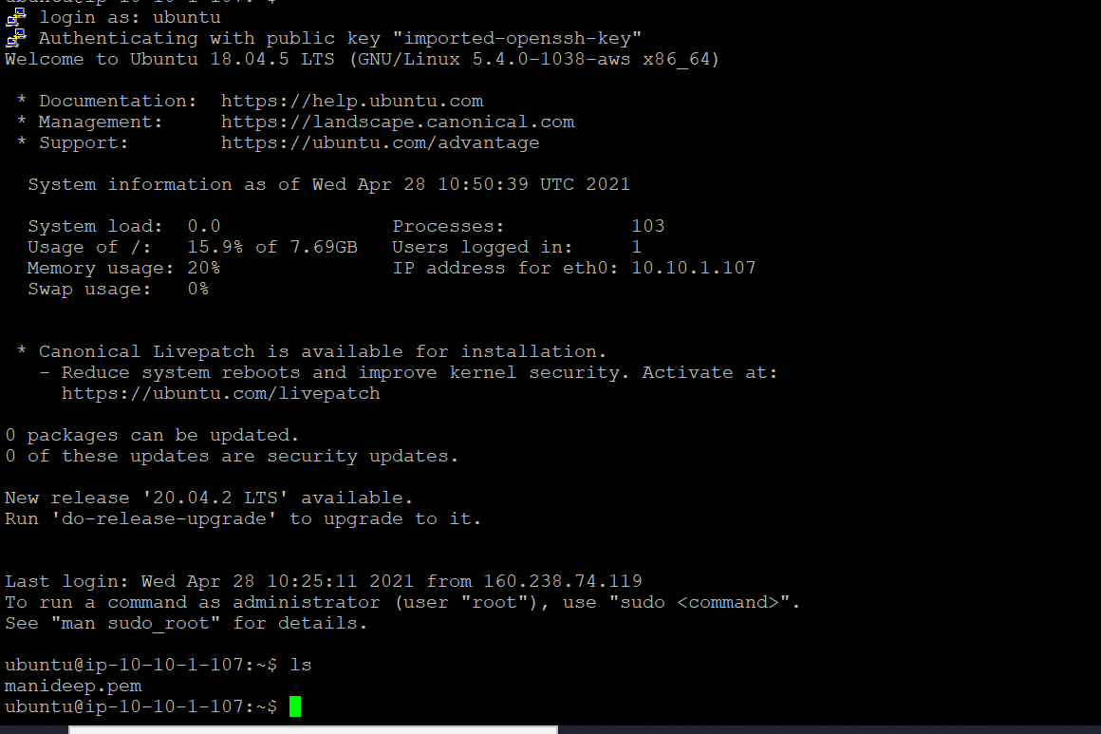

**We have moved the Manideep.pem file to this system**

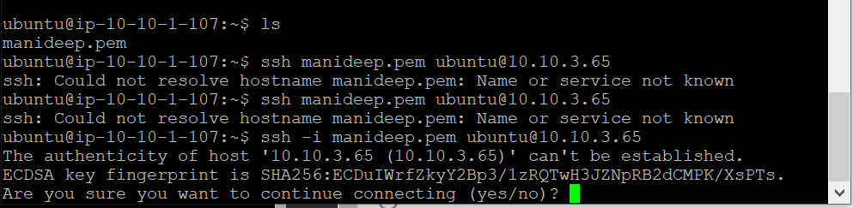

**I am doing ssh from my bastion-host to application-server**

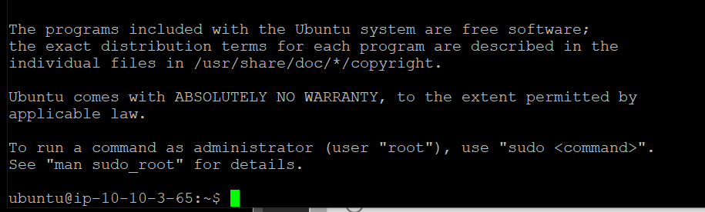

**Connected to application instance**

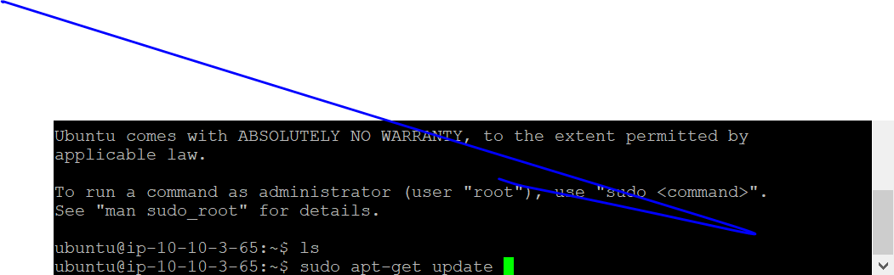

**Updating my application mechine**

[**https://github.com/Azharbhaigit/aws-code**](https://github.com/Azharbhaigit/aws-code)

**all the code related to application is on the git hub**

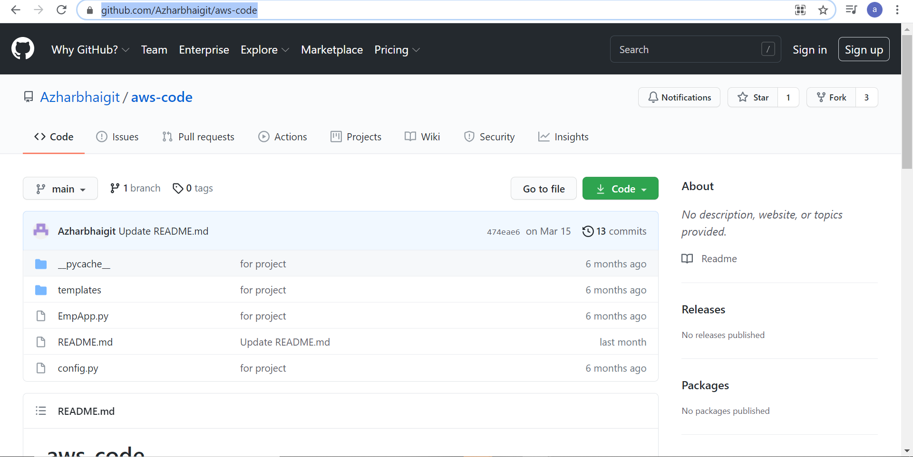

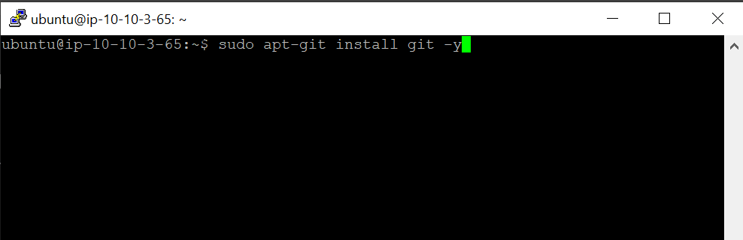

**We are installing git in our application server because we need to push the code from the got hub**

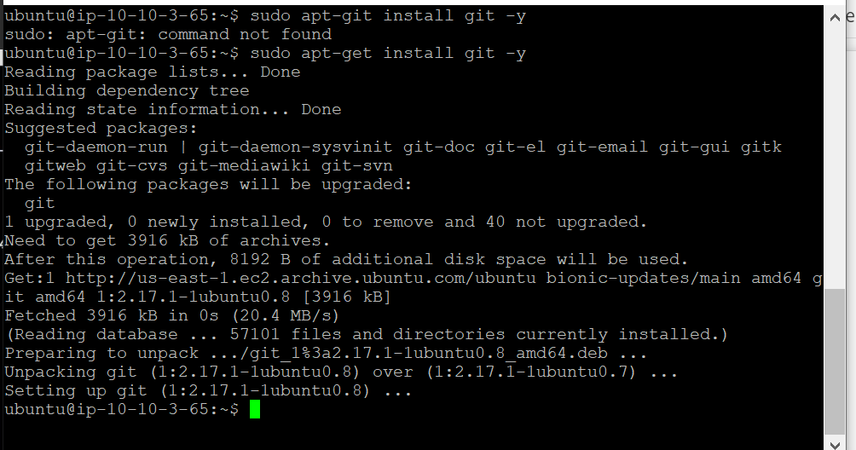

**Git was installed**

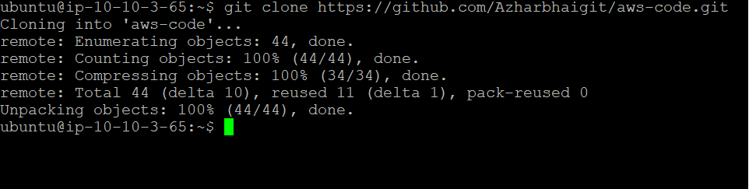

**Downloaded code from the git hub**

**Got our aws code**

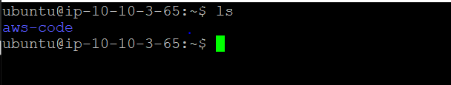

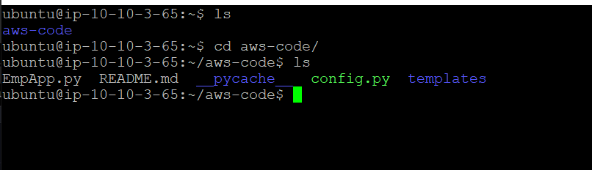

**We are having five files hear which are there in the git repository**

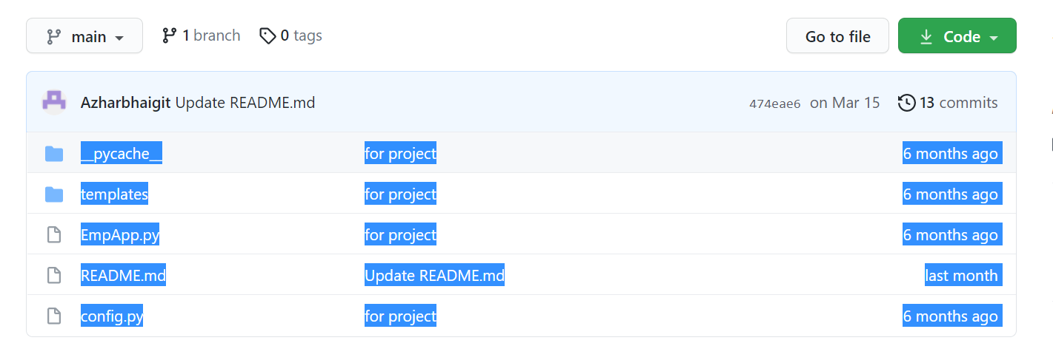

**All the git hub code is there in the gui and cli**

**We have created the code and updated to save the images metadata in the dynmo db table**

|  |
| --- |
|  |
| Save image file metadata in DynamoDB # |
|  | print("Uploading to S3 success... saving metadata in dynamodb...") |
|  |  |
|  |  |
|  | try: |
|  | dynamodb_client = boto3.client('dynamodb', region_name='us-east-2') |
|  | dynamodb_client.put_item( |
|  | TableName='employee_image_table', |
|  | Item={ |
|  | 'empid': { |
|  | 'N': emp_id |
|  | }, |
|  | 'image_url': { |
|  | 'S': object_url |
|  | } |
|  | } |
|  | ) |
|  |  |

**It will store the details in the the dynamodb table which was mntioned above**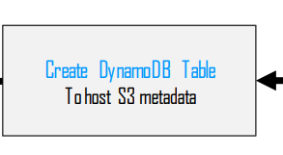

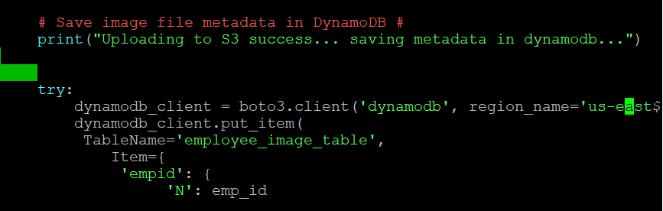

**We are making changes in the code like region name dynamodb table and details needs to be stored in the dynamodb table so based on the code we need to create a table in the dynmo table**

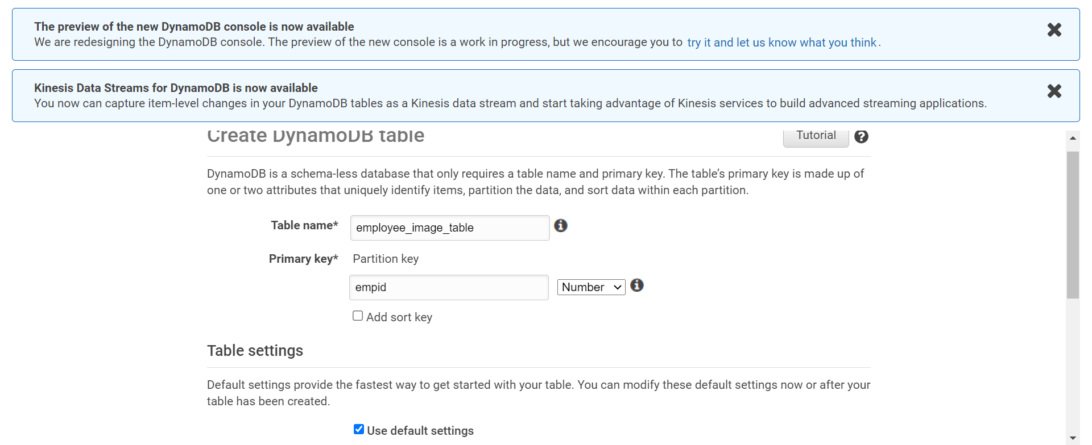

**Created a dynmo db table to save the data**

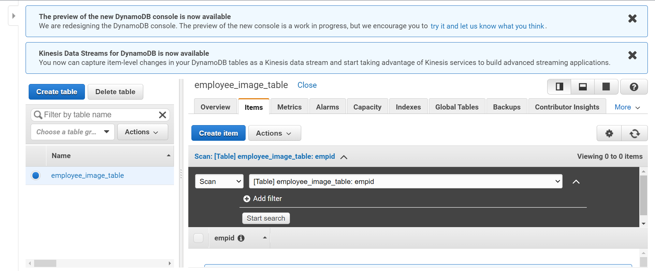

**Employee table was created in the dynamo table**

**Note:let us connect to the rds and let us create a employee table there as well**



**We need to install the mysql client to get access to the rds mysql instance**

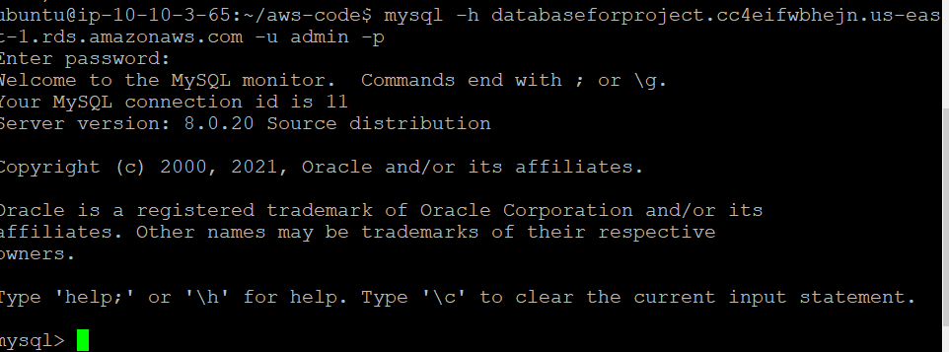

**We can able to connect to mysql successfully from our application server**

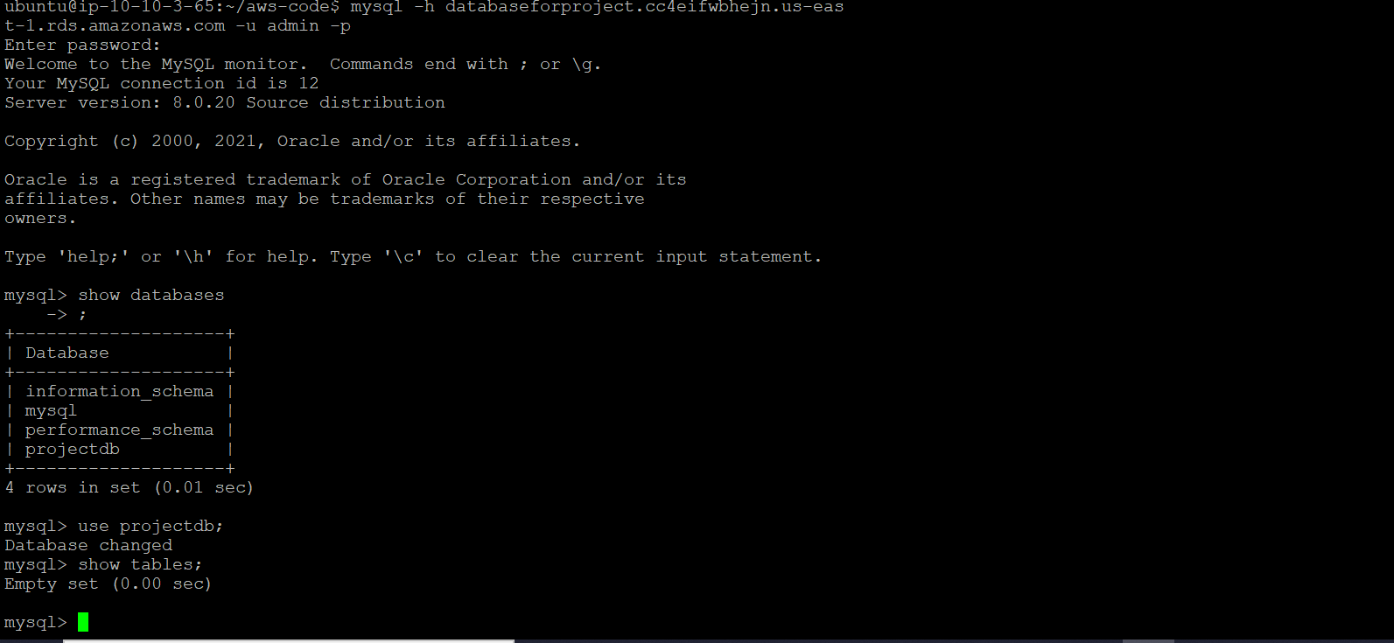

**We can see the database projectdb which was already created at the time of launching the instances**



**Employee table was created successfully**

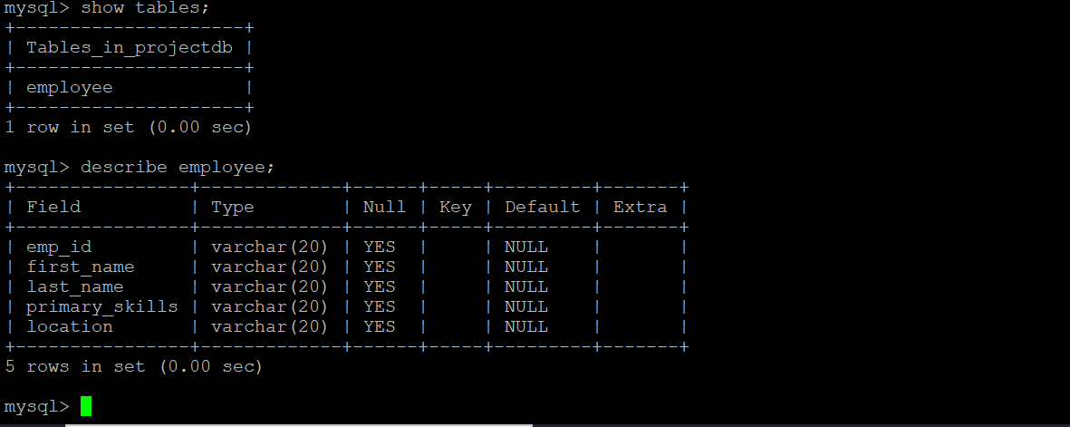

**We can able to see the created tables and details in the table**

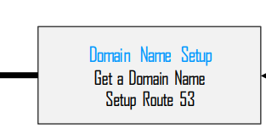

Domine name set up we are setting up the domine names hear

I brought my own domine name with name servers

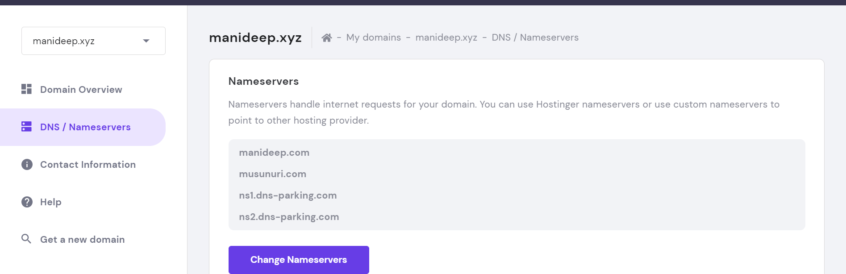

My domine name is Manideep.xyz and name servers are

**manideep.com**

**musunuri.com**

**ns1.dns-parking.com**

**ns2.dns-parking.com**

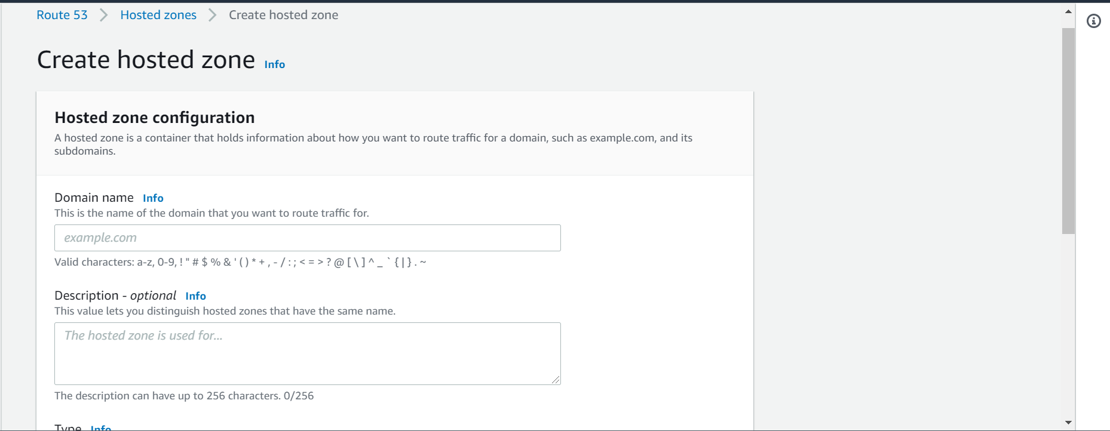

We are going to create a hosted zone we are giving all the details of domine name and description hear which we have already taken

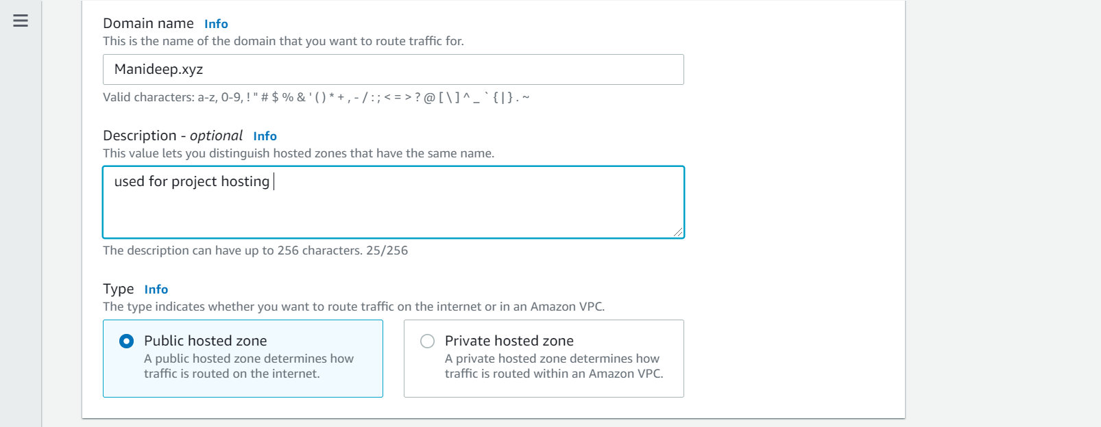

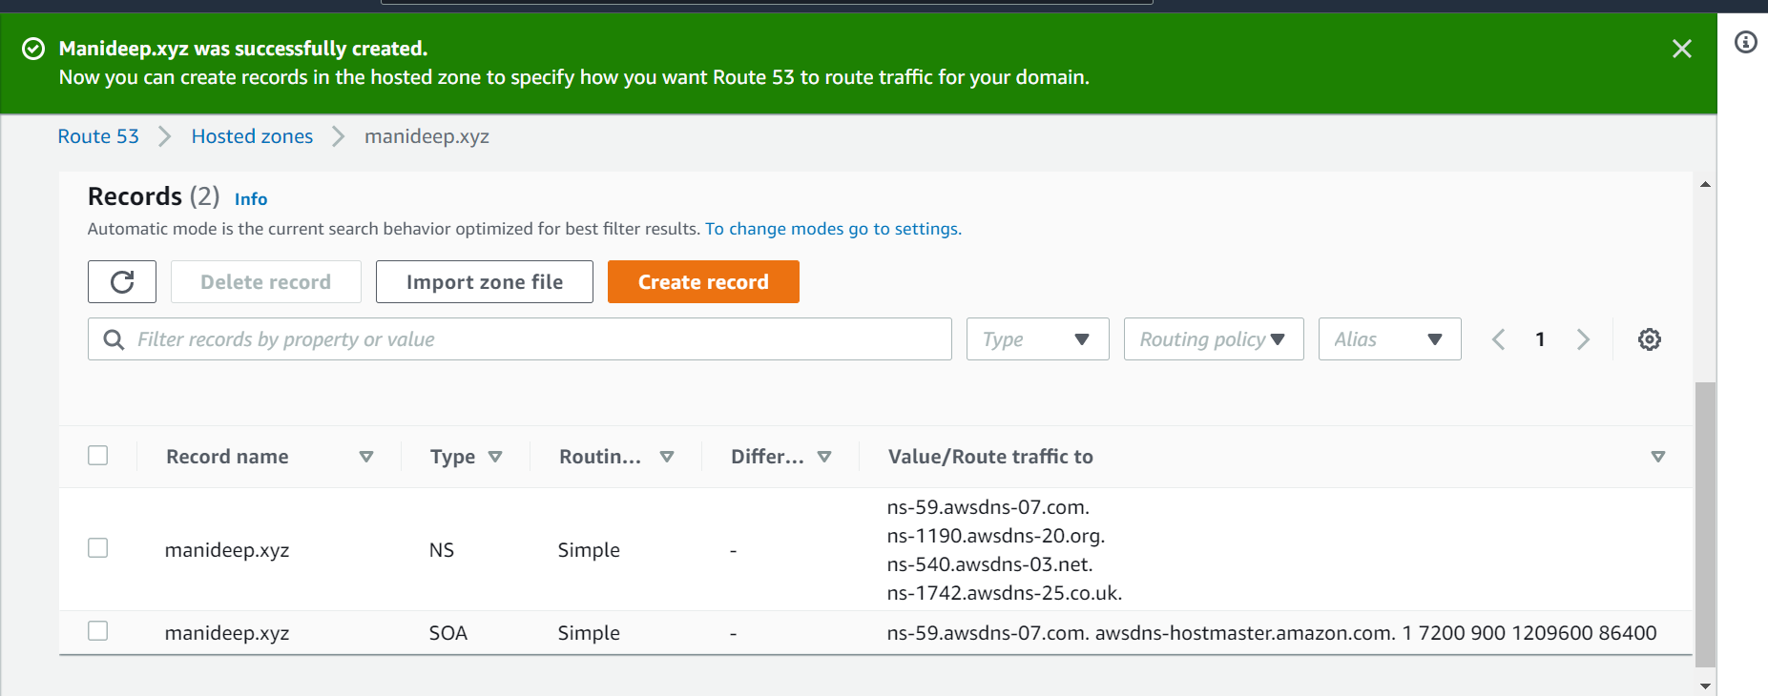

After creating the route 53 we got the name servers mentioned above

We are adding this name servers to the domine name which we have created above

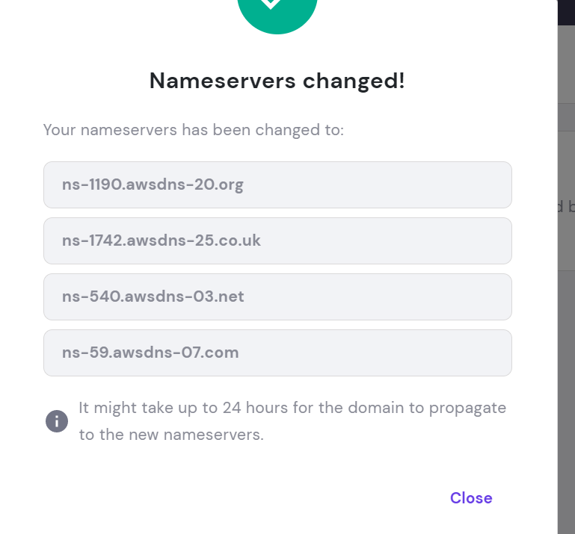

Added our name servers to domine which we got it

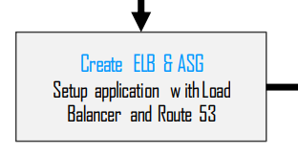

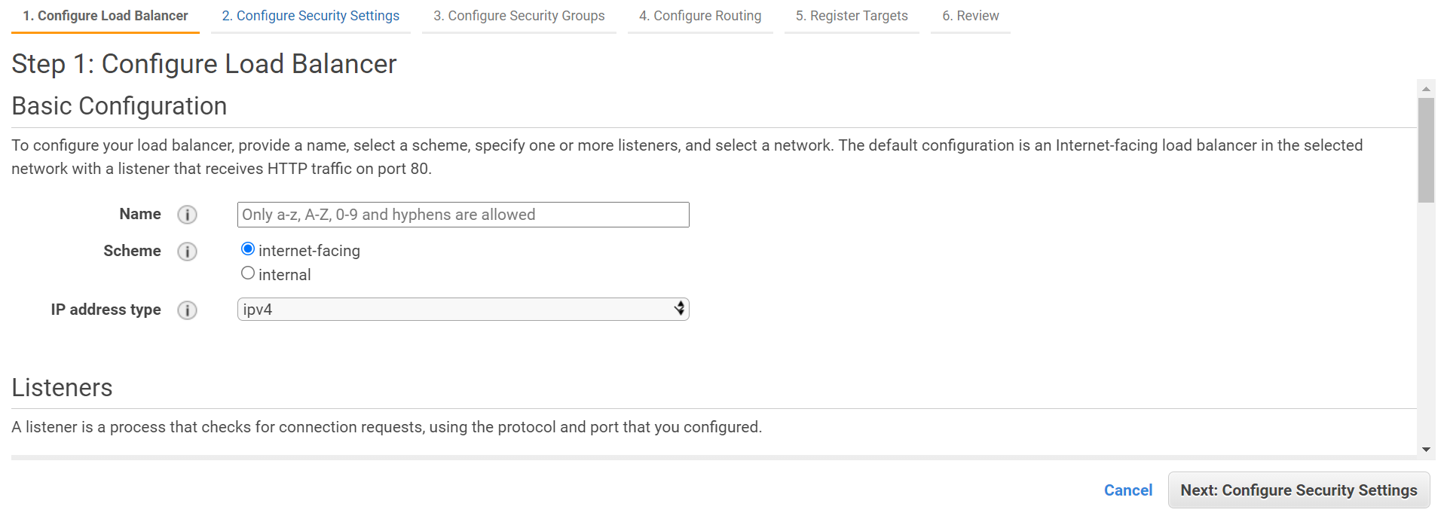

Creating a load balancer for the application

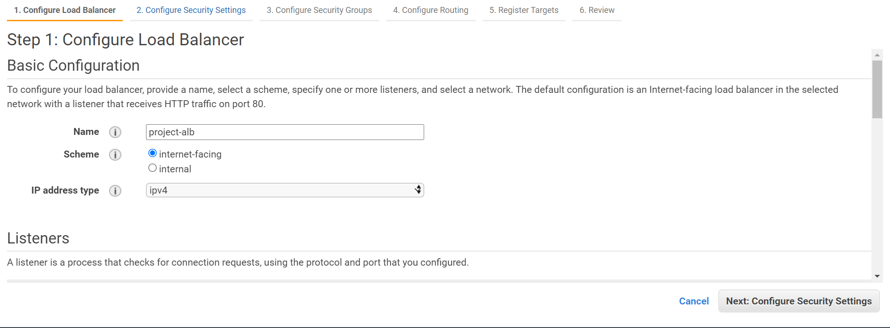

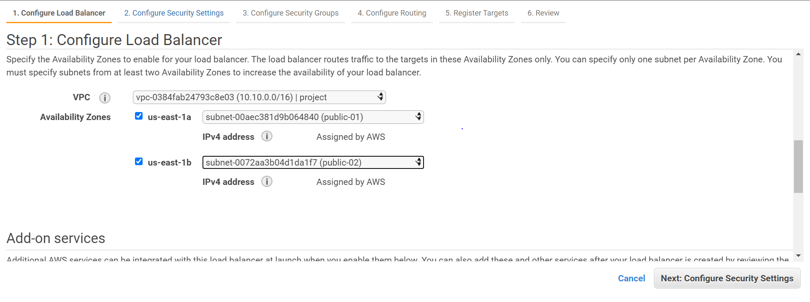

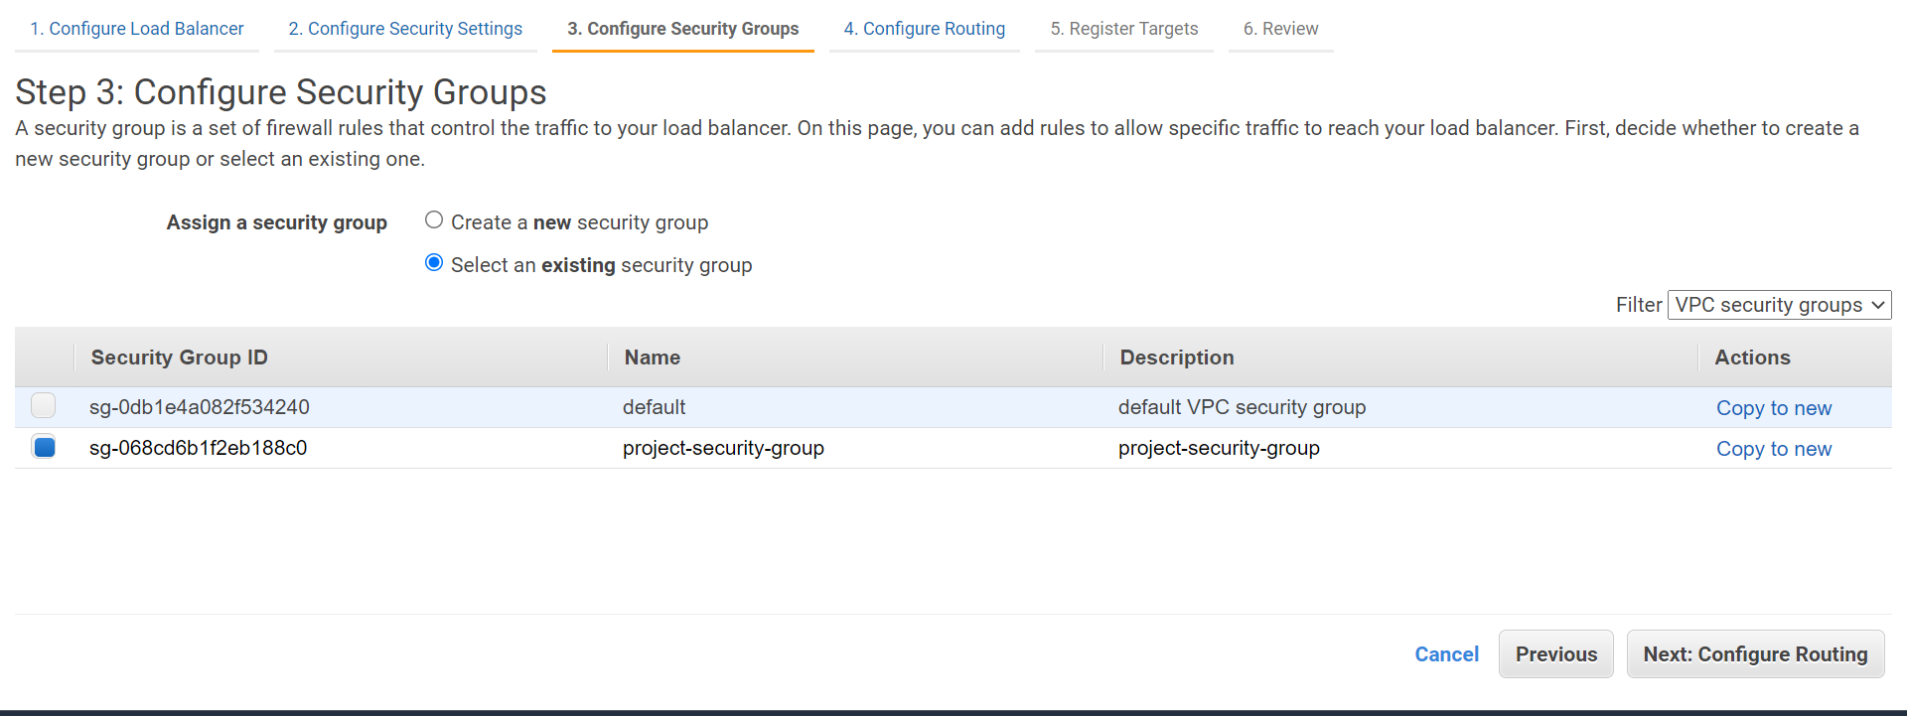

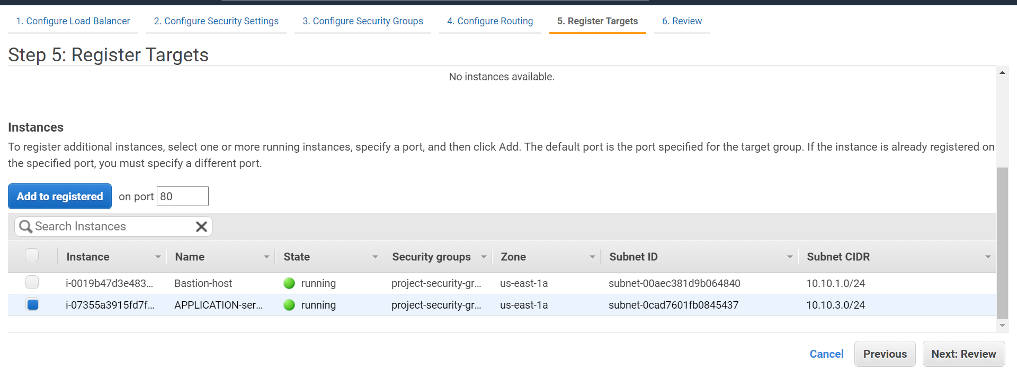

After elb was created

Register targets in the target group

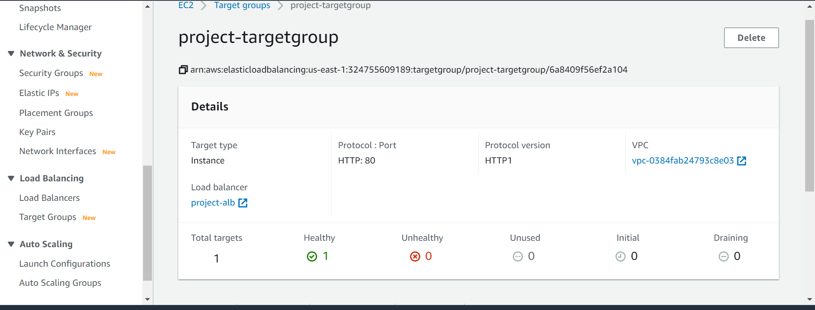

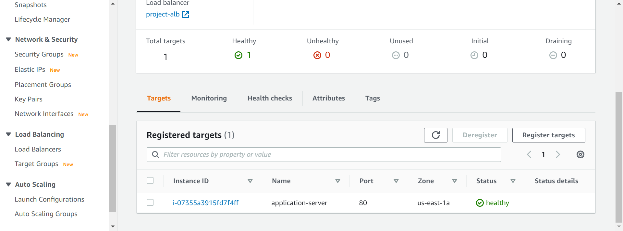

We are adding our application server in the targets because we are using this as a target for our application

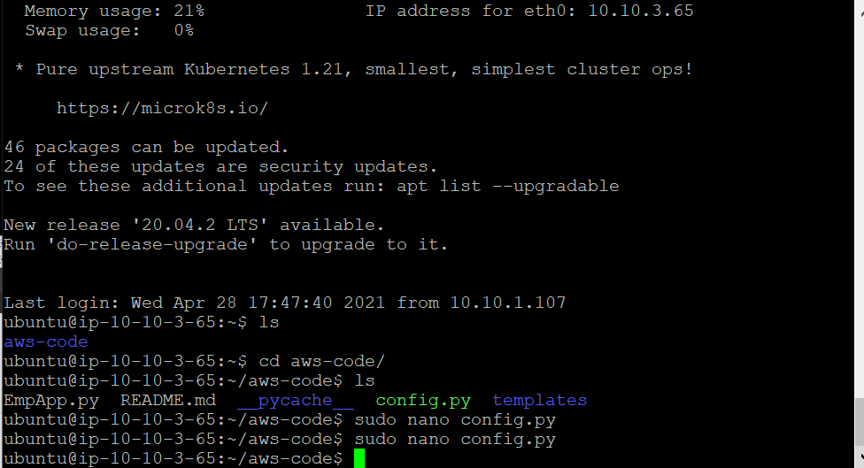

We need to make change in the config.py file and we need to add all the rds related details like end point username password and database details

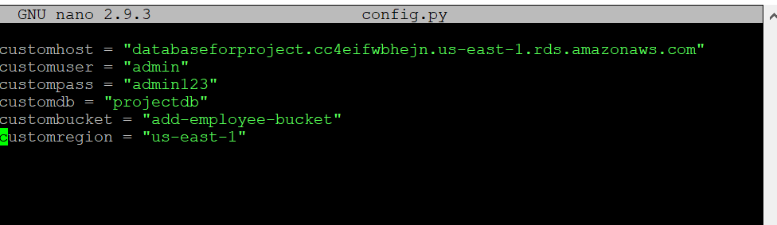

After making all the changes we need to install these below thinks

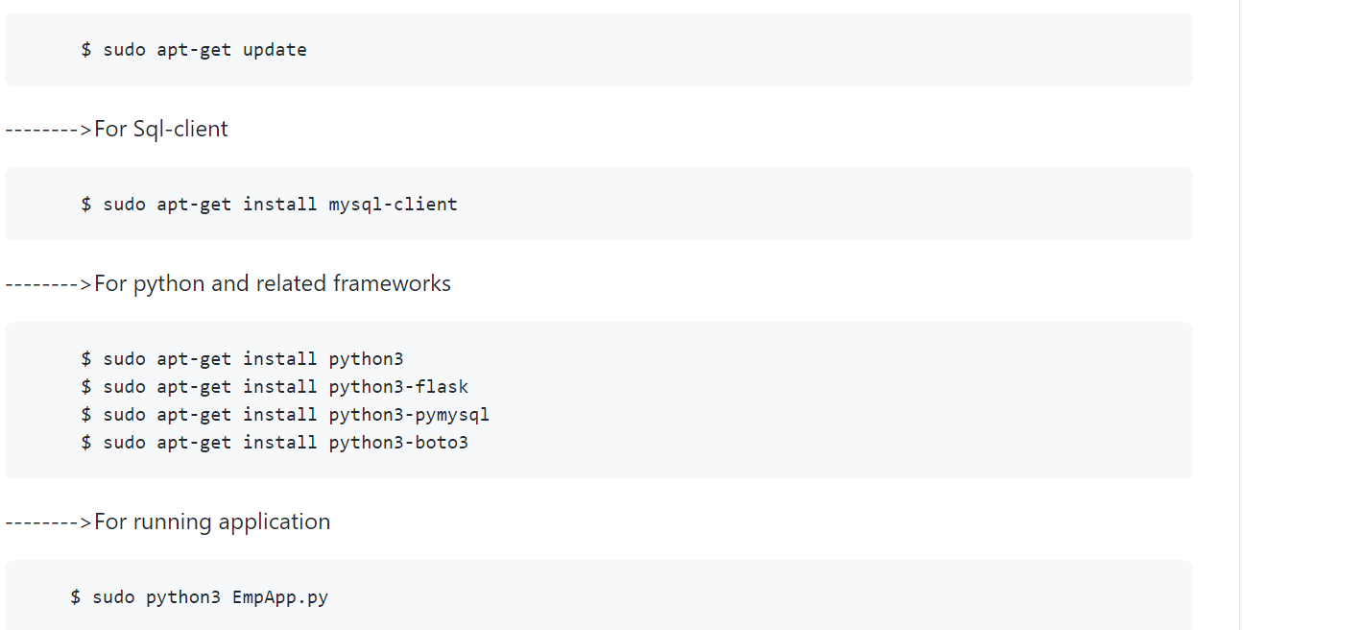

Because the code which we have written is in python so by installing this python librieries will help to run the code with out issues

These are the dependencies of the code

We need to check our alb now



Its working fine

sudo python3 EmpApp.py--------🡪 this is used to start your application

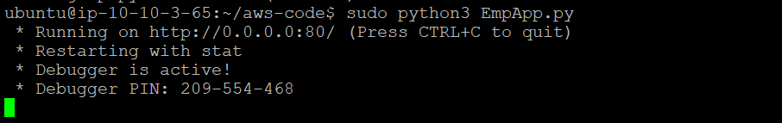

Application was started and you can see if you click on clrl+c it will stop the application

This is the alb endpoint project-alb-1908598190.us-east-1.elb.amazonaws.com

**DNS name**

project-alb-1908598190.us-east-1.elb.amazonaws.com

use this ens name in the browser

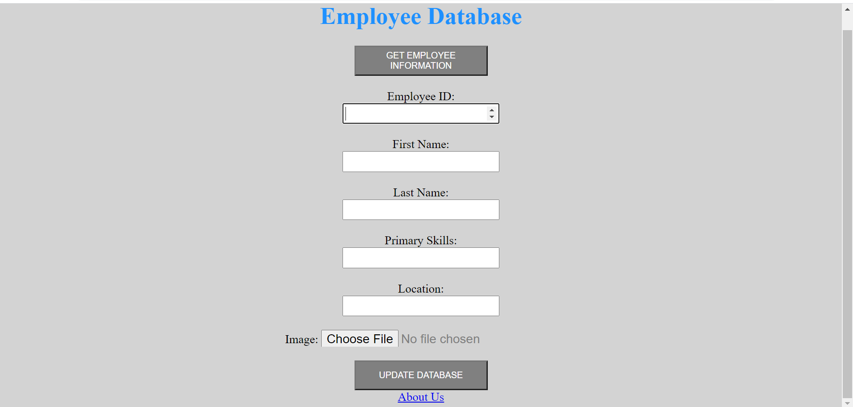

We will see the deployed application

If we click on update database once the data was updated it will show 502 gateway error because we need permissions for se mysql and dynmo db to be created so we need an iam role with all these permissions

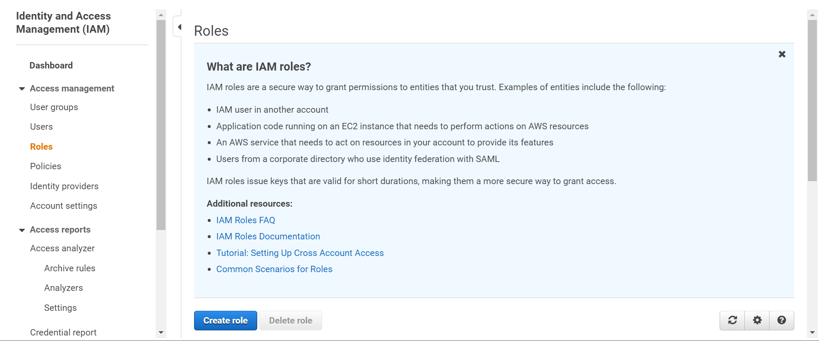

Create role

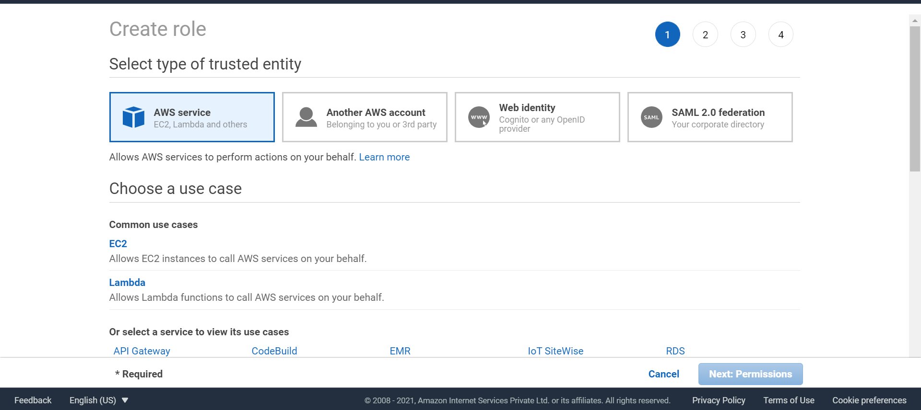

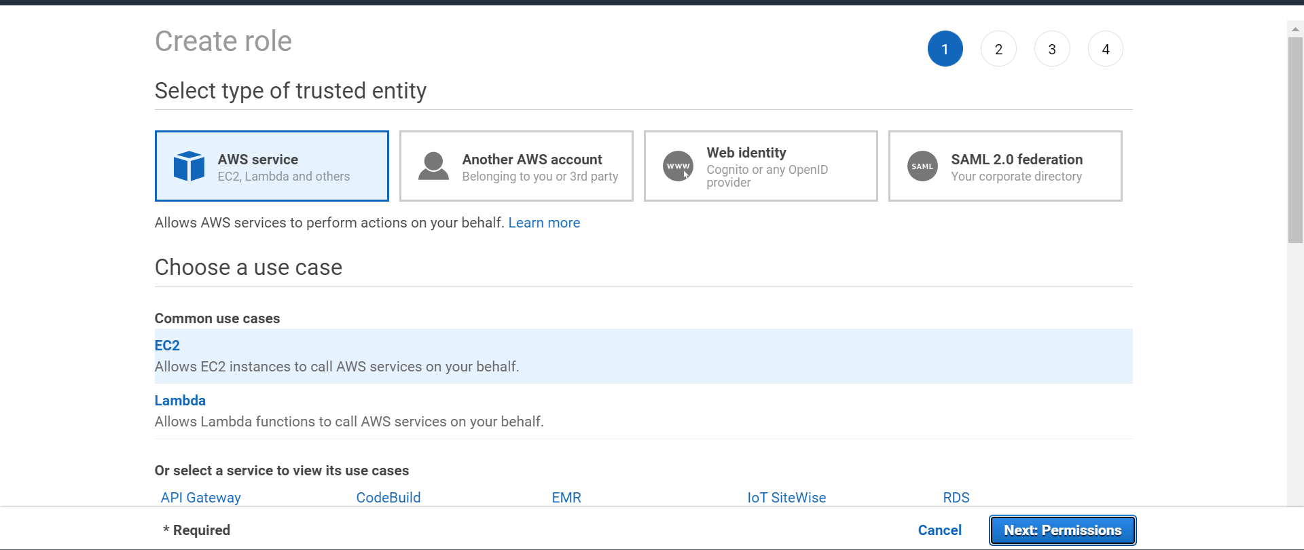

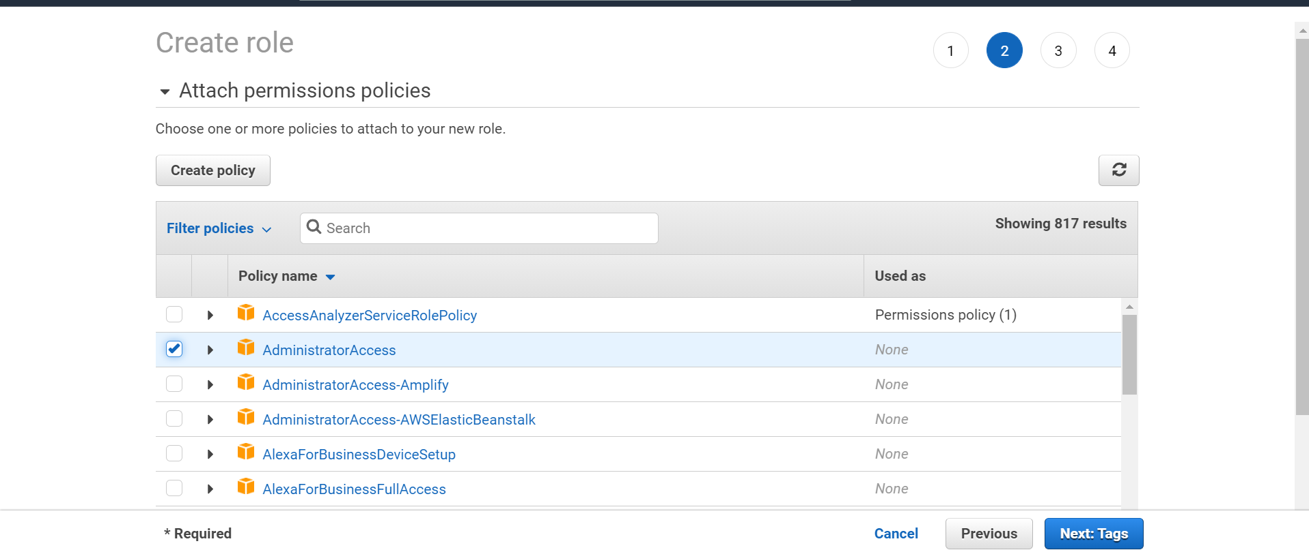

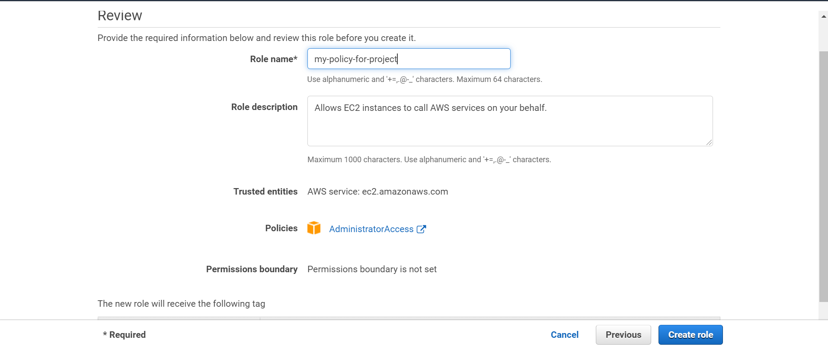

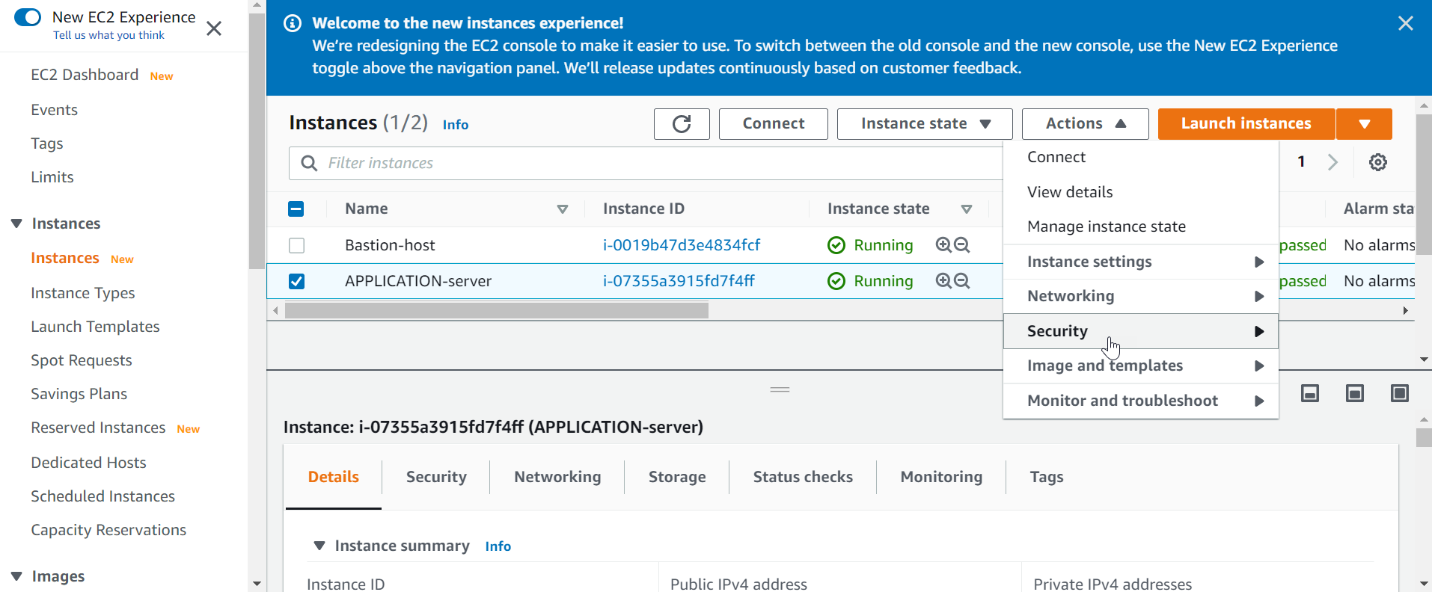

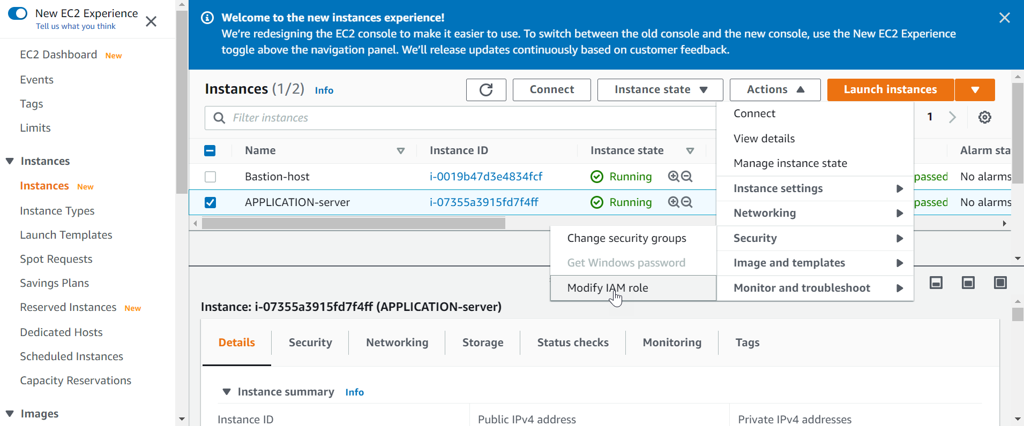

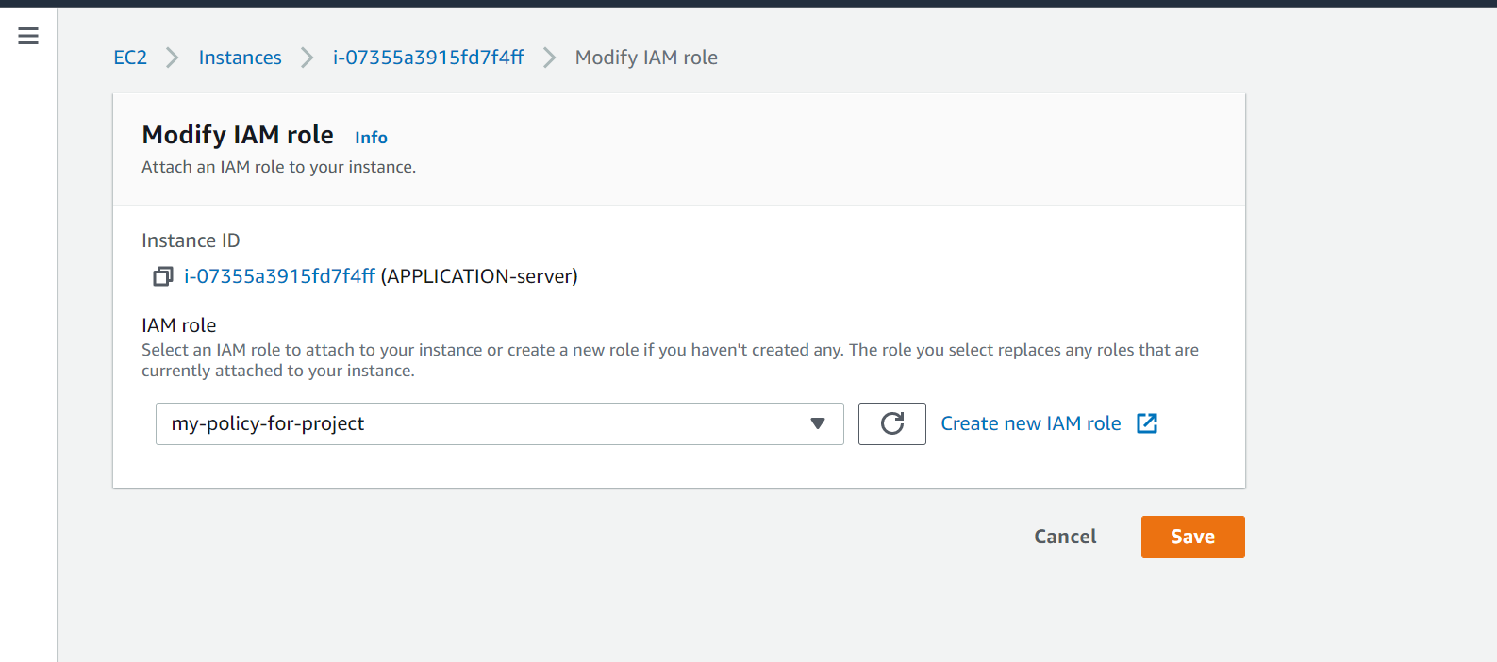

All the data is getting updated hear

ubuntu@ip-10-10-3-65:~$ sudo python3 EmpApp.py

python3: can't open file 'EmpApp.py': [Errno 2] No such file or directory

ubuntu@ip-10-10-3-65:~$ cd aws-code/

ubuntu@ip-10-10-3-65:~/aws-code$ sudo python3 EmpApp.py

* Running on http://0.0.0.0:80/ (Press CTRL+C to quit)

* Restarting with stat

* Debugger is active!

* Debugger PIN: 209-554-468

10.10.1.211 - - [28/Apr/2021 20:54:46] "GET / HTTP/1.1" 200 -

10.10.1.211 - - [28/Apr/2021 20:54:49] "GET / HTTP/1.1" 200 -

10.10.2.139 - - [28/Apr/2021 20:54:50] "GET / HTTP/1.1" 200 -

10.10.1.211 - - [28/Apr/2021 20:55:16] "GET / HTTP/1.1" 200 -

10.10.2.139 - - [28/Apr/2021 20:55:20] "GET / HTTP/1.1" 200 -

10.10.1.211 - - [28/Apr/2021 20:55:46] "GET / HTTP/1.1" 200 -

10.10.2.139 - - [28/Apr/2021 20:55:50] "GET / HTTP/1.1" 200 -

10.10.1.211 - - [28/Apr/2021 20:56:16] "GET / HTTP/1.1" 200 -

10.10.2.139 - - [28/Apr/2021 20:56:20] "GET / HTTP/1.1" 200 -

10.10.1.211 - - [28/Apr/2021 20:56:46] "GET / HTTP/1.1" 200 -

10.10.2.139 - - [28/Apr/2021 20:56:50] "GET / HTTP/1.1" 200 -

10.10.1.211 - - [28/Apr/2021 20:57:16] "GET / HTTP/1.1" 200 -

10.10.2.139 - - [28/Apr/2021 20:57:20] "GET / HTTP/1.1" 200 -

10.10.1.211 - - [28/Apr/2021 20:57:46] "GET / HTTP/1.1" 200 -

10.10.2.139 - - [28/Apr/2021 20:57:50] "GET / HTTP/1.1" 200 -

10.10.1.211 - - [28/Apr/2021 20:58:16] "GET / HTTP/1.1" 200 -

10.10.2.139 - - [28/Apr/2021 20:58:20] "GET / HTTP/1.1" 200 -

10.10.1.211 - - [28/Apr/2021 20:58:46] "GET / HTTP/1.1" 200 -

10.10.2.139 - - [28/Apr/2021 20:58:50] "GET / HTTP/1.1" 200 -

10.10.1.211 - - [28/Apr/2021 20:59:16] "GET / HTTP/1.1" 200 -

10.10.2.139 - - [28/Apr/2021 20:59:20] "GET / HTTP/1.1" 200 -

10.10.1.211 - - [28/Apr/2021 20:59:46] "GET / HTTP/1.1" 200 -

10.10.2.139 - - [28/Apr/2021 20:59:50] "GET / HTTP/1.1" 200 -

10.10.1.211 - - [28/Apr/2021 21:00:16] "GET / HTTP/1.1" 200 -

10.10.2.139 - - [28/Apr/2021 21:00:20] "GET / HTTP/1.1" 200 -

10.10.1.211 - - [28/Apr/2021 21:00:47] "GET / HTTP/1.1" 200 -

10.10.2.139 - - [28/Apr/2021 21:00:50] "GET / HTTP/1.1" 200 -

10.10.1.211 - - [28/Apr/2021 21:01:17] "GET / HTTP/1.1" 200 -

10.10.2.139 - - [28/Apr/2021 21:01:20] "GET / HTTP/1.1" 200 -

10.10.1.211 - - [28/Apr/2021 21:01:47] "GET / HTTP/1.1" 200 -

10.10.2.139 - - [28/Apr/2021 21:01:51] "GET / HTTP/1.1" 200 -

10.10.1.211 - - [28/Apr/2021 21:02:17] "GET / HTTP/1.1" 200 -

10.10.2.139 - - [28/Apr/2021 21:02:21] "GET / HTTP/1.1" 200 -

10.10.1.211 - - [28/Apr/2021 21:02:47] "GET / HTTP/1.1" 200 -

10.10.2.139 - - [28/Apr/2021 21:02:51] "GET / HTTP/1.1" 200 -

10.10.1.211 - - [28/Apr/2021 21:03:17] "GET / HTTP/1.1" 200 -

10.10.2.139 - - [28/Apr/2021 21:03:21] "GET / HTTP/1.1" 200 -

10.10.1.211 - - [28/Apr/2021 21:03:47] "GET / HTTP/1.1" 200 -

10.10.2.139 - - [28/Apr/2021 21:03:51] "GET / HTTP/1.1" 200 -

10.10.1.211 - - [28/Apr/2021 21:04:17] "GET / HTTP/1.1" 200 -

10.10.2.139 - - [28/Apr/2021 21:04:21] "GET / HTTP/1.1" 200 -

10.10.1.211 - - [28/Apr/2021 21:04:47] "GET / HTTP/1.1" 200 -

10.10.2.139 - - [28/Apr/2021 21:04:51] "GET / HTTP/1.1" 200 -

10.10.1.211 - - [28/Apr/2021 21:05:17] "GET / HTTP/1.1" 200 -

10.10.2.139 - - [28/Apr/2021 21:05:21] "GET / HTTP/1.1" 200 -

10.10.1.211 - - [28/Apr/2021 21:05:47] "GET / HTTP/1.1" 200 -

10.10.2.139 - - [28/Apr/2021 21:05:51] "GET / HTTP/1.1" 200 -

10.10.1.211 - - [28/Apr/2021 21:06:17] "GET / HTTP/1.1" 200 -

10.10.2.139 - - [28/Apr/2021 21:06:21] "GET / HTTP/1.1" 200 -

10.10.2.139 - - [28/Apr/2021 21:06:37] "GET / HTTP/1.1" 200 -

10.10.1.211 - - [28/Apr/2021 21:06:47] "GET / HTTP/1.1" 200 -

10.10.2.139 - - [28/Apr/2021 21:06:51] "GET / HTTP/1.1" 200 -

10.10.1.211 - - [28/Apr/2021 21:07:17] "GET / HTTP/1.1" 200 -

Data inserted in MySQL RDS... uploading image to S3...

Uploading to S3 success... saving metadata in dynamodb...

all modification done...

10.10.2.139 - - [28/Apr/2021 21:07:19] "POST /addemp HTTP/1.1" 200 -

Data inserted in MySQL RDS... uploading image to S3...

Uploading to S3 success... saving metadata in dynamodb...

all modification done...

10.10.2.139 - - [28/Apr/2021 21:07:20] "POST /addemp HTTP/1.1" 200 -

10.10.2.139 - - [28/Apr/2021 21:07:21] "GET / HTTP/1.1" 200 -

10.10.1.211 - - [28/Apr/2021 21:07:47] "GET / HTTP/1.1" 200 -

10.10.2.139 - - [28/Apr/2021 21:07:51] "GET / HTTP/1.1" 200 -

10.10.1.211 - - [28/Apr/2021 21:08:17] "GET / HTTP/1.1" 200 -

10.10.2.139 - - [28/Apr/2021 21:08:21] "GET / HTTP/1.1" 200 -

Where we have started this application

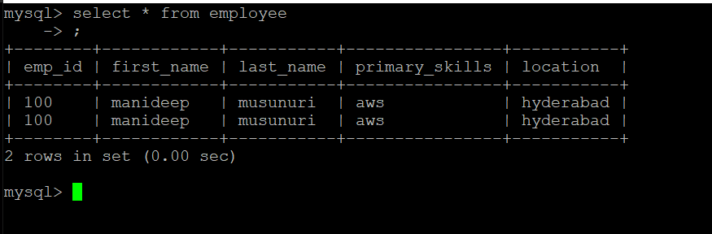

Data was updated in the mysql database

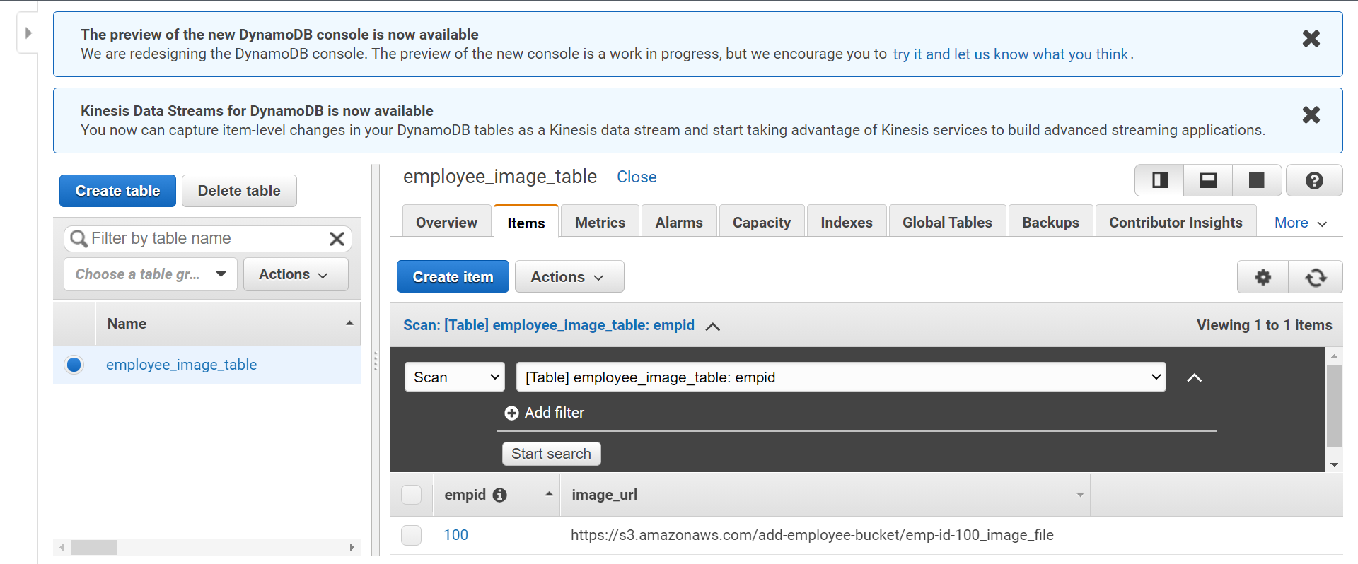

Metadata of the images was uploaded to s3

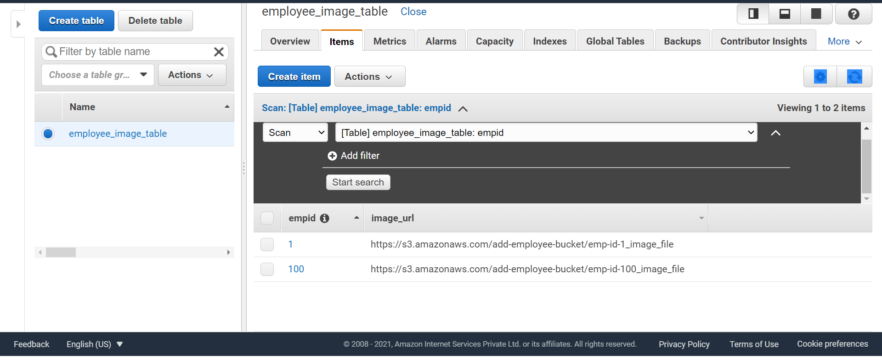

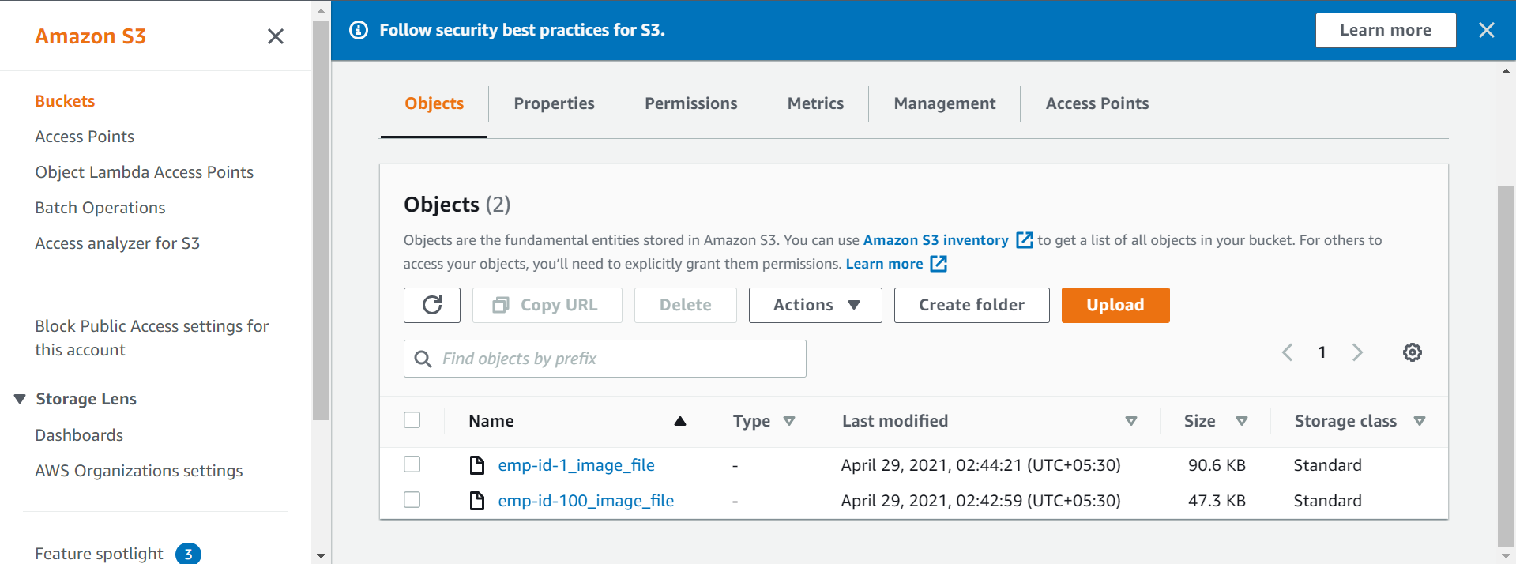

Images are getting stored in s3

Now we 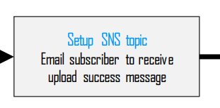

Now we are setting up the sns topic

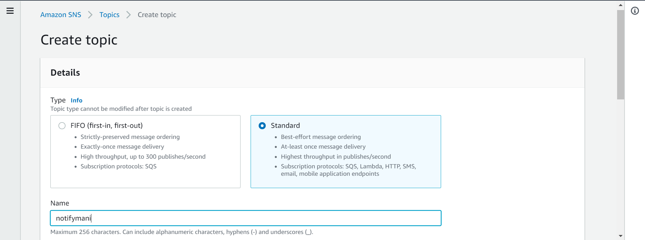

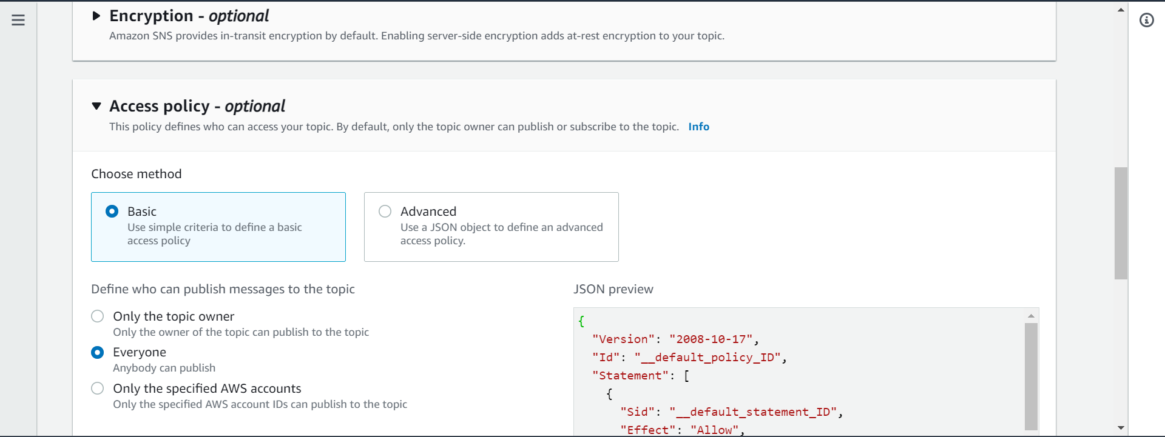

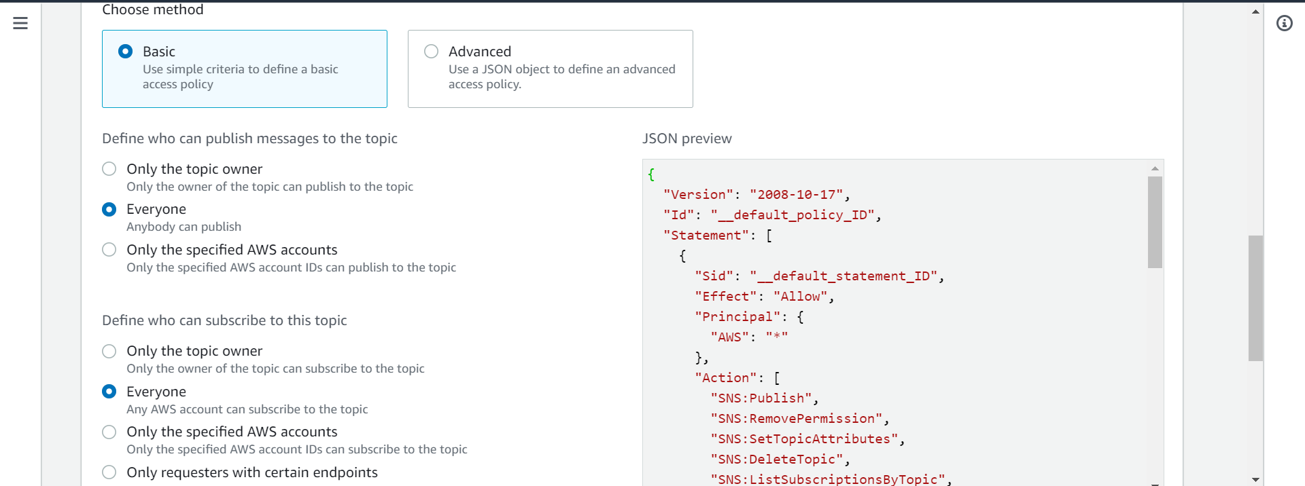

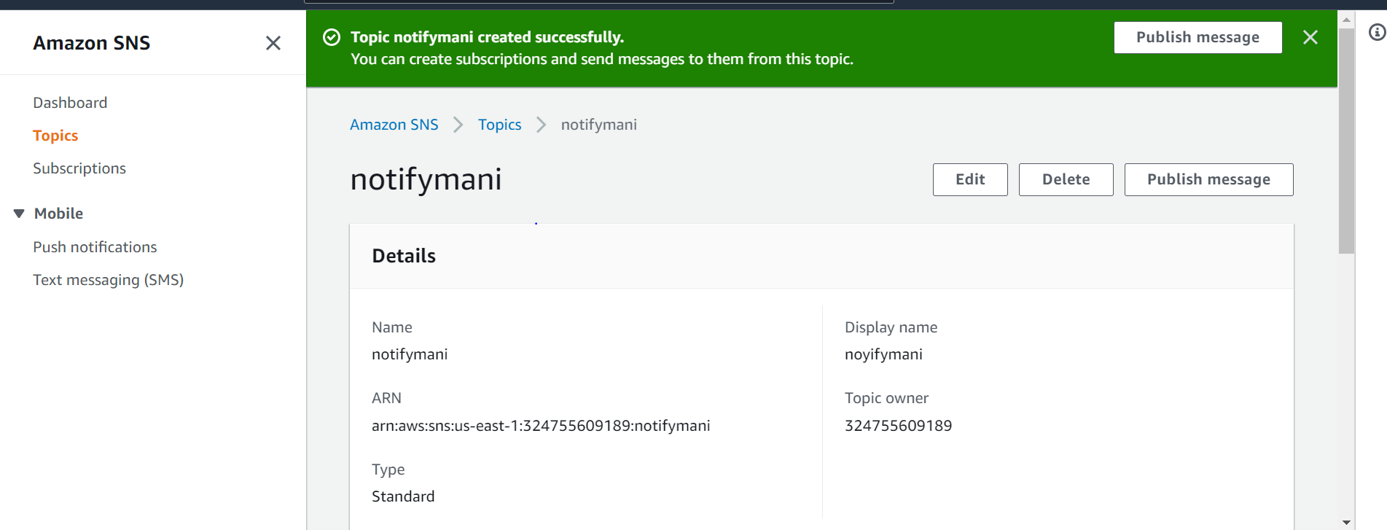

Topic got created

We need to work on subscription now

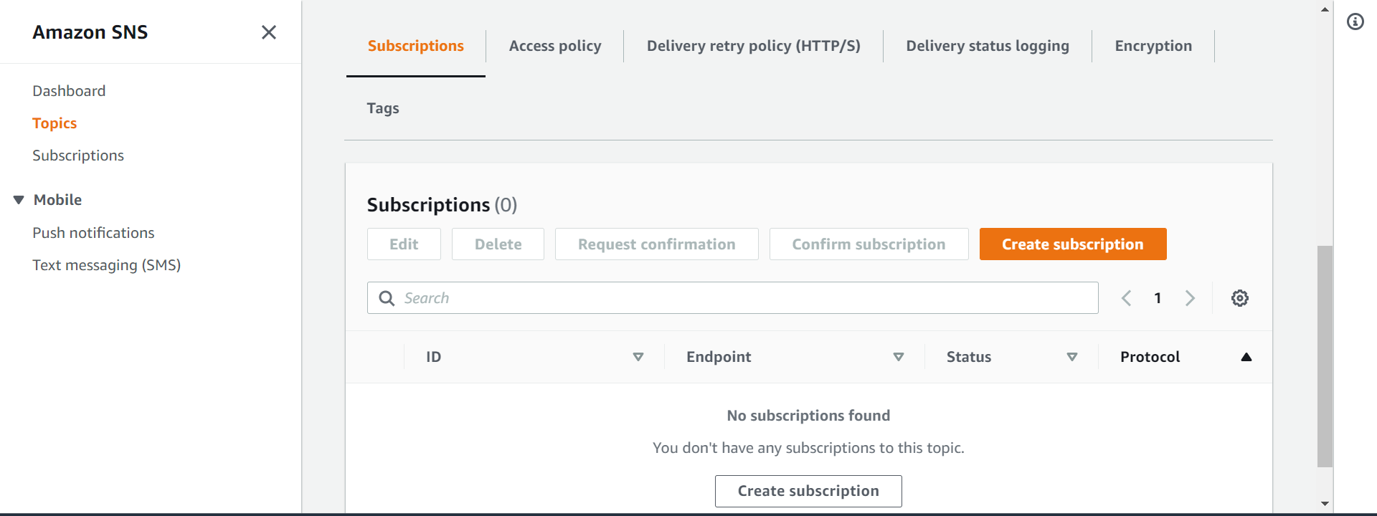

Create subscription

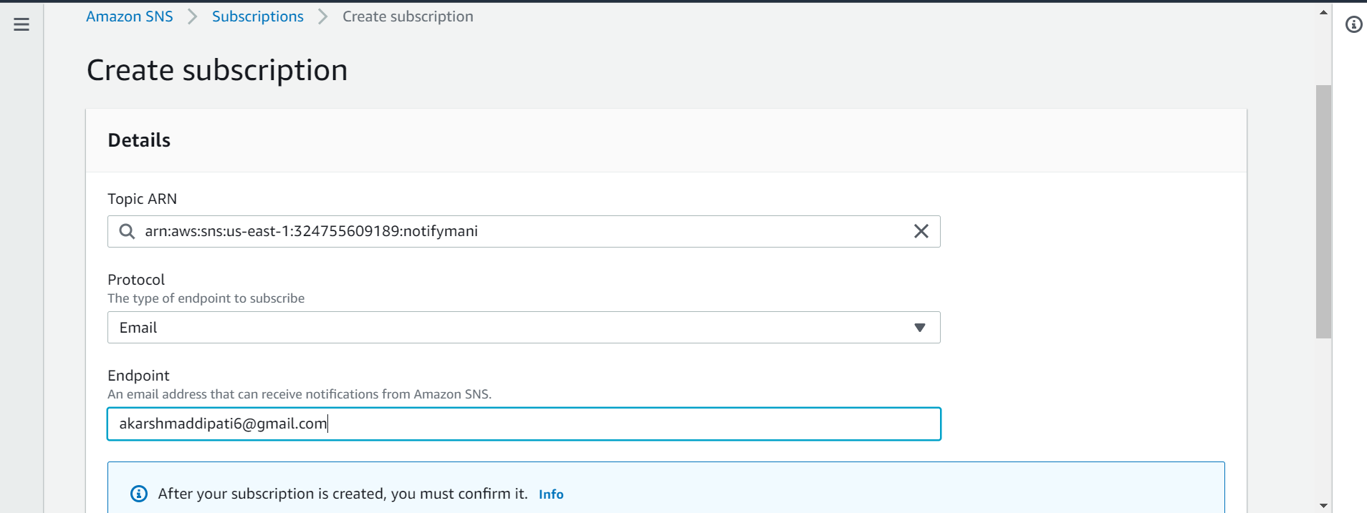

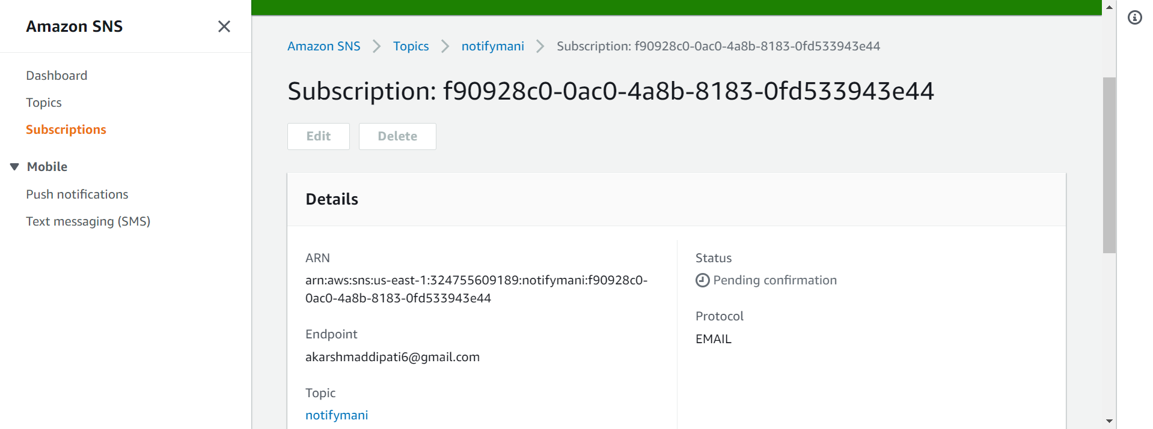

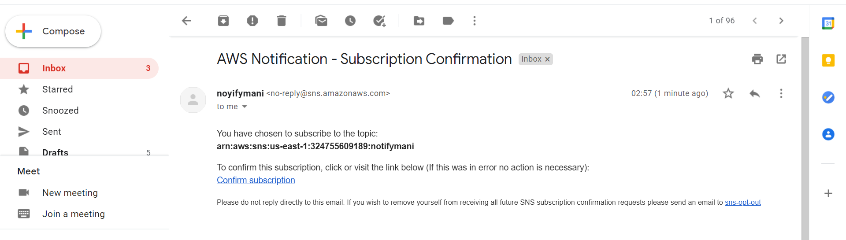

Got a mail from aws regarding subscription

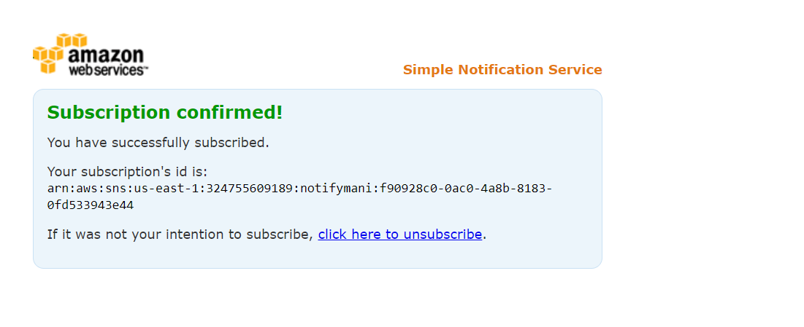 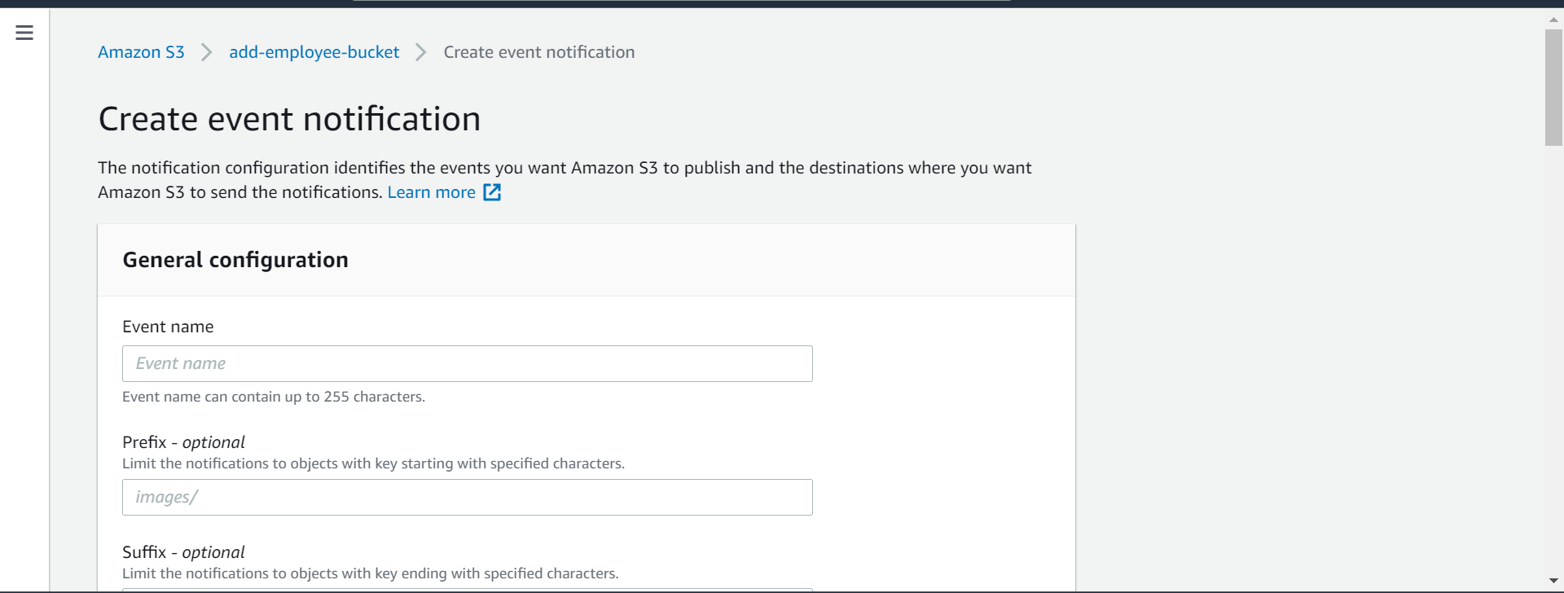

When ever the file was uploded the email will be triggred 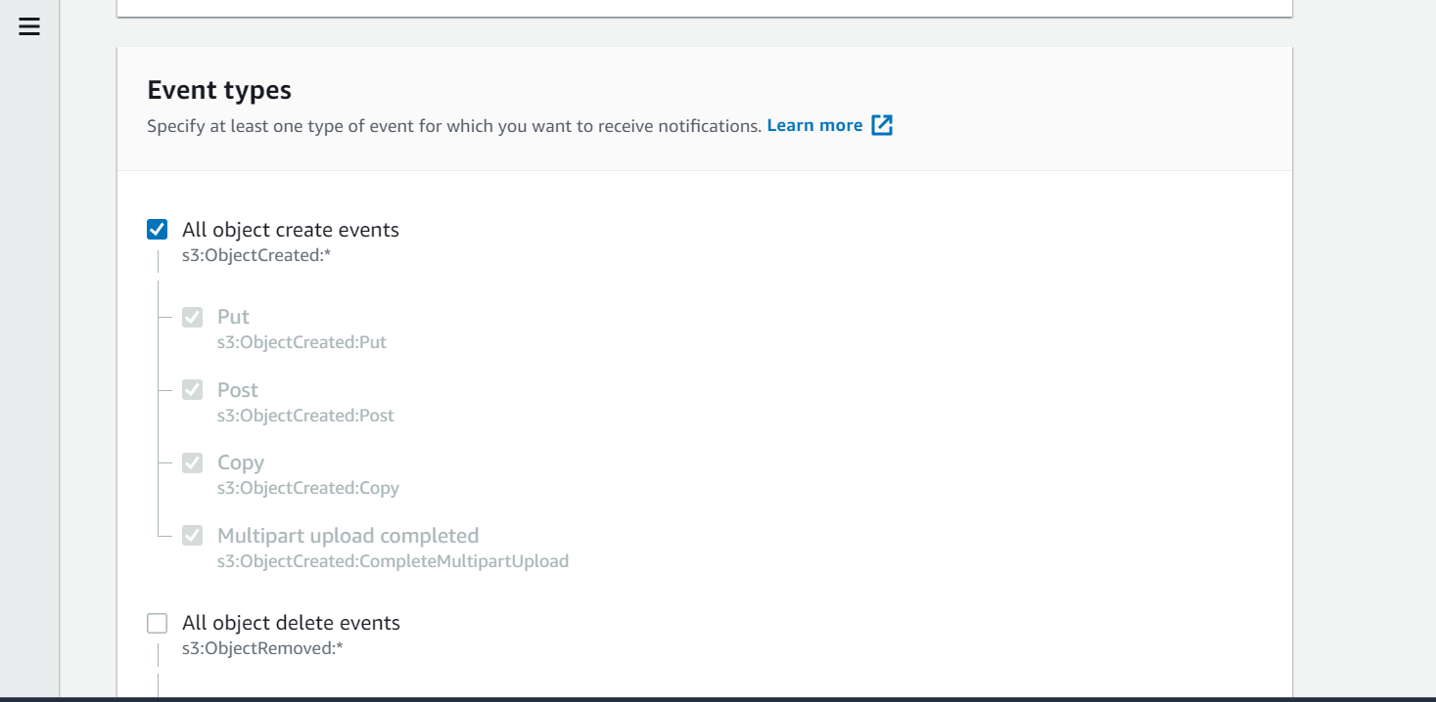

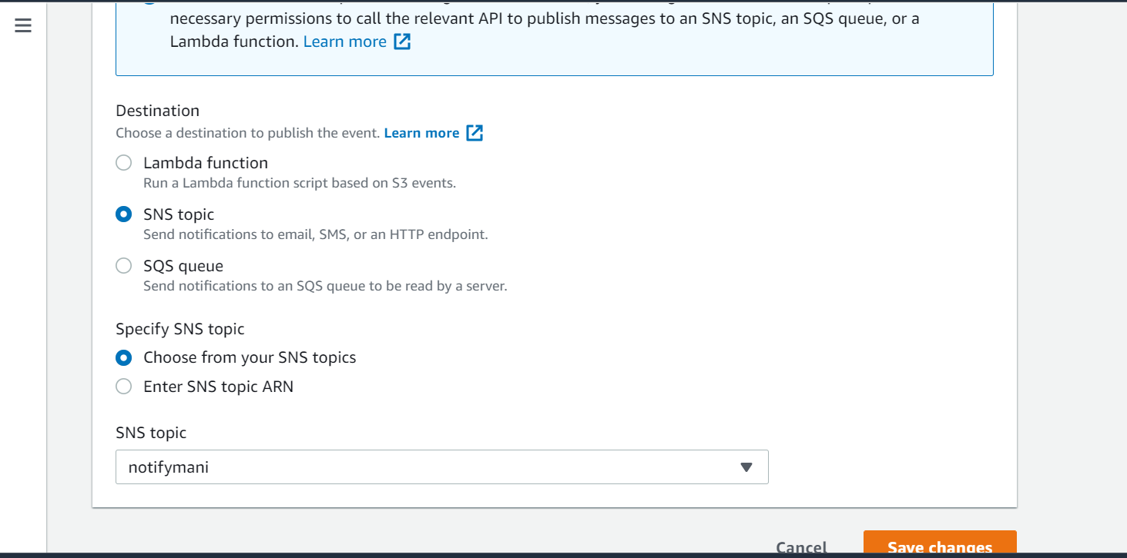 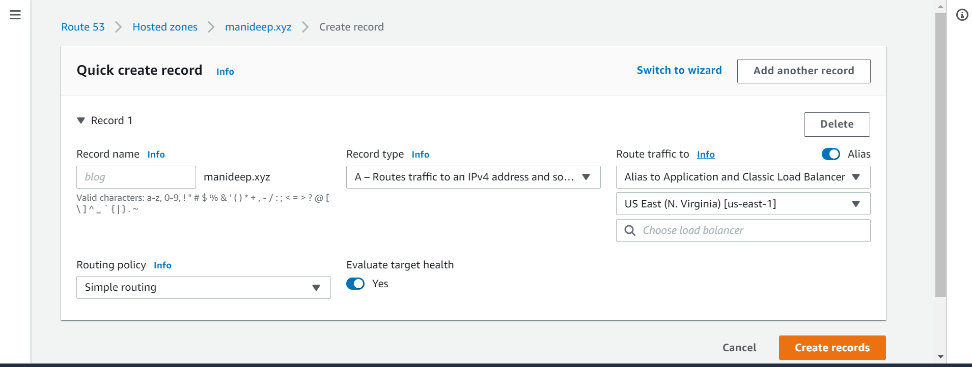

Creating records to reflect the alias

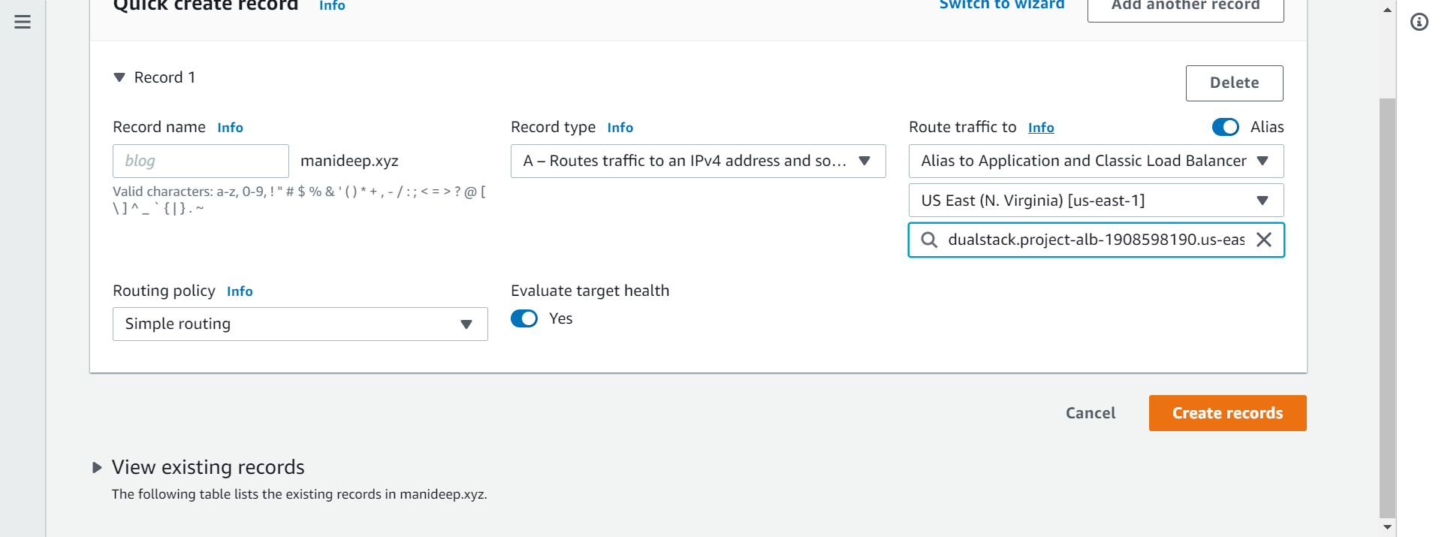

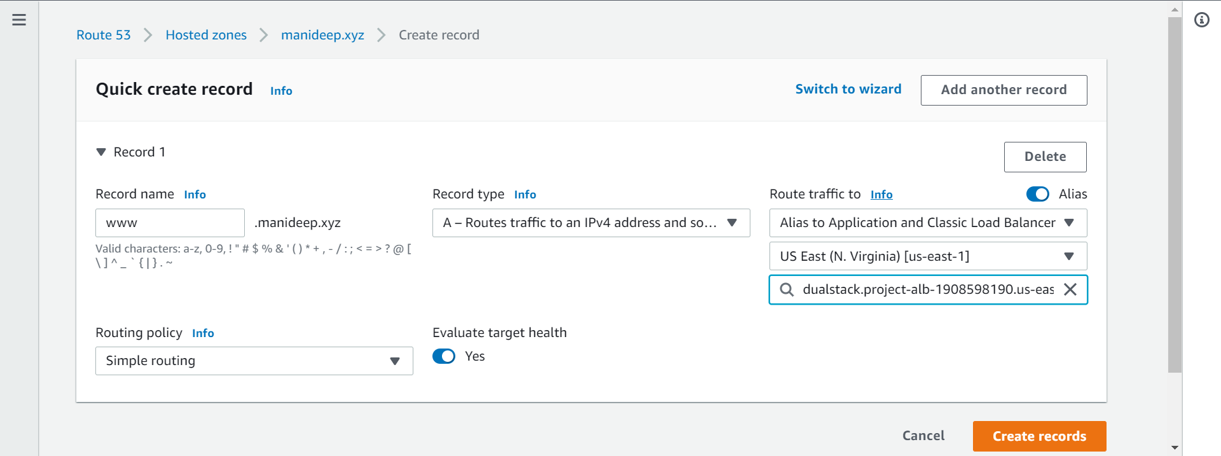

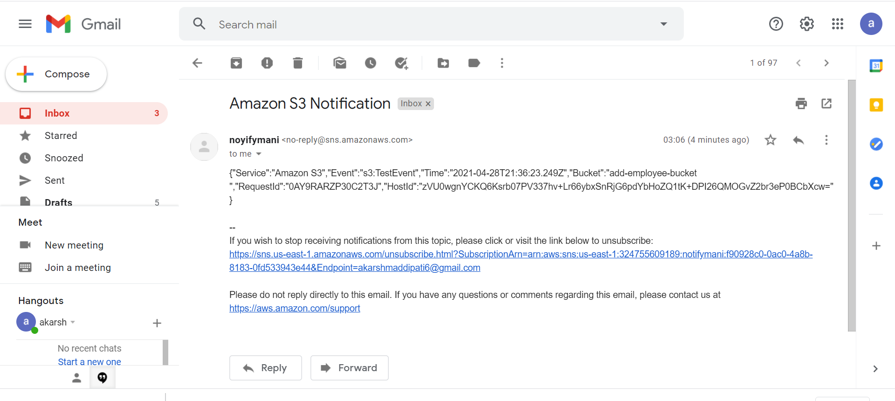

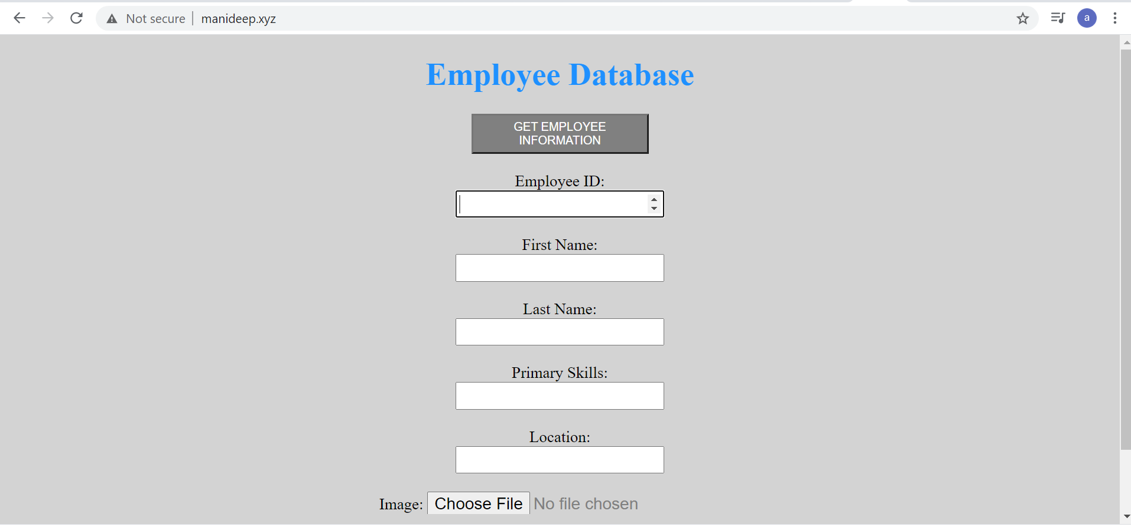

See manideep.xys is taking me to this web site

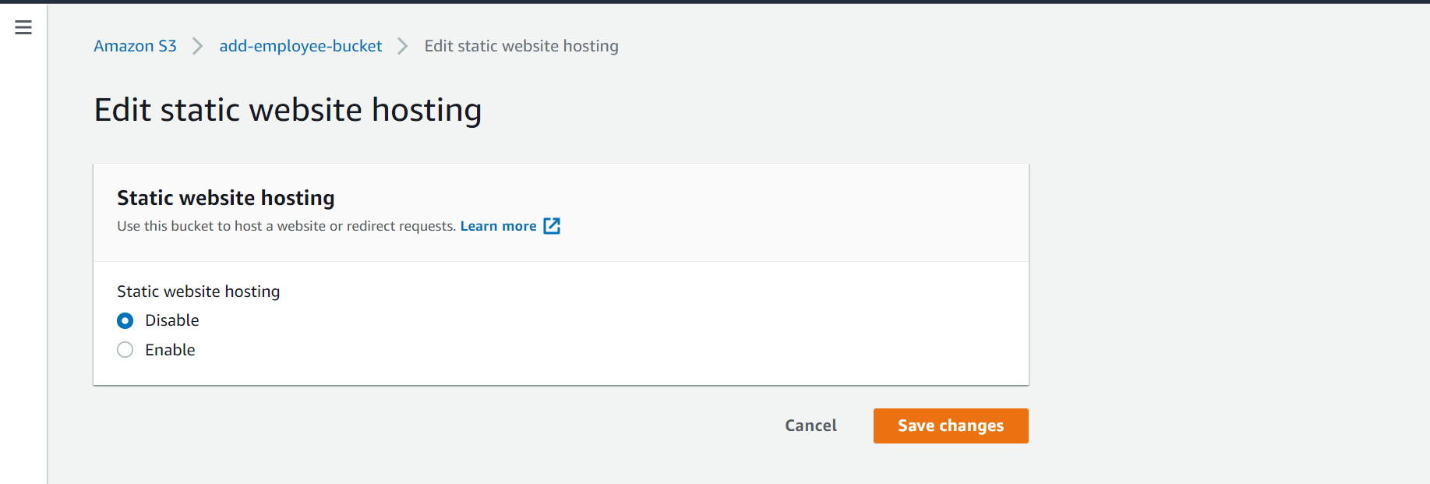

Enabling the static website hosting

